**LOOKING BACK AT 2021**

2021 was a good year for your alumni association! Although we did not achieve most of our goals for 2021, we came close! Last year we published four goals for 2021. They were: (1) increase membership in your alumni association, (2) increase the number of board members to at least 15, (3) increase our Foundation balance to $600,000, and (4) increase our presence in the community. The covid19 pandemic played a major role in our failure to achieve the fourth goal. Hopefully, you will be able to see your alumni association “out and about” in the community this year, especially at school functions. We fell just short of achieving our Foundation balance goal of $600,000. As of January 25, our Foundation balance was $595,110.41. We almost achieved our goal of fifteen board members. We presently have thirteen. We hope to add four or five more this year. Although we did not greatly increase our overall membership, it also did not greatly decrease either.

You can continue to help your association and GHS graduates by renewing your membership in the Greencastle Alumni Dollars for Scholars. Just complete the renewal form on page 7 and return it with your dues to us. The membership fee is ten dollars. Or you can contribute $25 to our scholarship fund in memory or honor of someone and your membership is free. And a $50 donation will have your name included in the Foundation’s published donor list for 2022.

A LITTLE OF

**THIS** and **THAT**

New officers for 2022 were approved by your Board. They are President Jon Blue ’69, Vice-President Cathy Gram Lowery ’69, Secretary Patty Sillery McCastle ‘72, and Treasurer Terri Sutherlin McKee ’74. Terri will remain as Scholarship Chairperson and Ron Blotch will be the Historian.

We are pleased to announce that we have four new board members. Former board members Anita Barr McEnulty ’63 and Audra Dorsett Holton ’54 have agreed to rejoin your board. First time board members are Josh Bonebrake from the class of 2011 and Sandra Quinnette Foster, class of 1971. We would like to have at least two board members from each decade. Although new board members from any decade would be acceptable, we especially are seeking new board members who graduated in the 1980s and later.

Your Board has four goals for 2022: (1) increase membership in the Greencastle Alumni Dollars for Scholars organization. Our goal is to at least double our membership numbers. (2) increase the number of board members to at least eighteen. (3) increase our Foundation balance to a minimum of $650,000 with a long term goal of $700,000. And (4) to increase our presence within the Greencastle Community (once the virus allows us to do so). To achieve these goals, we need your help! Please renew your membership today!

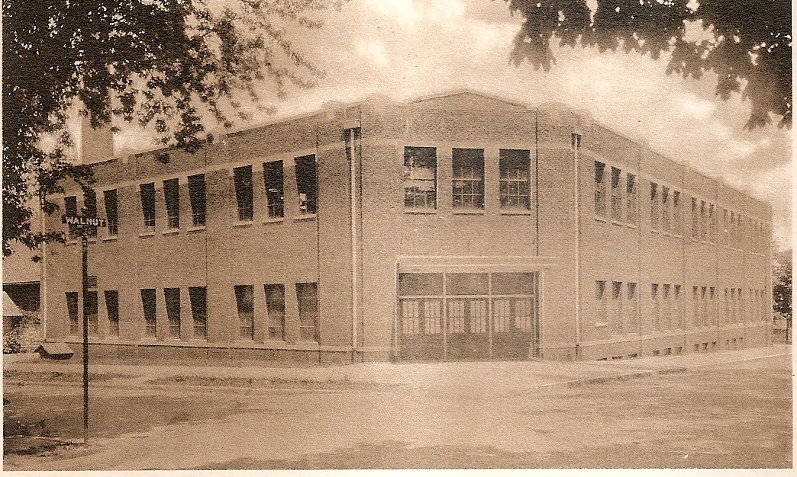

**TIGER CUBS IN THE 1990s (1992-93)**

When the 1992-93 school year started, each Tiger Cub athlete had high hopes of having a very successful season ending with a Sectional Championship! That dream was realized by four Tiger Cub teams and thirteen individuals.

Lori Garner was the first Tiger Cub of the school year to claim a Sectional title as she won the girls cross country title at South Putnam with a winning time of 16:05. The Lady Tiger Cubs won the South Vermillion volleyball sectional by defeating Cloverdale 16-14 and 15-12. They then defeated Riverton Parke 15-9 and 15-13 and South Vermillion 11-15, 15-3, and 15-2. The Lady swimmers were co-Sectional Champs as they tied Fountain Central with a team score of 263. The Lady Cubs claimed two individual titles as Angela Christian won the one meter diving title with 333.00 points and Mandy Modlin claimed the 100 yard backstroke title with a time of 1:06.60. The wresting squad added to their resume with five individual Sectional Championships as Derek Burchett (103 lbs.), Scott Williams (119), Scott O’Hair (140), Brian Black (152), and Tony Eltz (heavyweight) won their respective weight classes. The girls basketball team claimed the third team Sectional Championship of the school year at Cloverdale as they defeated Cloverdale 55-32 and Monrovia 45-42. In boys swimming Brandt Modlin claimed the title Sectional Champ by winning the 100 yard butterfly with a time of 55.83. The boys basketball squad won their own sectional by defeating North Vermillion 65-53, Rockville 53-43, and South Putnam 35-32. The Cubs then won the opening game of the Lafayette Jeff regional by defeating Attica 73-66. The Cubs dream of being regional champs was ended in the championship game by Lafayette Jeff. In girls track Lori Garner proved that her Sectional Championship in cross country was no fluke as she won both the 1600 meter run and the 3200 meter run. She claimed the 1600 meter title with a winning time of 5:35.0 and the 3200 meter title with a 12:37.0 effort. In boys track Jason Gibbs proved that he had springs in his legs as he won both the long jump and high jump Sectional Championships. He won the long jump with a leap of 20’0” and the high jump with a height of 6”2”.

Thirteen individual Sectional titles (three by Lori Garner and two by Jason Gibbs) and four team Championships made the 1992-93 an overall success for the Greencastle Tiger Cubs!

**1964-65 DAIRY JUDGING**

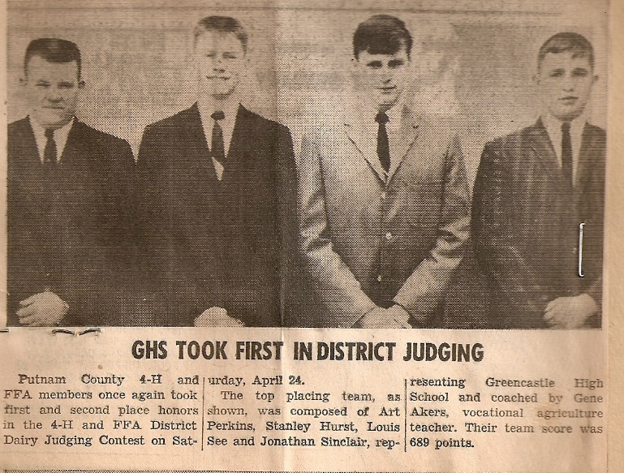

(L-R): Art Perkins, Stanley Hurst, Louis See, Jonathan Sinclair (photo from the Daily Banner)

**WE NEED YOUR HELP**

One of our goals for this year is to increase our membership numbers. You can help us do that. If each of our present members would recruits two new members we could triple our membership! Remember you do NOT have to be a GHS graduate to be a member of our organization. You just have to be someone who wants to help GHS graduates! Although we need more members from all years, we especially need more members who graduated in the 1980s, 1990s, 2000s, and 2010s.

**BROWN, CHURCHILL, LUZAR, & NORRIS INDUCTED INTO ATHLETIC HOF**

Former GHS standouts Gib Brown (class of ‘59), Ray “Wheaties” Churchill (’67), Louie Luzar (’67), and DeWayne “Pete” Norris (’68) were recently inducted into the Greencastle High School Athletic Hall of Fame. Gib Brown earned all-state honors in football in 1958 and was a mainstay on the basketball squad. Brown attended Indiana University on a football scholarship. Churchill, a three-sport standout, was named all-state in football in 1966, qualified for the track state meet in the long jump in 1966, and set the school record in the long jump. He attended the University of Iowa on a football scholarship. Luzar, also a three-sport standout, was all-state in football in 1966 and attended Butler University on a football scholarship. And Norris was another three-sport star. He was selected to the high school football all-star squad after the 1967 season, earned honorable mention all-state in basketball in 1968, and qualified for the state track meet in the long jump in 1968. Gib, Wheaties, Louie, and Pete – four GHS All-Time Greats!!

**1988-89 JUNIOR CLASS OFFICERS**

(1989 Minaret)

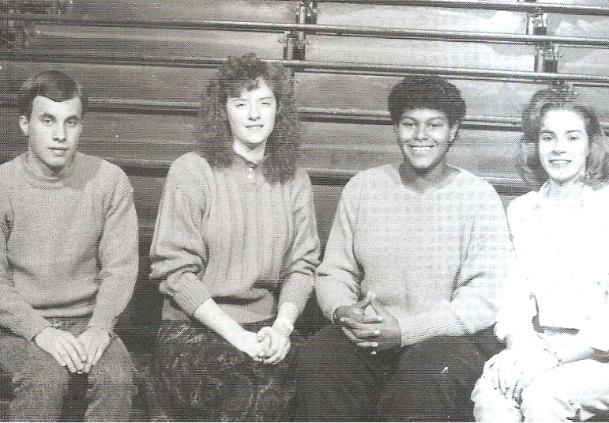

(L-R): Keith Adams (Treasurer), Kristi Lewis (Vice-President), Kim Archer (President), Nikki Michel (Secretary)

**THOUGHT OF THE DAY**

Lettin’ the cat outta the bag is a whole lot easier’n than puttin’ it back in. (Will Rogers)

A LITTLE MORE

**THIS** and **THAT**

Unfortunately, for a couple of reasons we had to cancel last fall’s all-class reunion dinner. We presently are planning to have one in 2022. Please keep June 18th open for the 2022 Greencastle Alumni All-Class Reunion Dinner. Details will be included in our next issue of Tiger Tales.

We are pleased to announce that both of our websites are now “up and running”! A big thank you to Scott Monnett, Todd Detro, and Josh Bonebrake for their efforts. You can access our Dollars for Scholars website with greencastle-alumni.dollarsforscholars.org. And greencastlealumni.org will connect you with our alumni website. Scholarship applicants now use the Dollars for Scholars website to apply.

Last fall’s Farm to Fork Dinner sponsored by the four Putnam County High School Alumni Associations was a huge success. The proceeds are split evenly among the four groups. We received $2,500. Thank you to those who supported this event through sponsorship and/or attendance!! The tentative date for this year’s event is September 17th.

We will be awarding twenty $1,000 alumni scholarships and one $500 Maxine Haskett scholarship this coming spring. Students applied online through our Dollars for Scholars website.

Congratulations to GHS student/athletes Charlie Menzel and Kadence Shaner. Charlie qualified for the Regionals and the Semi-State in boys’ cross country last fall. And Kadence qualified for the Regionals in girls’ golf.

On a sad note, board member Paul Gould (class of ’58) passed away last September 7th. He was a dedicated board member who did not miss any meetings until he became ill. He is survived by his wife Ginny, sons Rodney and Mark, three grandchildren, and siblings Bill Gould and Suzy Schneider. The board will miss his positive attitude! RIP Paul!!

**MEET YOUR BOARD MEMBERS**

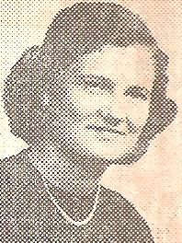

**AUDRA DORSETT HOLTON**

Audra is a 1954 graduate of Greencastle High School. She just recently rejoined the board after serving as a board member from 2001 to 2018. After graduation, Audra attended LaSalle University of Chicago majoring in accounting. She worked for many years for Western Indiana Employment and Training, retiring in 2005. She has been employed as an accountant, employment training specialist, factory group leader, and bookkeeper. She also helped her husband work their farm. Except for four years when she lived south of Indianapolis, Audra has lived her entire life in Putnam County. Audra has four children and one stepson, thirteen grandchildren, fourteen great grandchildren, and four great-great grandchildren. In her spare time Audra enjoys playing euchre and sewing. Having raised goats for several years she also enjoys attending goat shows. 

**SUZY GOULD SCHNEIDER**

Suzy Schneider is a long-time board member, having been on the board since 2007. She graduated from GHS in 1964. After graduation she worked for Hammond & Hammer Accountants for two years. She then entered the banking industry working for Central National Bank in Greencastle. In 1980 she acquired her real state license but continued working in the banking industry. She married the love of her life, George Schneider in 1974. They lived in the Valparaiso area as George was assigned to the State Police Post at Dunes Park. In 1980 they moved to Greencastle as George was reassigned to the Putnamville State Police Post. In 1995 Suzy left the banking career to start and manage a real estate company. After twenty-five plus years of helping people buy and sell their homes Suzy retired in 2020. Suzy and George enjoy spending time with their two daughters Stephanie Christopher and Michelle Evans plus their three granddaughters and two grandsons. In her spare time Suzy enjoys reading. And since she retired, she enjoys (her words) “cleaning out drawers and closets to get rid of STUFF we do not need. Believe it or not, been kind of fun.”

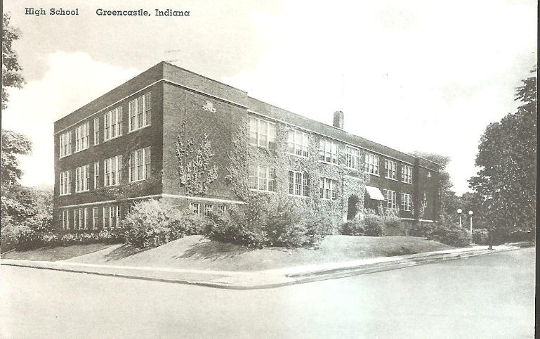

**GREENCASTLE HIGH SCHOOL – SPRING STREET**

**STATE CHAMPIONS**

1925 - Andrew Ray Sears - Mile Run

1926 - Andrew Ray Sears - Mile Run

1927 - Andrew Ray Sears - Half-Mile Run

1927 - Andrew Ray Sears - Mile run

1962 - Steve Norris - High Jump

1981 - Lisa Allen - 800 Meter Run

2005 - Andy Weatherford - 1600 Meter Run

2006 - Andy Weatherford - 1600 Meter Run

2017 - Emma Wilson - 1600 Meter Run

2017 - Emma Wilson - 3200 Meter Run

2017 - Emma Wilson - Cross Country

2018 - Emma Wilson - 3200 Meter Run

2018 - Emma Wilson - Cross Country

**GHS ALUMNI MEMORIES**

We contacted two GHS Alumni and asked them about their high school memories. Their responses are:

**TERESA PAULLUS TROUT**

GRADUATION YEAR: 1982

PRESENT ADDRESS: Greencastle, Indiana

FAVORITE HIGH SCHOOL TEACHER: Stan Ward: I loved his humor and baseball stories. He was a respected father figure to me. One day he taught me how to drive a stick shift that I “killed” every few feet! (I was babysitting his kids and he wanted me to drive his car to transport them.) He was a man of tremendous patience!

FAVORITE MIDDLE SCHOOL TEACHER: Rita Cain – Gym/Health Teacher: She invested in my life and took me to Terre Haute, just the two of us one Saturday morning to watch a gymnastics event. This act of kindness still speaks to me. She also let me borrow the coolest outfit for a mixer my 8th grade year! Who does that?!

FAVORITE ELEMENTARY TEACHER: Mr. Avery stands out in my mind (not a teacher but Principal).

FAVORITE HIGH SCHOOL EXTRA-CURRICULAR ACTIVITY: Diving and Cheerleading

FAVORITE HIGH SCHOOL MEMORIES: (1) April 18th, 1981 being asked out by Troy Trout the love of my life and never regretting that decision to marry him! (2) Seeing Carla Fisher being crowned Senior Princess during a football game! (3) Cheerleading in Indianapolis at Market Square Arena during half-time! (4) Breaking the Diving Record my senior year.

MOST EMBARRASSING HIGH SCHOOL MOMENT: After a basketball game my freshman year we were traveling home on the school bus and I was dared to moon the car behind us and, of course, succumbed to the pressure of being an idiot. There are many embarrassing moments where I lacked a lot of poise and gracious tact in those days!

WHAT WOULD YOU DO DIFFERENT: Being a part of the band would have been a priority and would have come in handy later in life touring with Kenny G!...taking four years of French or Spanish instead of ZERO would have been a wonderful springboard for the ten years I spent overseas in Portuguese and French speaking countries…investing in the lives of my classmates and bringing value to them instead of being so inwardly focused is a regret! But my greatest regret is not having the Lord in my life at an early age. This would have helped me with all the **stupid** decisions I made and the heartache I caused with so many situations. Thank you, classmates, for your forgiveness extended to me.

**JACQUE SCHAFER**

GRADUATION YEAR: 1965

PRESENT ADDRESS: Austin, Texas

FAVORITE HIGH SCHOOL TEACHER: Miss Slack, Drama Teacher

FAVORITE MIDDLE SCHOOL TEACHER: Putnamville School – Mr. Schopmeyer

FAVORITE HIGH SCHOOL EXTRA-CURRICULAR ACTIVITY: Triple Trio, Drama

FAVORITE HIGH SCHOOL MEMORY: No Favorite

MOST EMBARRESSING HIGH SCHOOL MOMENT: Sadie Hawkins Dance

**DID YOU KNOW**

Since the Indiana Association of Communities and Towns (ACT) began awarding the “Green Communities of the Year in 2008, only Greencastle has received the award in three consecutive years.

**2022 GREENCASTLE ALUMNI DIRECTORS**

Jon Blue ’69 (President) 765-721-1539

Cathy Gram Lowery (Vice-Pres.) ‘69 765-721-0150

Patty Sillery McCastle (Secretary) ‘72 765-721-2320

Terri Sutherlin McKee ’74 (Treasurer) 765-653-5620

Ron Blotch ’65 317-989-5601

Mary Lou Blue 630-750-9185

Josh Bonebrake ’11 765-720-2359

Todd Detro ’87 317-281-6508

Sandra Quinnette Foster ‘71

Jane Green Hansen ’69 765-653-4969

Audra Dorsett Holton ’54 765-720-0099

Anita Barr McEnulty ’63 765-720-2568

Suzy Gould Schneider ’64 765-620-2822

**REMEMBER: MEMBERSHIP RENEWAL IS DUE**

**SENIOR CORDS**

(1962 Minaret)

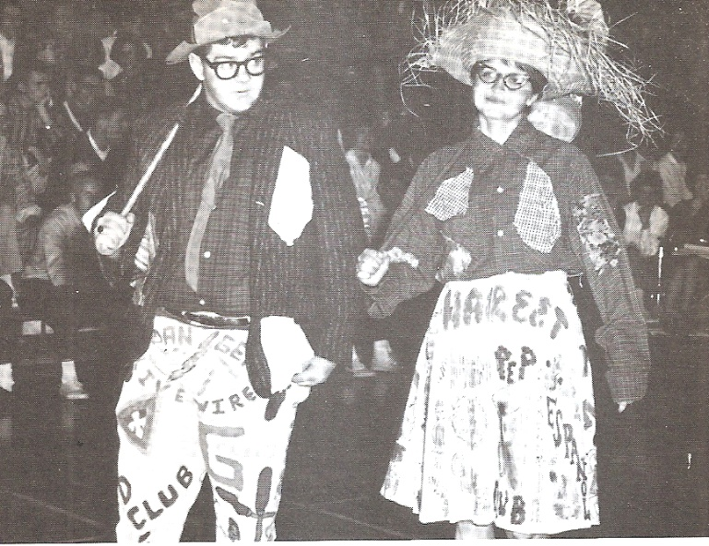

Morris Sutherlin and Harriett Williams added interest to the senior cords contest and perhaps prophesied the class’s future?-in their hobo costumes.

**IMPROVEMENTS PLANNED FOR GREENCASTLE SCHOOLS**

Major renovations at the Greencastle schools have progressed beyond the planning stages. Some improvements have already been completed with the others scheduled to start in the near future. The new artificial surface at the John Fallis Football Field was completed last fall and will be used for soccer games as well as football games. The track is being resurfaced. Other improvements include: (1) a secure indoor connection between the main GHS building and McAnally Center; (2) a new, more accessible north entrance to McAnally Center; (3) long banks of windows running along the east side of the high school; (4) expanding the high school lunch room and a large “G” on the façade; (5) improvements in the high school science labs and media center; (6) improvements in the non-classroom areas of the high school including an open stairwell and increased size in the commons area; (7) an auxiliary gym behind the new connector; (8) expanded weight and wrestling rooms; (9) moving the baseball and softball fields to the bus barn property between Veterans

Highway and Martinsville Street; (10) new science labs at the middle school; and (11) more secure entrances at all the buildings. All of the work should be started by the middle of 2023.

**CLASS OF 1954 – PREDICTIONS FOR 1979**

**Marcia Bettis** is the head pharmacist at Fleenor’s Drug Store.

**Wilma Cox** has distinguished herself for America by being the first woman ever to climb Mt. Everest.

**Joe Miles** manufactures zoot suits and has no less than forty factories around the world.

**Audra Dorsett** has invented a machine that is a boon to all super markets. The machine burps out radishes.

**Jane Rightsell** is the first woman jockey ever to ride in the Kentucky Derby.

**Marcia Myers** is working for Arthur Murray as a dancing instructor and her recent innovation, the “funny hop” has taken the country.

**CLASS REUNIONS**

Is your class planning a class reunion for 2022? If so, please let us know so we can include it in our next issue of Tiger Tales. As of now, we do not know of any class reunion being scheduled. This may be due to the virus. Or we have just not been notified. So, if your class is having one, or you know of a class that is, PLEASE contact us. We would greatly appreciate it!

**IT'S TIME TO RENEW YOUR MEMBERSHIP!**

**STATE RUNNER-UPS**

1931 - Boys Basketball

1933 - Boys Basketball

1964 - Elliott Williams - High Jump

1991 - Susan Stark - 800 Meter Run

2003 - Charlie Pingleton - Wrestling

2004 - Charlie Pingleton - Wrestling

2006 - Andrew Bretscher - 50 yd. freestyle

2006 - Andrew Bretscher - 100 yd. freestyle

2013 - Colleen Weatherford - 800 Meter Run

2021 - Brach Carrington - Wrestling

Greencastle Alumni Dollars for Scholars, Inc.

formerly known as GHS Alumni Association

Join or Renew Now!

Joining or renewing your Greencastle Alumni Membership will allow you to benefit in a variety of ways...

* You will receive the Tiger Tales newsletter up to 3 times per year
* Receive current news about the association and upcoming events
* Maybe you just want to reminisce or contact former classmates
* Support the awarding of scholarships to GHS graduates

The GHS Alumni Association was created in 1995 for the purpose of supporting Greencastle High School and operating a Scholarship Fund for our graduates. We currently use a number of fundraising events and activities to add to our scholarship fund including the All Class Reunion Dinner held June 18, 2022, as well as the Farm to Fork Dollars for Scholars in Putnam County Dinner to be held September 17, 2022.

**Membership is only $10 per person per year. To join or renew, complete this application form and mail it to us with your $10 dues payment. Another option is a one-year free membership with a $25 contribution to the Greencastle Alumni Dollars for Scholars, Inc. Scholarship Fund. A $50 donation will be listed in a Banner Graphic Ad. All contributions may be designated**

**"In Honor of” _______________ or "In Memory of” _____________________ for anyone that you choose.**

Please Print

 JOIN  RENEW

**_______________________________________________________________________________ _____________**

Name (include Middle Initial and/or Maiden Name) Class Year

**_______________________________________________________________________________ _____________**

Name (for use by Couples please include Middle Initial and/or Maiden Name) Class Year

**_________________________________________________________________________________________________**

Address City State Zip

**_____________________________________ _____________________________________________________**

Phone Email Address

Receive Tiger Tales via email? Yes _______ No ____________

Total Enclosed $_____________ Mail to. **Greencastle Alumni Dollars for Scholars, Inc.**

**P.O. Box 846**

Referred By: __________________ **Greencastle, Indiana 46135**

* Contribution to Greencastle Alumni Dollars for Scholars, Inc. Scholarship Fund
* **In Honor of ___________________________or In Memory of _________________________________**

