|  |
| --- |
| **Parish Council**  Armitage with Handsacre  Shropshire Brook Road  Rugeley  **WS15 4UZ** |
|  | | | |  |
|  |  | | |  |
|  |  | | |  |
| Vehicle Owner/User  War Memorial. Parish Council Car Park  **WS15**  **Ref:** Notice of Car Park Closure & Alternate Parking arrangements | | | | **Dated:** 25th January 2021 |
|  | |  |

Dear Vehicle Owner

This letter is to inform you that the Parish Council will be undertaking a planned (planning approved) restoration of the War Memorial (and immediate area) with works beginning on the **5th July 2021**.

To facilitate the contractors and upgrade works, the Parish Council car park on the map below will be **closed from Monday the 5th July 2021 at 10:00AM to the 1st September 2021 at 10:00AM**.

The Parish Council would kindly request that any vehicle (that you own) parked on the car park be relocated to the alternate parking site at the Village Hall which is being made available during the closure.

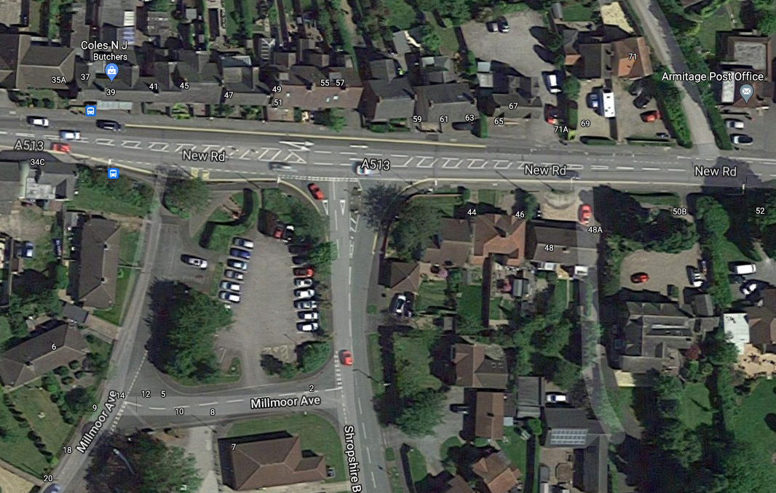

**What do I need to do to support the Parish Council with the planned restoration?**

1. Contact the Parish Council via one of the methods below to be provided with a car parking permit that allows *free parking* at the Village Hall throughout the car park closure.

|  |
| --- |
| **Email address:** [samantha.laplanche@armitagewithhandsacre-pc.co.uk](mailto:samantha.laplanche@armitagewithhandsacre-pc.co.uk)  **Website:** <https://armitagewithhandsacre-pc.co.uk/> (*Contact Us* as the bottom of the webpage)  **Telephone:** (01543) 490 004 |

1. Please relocate any vehicle that you park by the War Memorial on the car park highlighted to the alternate parking provided at the Village Hall on Shropshire Brook Road.
2. Display the parking permit in your vehicle windscreen whilst parked at the Village Hall.

By moving your vehicle to the parking provided, this will help to ensure the War Memorial contractors have the access they require to complete the planned restoration works.

Thank you for your support. I really look forward to seeing the outcome for the Parish with the restoration. Rest assured, the Parish Council is doing everything it can possible to complete the works before this years Remembrance Day and Service.

Yours Faithfully

Archie Maddocks

**Chairman**

**Armitage with Handsacre Parish Council**