Traffic management Wood End Lane, Fradley
November 2021 | www.hs2.org.uk

High Speed Two (HS2) is the new high speed railway for Britain. Balfour Beatty VINCI (BBV) is working in partnership with HS2 Ltd to build the new high-speed railway in your area.  The work we are doing  We will be installing temporary traffic lights and a lane closure on Wood End Lane, this is to allow us to safely carry out utility surveys in this area, including, CCTV drain clearance, Ground Penetration Radar Survey (GPRS) and trial trenching, which will involve digging into the ground to establish what utilities are underneath the surface.  This will provide us with information we need to develop our construction plans.  When will these works take place  These works will take place in three locations along Wood End Lane, over three periods of time (please see map overleaf).  Phase one – From 29 November 2021 until 17 December 2021.  Phase two – From 10 January 2022 until 28 January 2022.  Phase three – From 31 January 2022 until 18 February 2022.  Our working hours will be from 8:00am until 6:00pm Monday to Friday. Access to properties will always be maintained. Our workforce can be on site one hour before and after to set up and secure our equipment.  HS2 and the COVID-19 outbreak  We are continually reviewing the works on our construction sites in line with Government and Public Health England (PHE) advice on dealing with COVID-19. The Government’s current COVID-19 strategy makes clear that construction activity can continue as long as it complies with this guidance. The health and safety of our workforce and the communities we affect is our key priority. Please be assured that those sites that are currently still working are doing so because they can operate within PHE and construction industry guidelines  If you have a question about HS2 or our works, please contact our HS2 Helpdesk team on 08081 434 434  or email hs2enquiries@hs2.org.uk |  |  | Duration of works  Phase one - 29 November 2021 until 17 December 2021  Phase two - 10 January 2022 until 28 January 2022  Phase three - 31 January 2022 until 18 February 2022  Our working hours will be 8:00am to 6:00pm Monday to Friday.  Our workforce can be on site one hour before and one hour after to set up and secure our equipment.  Please note these works maybe subject to change.  What to expect  Temporary traffic light and lane closure.  Some disruption to travel times  Low levels of noise from our machinery.  What we will do  Inform you in advance of any changes to the dates shown.  Ask you to register with hs2instaffordshire.co.uk to receive updates.

Traffic management Wood End
Lane, Fradley

Notification

www.hs2.org.uk

Temporary lane closure with traffic lights Wood End Lane 8:00am until 6:00pm.

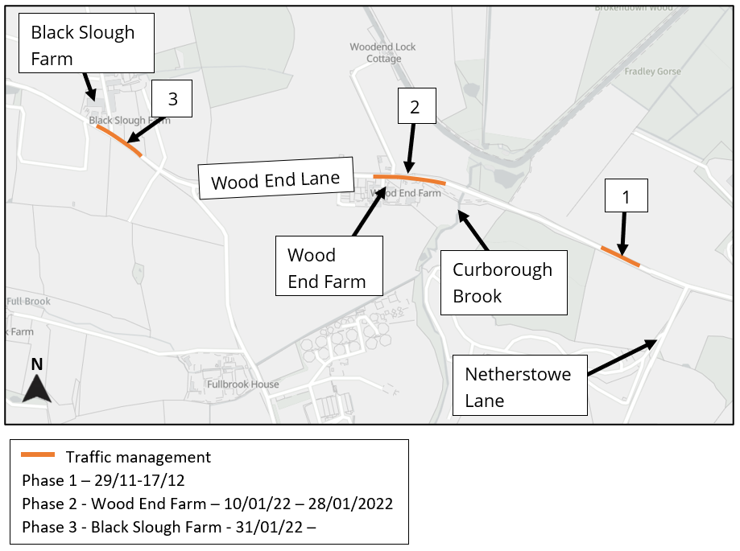

What else is happening
in your area?
www.hs2.org.uk

Contact our HS2 Helpdesk team
Our team is here to listen and respond to your enquiry, complaint or feedback to help us be a good neighbour.
You can contact our Helpdesk team all day, every day of the year on:
Freephone: 08081 434 434
Minicom: 08081 456 472

Email: hs2enquiries@hs2.org.uk

Keep up-to-date with your local community website
To find out more about what’s happening in your area and receive regular email updates, you can sign up to our local community websites at: www.hs2inyourarea.co.uk.

About our Community and Business Funds
We are offering two funds that are available to local communities and businesses between the West Midlands and London, to help with the disruption caused by our construction work. These are the Community and Environment Fund (CEF) and the Business and Local Economy Fund (BLEF).
The CEF is designed to give communities the opportunity to share in the benefits of HS2. It is an allocated fund that communities are able to apply for, to help to support local projects that aim to improve their local area.
The BLEF is designed to support local economies that may be disrupted by the construction of HS2. BLEF grants are for local business support organisations and local authorities to help maintain business activity in local communities.
For more information about each of these funds, including how to apply, please visit: https://www.groundwork.org.uk/hs2funds

Keeping you informed
We are committed to keeping you informed about work on HS2. This includes ensuring you know what to expect and when to expect it, as well as how we can help.
Residents’ Charter and Commissioner  The Residents’ Charter is our promise to communicate as clearly as we possibly can with people who live along or near the HS2 route.  www.gov.uk/government/publications/hs2-residents-charter  We also have an independent Residents’  Commissioner whose job is to make sure we keep to the promises we make in the Charter and to keep it under constant review. Find reports at:  www.gov.uk/government/collections/hs2-ltd-  residents-commissioner  You can contact the Commissioner at:  residentscommissioner@hs2.org.uk  Construction Commissioner  The Construction Commissioner’s role is to mediate and monitor the way in which HS2 Ltd manages and responds to construction complaints. You can contact the Construction Commissioner by emailing:  complaints@hs2-cc.org.uk  Property and compensation  You can find out all about HS2 and properties along the line of route by visiting:  www.gov.uk/government/collections/hs2-property  Find out if you’re eligible for compensation at:  www.gov.uk/claim-compensation-if-affected-by-hs2  Holding us to account  If you are unhappy for any reason you can make a complaint by contacting our HS2 Helpdesk team. For more details on our complaints process, please visit our website:  www.hs2.org.uk/how-to-complain | Contact Us  Contact our HS2 Helpdesk team all day, every day of the year on:  Freephone 08081 434 434  Minicom 08081 456 472  Email hs2enquiries@hs2.org.uk  Write to:  FREEPOST  HS2 Community Engagement  Website www.hs2.org.uk  To keep up to date with what is happening in your local area, visit: www.hs2inyourarea.co.uk  Please contact us if you’d like a free copy of this document in large print, Braille, audio or easy read. You can also contact us for help and information in a different language.  HS2 Ltd is committed to protecting personal information. If you wish to know more about how we use your personal information please see our Privacy Notice https://www.gov.uk/government/publications/high-speed-two-ltd-privacy-notice

Reference number:

High Speed Two (HS2) Limited, registered in England and Wales.
Registered office: Two Snowhill, Snow Hill Queensway, Birmingham B4 6GA.
Company registration number: 06791686. VAT registration number: 888 8512 56.

