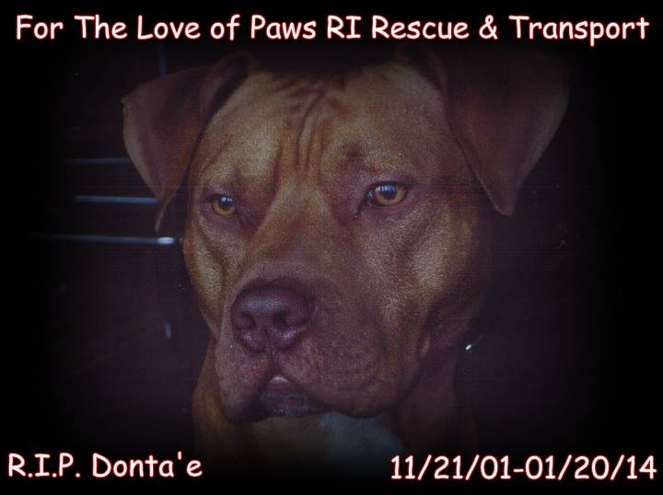
WWW.FORTHELOVEOFPAWSRI.ORG
INFO@FORTHELOVEOFPAWSRI.ORG
401-316-4865
Adoption & Foster Application

Today’s Date: _______________________________________________

Animal of Interest: _______________________________________________

ABOUT YOU

1. YOUR Name: _______________________________________________

2. YOUR Age: _______________________________________________

3. Home Street address

Mailing address _______________________________________________

City, State, Zip _______________________________________________

4. Email addresses: _______________________________________________

6. Telephone numbers _______________________________________________

7. Occupation: _______________________________________________

8. Employer: _______________________________________________

9. Driver license or other permanent ID number: State Issued & Number

_______________________________________________

10. Please list two personal references that we may contact:
Name Relationship: _______________________________________________
Phone: _______________________________________________

Name Relationship: _______________________________________________

Phone: _______________________________________________

ABOUT YOUR HOME

11. How many TOTAL OTHER PEOPLE live in your household?
Please list their names, ages and relationship to you:

12. Is everyone in the household in favor of adopting or fostering a dog? ◻YES ◻NO

13. Does anyone in the household have pet allergies? ◻YES ◻NO

14. Describe your home ◻House ◻Condo ◻Apartment ◻Other

Are you: Owner ◻Renter ◻Sub-let ◻HOA member ◻Co-op member ◻Other

◻Front door opens to street ◻Front door opens into courtyard or entryway

◻No Yard ◻Unfenced Yard ◻Partly Fenced Yard ◻Completely fenced yard

FOR CONDO: Do HOA rules allow pets? Any breed/size restrictions?

FOR RENTALS: ***Please attach Landlord’s written permission or applicable rental agreement page(s).
15. Describe your yard: ◻Small ◻Medium ◻Large ◻Size Front:_ feet by _feet

Surface (grass, stone, etc.) _______________________________________________

Height of fence feet - made of? ◻wood ◻chain link ◻brick ◻other

Number of Gates ___________

have locks? ◻YES ◻NO

Gates open on street-side? ◻YES ◻NO.

12. Who has access to your yard, besides you (for example, gardener, pool cleaner, children, utility, roommates, people in other units, other dogs, other pets?)

13. Does your city or county have any breed restrictions? ◻YES ◻NO
Please specify: _______________________________________________

ABOUT YOUR EXPERIENCE WITH DOG(S)
If you currently have a dog:

14. How did you come to have the dog _______________________________________________

15. How old was the dog when you first met? _________

How old is the dog now? _________

16. How many TOTAL OTHER PETS live in your household? ____________

For OTHER PETS, please answer the following for each pet:
Name Gender _______________________________________________

Breed-description _______________________________________________

Age Weight _______________________________________________

Neutered ◻YES ◻NO

Name Gender _______________________________________________

Breed-description _______________________________________________

Age Weight _______________________________________________

Neutered ◻YES ◻NO

Name Gender _______________________________________________

Breed-description _______________________________________________

Age Weight _______________________________________________

Neutered ◻YES ◻NO

17. How would you describe your level of experience with dogs?

◻Never had a dog ◻Childhood pet ◻Had one or more dogs as an adult

◻Experience with dogs ◻less than 30 lbs ◻30-60 lbs ◻60+ lbs

Experience with specific breeds _______________________________________________

◻Dog-related business or profession

- Foster or rescue experience – Name of organization _______________________________________________

GENERAL QUESTIONS (please answer all)

19. How long have you been thinking about adopting or fostering a dog? _______________________________________________

20. What are your primary reasons for wanting to adopt or foster a dog?

Security ◻Companionship ◻For the children ◻As a gift for someone ◻Friend for current pet ◻Other

21. When was the last time you had a dog? _______________________________________________

22. What breed was your dog? _______________________________________________

23. Was he/she spayed or neutered? ◻YES ◻NO

24. What happened to the dog? _______________________________________________

25. Have you ever had an animal that required a major surgery for an injury or illness?
◻YES ◻NO If yes, please explain:

PLANNING A PROSPECTIVE ADOPTION OR FOSTER CARE EXPERIENCE (please answer all)
26. When you go on vacation, who will care for this dog

_______________________________________________

27. What kind of dog food will you feed this dog?

_______________________________________________

28. Do you have a regular Veterinarian? ◻YES ◻NO

Name: _______________________________________________

Animal Hospital (local) Name:

_______________________________________________

29. Who will groom and bathe this dog?

_______________________________________________

30. What will you use for flea control?

_______________________________________________

31. Would this dog wear a collar? ◻YES ◻NO ◻Sometimes-WHEN?

_______________________________________________

32. Would your dog walk off leash? ◻YES ◻NO ◻Sometimes-WHEN?

_______________________________________________

33. What would happen to this dog if you had to move?

_______________________________________________

34. What is the longest this dog would be left alone each day?

_______________________________________________

35. Where will this dog spend its days? (inside, outside, etc.)_______________________________________________

36. Where will this dog sleep? _______________________________________________

37. Who will be ultimately responsible for this dog?

_______________________________________________

38. If you have children, please describe their previous experience with dogs:

_______________________________________________

39. How will this dog get exercise?

_______________________________________________

40. How will you discipline this dog?

_______________________________________________

41. Will you plan to obedience train the dog?
◻YES ◻NO ◻Obedience classes ◻ 1-to-1 Training ◻Videos/Books ◻Seek help if problem arises ◻Other

FOSTER AND ADOPTED DOGS – WONDERFUL BUT LESS THAN PERFECT (please answer all)

42. WHAT WOULD CAUSE YOU TO REACH YOUR LIMIT OR WANT TO RETURN THIS DOG?
CHECK ALL THAT APPLY:
◻Hair on your furniture/Shedding
◻Stains on rugs
◻Animal on the bed
◻Illness
◻Humping
◻Aggression towards other dogs
◻Barking too much
◻Shy with people
◻Biting
◻Escaping
◻Other pets don’t like the dog
◻Jumping up
◻Poor watchdog
◻Worms
◻Digging
◻House-training challenges
◻Growling at guests
◻Needs grooming
◻Chewing
◻Vet Bills
◻Not a good dog park dog
◻Shy with dogs
◻Food allergies
◻Fleas
◻Ticks
◻Aggressive on leash
◻Carsickness
◻Allergies
◻Marriage
◻Divorce
◻Doggie destruction OF WHAT__________________________________________
◻Moving
◻New Child
◻Spouse/partner does not like dog
◻My financial problems
◻OTHER_ Please Explain_______________________________________________
◻ NOTHING.

PLANNING FOR INVESTMENTS OF MONEY AND TIME (please answer all)

43. Dogs require investment of time and money. Can you afford to provide medical care,
grooming, proper diet, shelter and exercise for this dog? ◻YES ◻NO ◻
LIMITS: _______________________________________________

44. Are you able to make a long-term commitment to care for this dog? ◻YES ◻NO
◻LIMITS: _______________________________________________

45. If a behavioral challenge arises, will you seek help from the trainer we recommend? ◻YES ◻NO

46. Would you consult and pay for a trainer or behaviorist if challenges develop?
◻YES ◻NO

47. How did you find out about this dog?

_______________________________________________

PLEASE CHECK ALL THAT APPLY. YOU ARE WELCOME TO ASK QUESTIONS!

◻ I understand that paying for medical needs, spaying or neutering, routine vaccinations, and micro-chip identification systems, are necessary components of either preparing a dog for adoption, or immediate post-adoption costs that must be borne by adopters.

◻ I understand that food, leashes, collars, crates, transportation expenses, and other expenses, are necessary to carry out the care of dogs while in foster care.

◻ I understand that an adoption donation is necessary to help offset costs incurred to rescue and care for each dog.

PLEASE INITIAL:
____ I understand that this dog is to be returned to me, Wendy Perry immediately if there’s a problem with keeping him. He is not to be turn over to another shelter or to another adopter. This adoption is not transferable.

I agree to donate an amount that represents my ability to further the rescue work necessary for this and every other dog to be rescued by Wendy Perry. Because most animals cost more than the minimal donation to care for, Wendy Perry welcomes you to make a larger donation if you are able.

◻Yes I agree to donate an amount of ◻$325 ◻More than $340 : ◻Other: _______________

◻No, I cannot make any donation at this time, because please explain

NOW COMES THE FUN PART!

49. Please describe your dream dog. Please include any preferences regarding gender, personality type, energy level, fur, age, expectations of dog behavior, and anything else you think will help us match you with your dream dog.

**Please include two references (Not Related):

1. _______________________________________________

2._______________________________________________

**Please include Veterinary Information:

Please Initial:
_____ I understand that a home check is required before any dog is approve to be placed.

Thank you for your interest in one of our pups!
Please email this form to
info@fortheloveofpawsri.org

Review date Reviewed by (print name)
REVIEWER’S email / telephone (cell/text?)
OUTCOME / COMMENTS / RECOMMENDATIONS:

