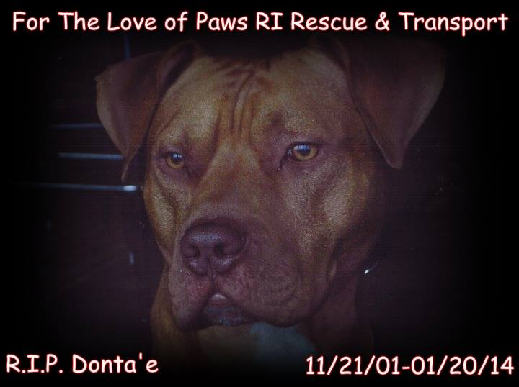
WWW.FORTHELOVEOFPAWSRI.ORG
INFO@FORTHELOVEOFPAWSRI.ORG
401-316-4865

Adoption Contract

ADOPTER'S INFORMATION:

Name: __________________________

Phone Number: ____________________________

Address: ____________________________________________

City, State, Zip: ______________________________________

**License /SSN # _______________________________________

DOB: _______________________________________

INFORMATION ABOUT ADOPTED ANIMAL:

Cat/Dog/Other: ___________________

If Other please
specify: __________________________ M/F ______________

Date of Birth: _____________________ Color: _____________
Other description/markings: _________________________________________

Microchip ID: _________________________________________

Rescue ID Number: _________________________________________

Breed: _________________________________________

ADOPTER'S AGREEMENT

•

I agree that the animal is being adopted for myself and will not be sold, adopted, or given to another party.

•

I agree that the animal will not be allowed outdoors without supervision. When taking my dog outdoors, she/he will be on a secure harness and wear proper ID.

•

(If adopting a cat) I agree that I will not de'claw the cat or allow the cat outdoors.

•

(If adopting a dog) I agree that this dog is to be a companion animal, not a guard dog. The dog will live
inside my home.

•

I agree that the animal must be spayed/neutered by 5 months of age. If the animal is not
spayed/neutered prior to adoption, proof of surgery must be mailed to the rescue within 30 days of the
procedure.

•

I agree to care for the animal in a humane manner. This includes supplying adequate food, water, shelter, attention, and medical care.

•

I agree that if at any point I can not keep the animal, I will return him/her to the original rescue without requesting a fee.

•

I understand and agree that the current rescue makes no guarantees about the animal's temperament and is not responsible for future damages or injuries caused by the animal.

•

I give the current rescue permission to call or visit my home at any reasonable time to assure that the animal is being properly treated and cared for.

•

I agree to keep the rescue informed of my current home address and phone number.

I hereby agree that this pet shall wear a collar or harness with identification tags at all times.

•

To abide by all laws and ordinances concerning this dog in the community in which I reside.

•

To provide annual veterinary examination, monthly heart-worm preventative, yearly stool samples, rabies according to my state’s regulations, and vaccinations, monthly flea prevention medication and dental care as determined by my veterinarian.

•

The above dog will not be euthanized in a non-emergency situation without notifying For The Love of Paws RI Rescue
by registered letter and giving 14 days to respond.

If dog needs to be euthanized because of an emergency, you must contact by phone said rescue prior to euthanization at
401-316-4865 the decision to euthanize must also be approved by said rescue.

In the event of an emergency resulting in an evacuation from the house, area, or state by the owners, this dog is to be evacuated with said owners. No exceptions to this are allowed.

I agree that all statements I have made on this form are true. If it is found that any statements I have made on this form are not true the adopted animal can be confiscated at any given time without notice. If at any time it is to be found that the animal listed above is not being taken care of properly he/she will be confiscated without notice

Adopter's
Signature: ________________________ Date:_________________

This contract is a written agreement to transfer ownership of adoptive pet from
the

Rescuer (name)___________________________________________________

to the Adopting Parent(s)
(name)_______________________________________

on this date: _________________________________.

Adoption Fee: $475.00

Rescuer and Adopting Parents have agreed upon the sum of
donation to Rescuer for help with expenses incurred by
saving this pet from the shelter and vet bills.

I agree that all expenses incurred after I take possession of pet will be my sole responsibility and Rescuer is released of any and all liabilities whether financially or other.

•

I hereby understand that the Rescuer has obtained this animal from the shelter stated above and may have no prior information of age, breed, health issues,training, registration, or other. Any information shared by Rescuer is of own experience with the pet and Rescuer makes no warranties of any kind concerning pet.

For The Love of Paws RI Rescue

Authorized Representative:___________________________

Sign: ___________________________

Date: ___________________________

Approved Date : ____________________________

