|  |  |  |  |  |
| --- | --- | --- | --- | --- |
| |  |  | | --- | --- | | Spring 2022  Events |  | |  |  | |
| * March 12th & 13th - Opening Weekend – Come join us for Living History Demonstrations throughout the Village! * April 8th & 9th – Farm, Ag & Ecology Days * April 22nd, 23rd & 24th – Civil War Era Historical Days   **Stay Tuned for more events!**  **Come out this season and experience our new 1800’s Woodworking Living History Exhibit!** |

# Heading 1

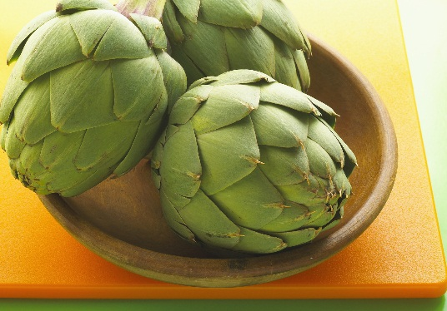

## Heading 2

View and edit this document in Word on your computer, tablet, or phone. You can edit text; easily insert content such as pictures, shapes, and tables; and seamlessly save the document to the cloud from Word on your Windows, Mac, Android, or iOS device.



## Heading 2

Want to insert a picture from your files or add a shape, text box, or table? You got it! On the Insert tab of the ribbon, just tap the option you need.

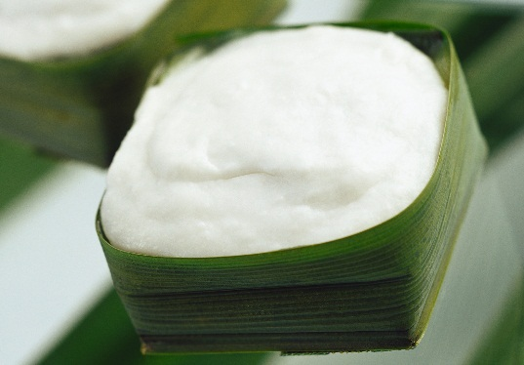

## Heading 2

To apply any text formatting you see on this page with just a tap, on the Home tab of the ribbon, check out Styles.