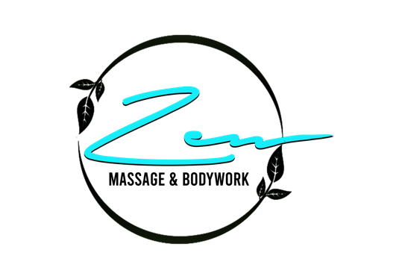
Esthetician Client Intake Form
Personal Information
Name ____________________________________ Phone Number _______________________
Address ______________________________________________________________________
Date pf Birth _____________. E-mail _______________________________________________
Conditions you are experiencing today (Please select all that apply):
O Headache O Inflammation O Muscle Cramps. O Anxiety. O Fatigue O Insomnia. O Stress
______________________________________________________________________________
Esthetics Information
What type of skin do you have?
O Normal. O Oily O Dry O Combination O Unsure
What areas of concern do you have regarding your skin?
O Breakouts/ Acne O Blackheads/Whiteheads O Uneven Skin Tone O Sun Damage
O Excessive Oil/ Shine O Wrinkles/Fine Lines O Dull/Dry Skin. O Rosacea
O Broken Capillaries O Redness O Dehydrated O Sun,Liver,BrownSpots
Other _________________________________________________________________________
Do you smoke? Yes No
Have you been under the care of a dermatologist within the past year? Yes. No
Have you had chemical peels, microdermabrasion or resurfacing treatments in the past month? Yes. No
If yes, please describe ____________________________________________________________
Have you received Botox, Restylane, or Collagen injections in the past 6 months? Yes. No
If yes, please specify _____________________________________________________________

Have you ever had an allergic reaction to any of the following?
O Cosmetics O Medicine O Food O Animals. O Sunscreen. O Iodine
O Pollen. O AHAs. O Fragrance O Shellfish O Latex
Other _________________________________________________________________________

Do you currently have a skin care routine? Yes. No
What skin care products are you currently using? _____________________________________
______________________________________________________________________________
Have you had any reaction to products during a facial? Yes. No
If yes, please specify _____________________________________________________________

______________________________________________________________________________
By signing below, you agree to the following
I have completed this form to the best of my ability and agree to inform the technician of any changes to the above information. I have been informed of and understand the contraindications to the requested treatments and agree that I do not have any condition(s) that would make the requested treatment unsuitable. I will inform the esthetician of any discomfort I may experience at any time during my treatment to allow them to adjust accordingly, I agree to waive all liabilities toward my esthetician and the employer for any injury or damages incurred due to any misrepresentation of any health history.
Cancellation policy: Cancellation requests may be submitted via text (561) 465- 6063, Via e-mail zensationalmb@gmail.com or through the booking system (confirmation reminders sent to you prior to your appointment via email). Cancellation request MUST be submitted at least 24 hours prior to your scheduled appointment. First offense, you will be charged 50% fee of the total retail value of your session, 100% thereafter. Failure to pay will prevent you from scheduling any future appointments until fee is paid in full.
Client Signature ____________________________________. Date _______________________

