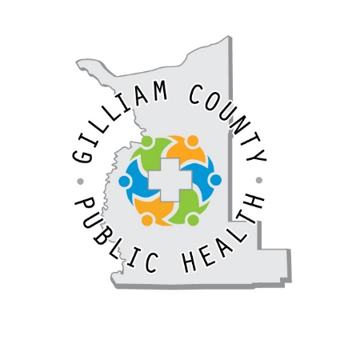Gilliam County Public Health

Referral Form

Please indicate which service the person(s) might be interested in.

WIC (Special Supplemental Nutrition Program for Women, Infants & Children)

Immunization needs

Tobacco Cessation NRT (Nicotine Replacement Therapy)

Babies First! (Nurse Home Visiting)

**Patient Name:** Enter Name of Person **DOB:** Date of birth **Age:** Age

**Phone/best way to contact:** Enter phone number

**Email:** Enter email address

**Address:**  Physical address or P.O. Box, City, Zipcode

Referred by: Please enter your name and company

Phone: Enter your contact phone

Date of Referral: Enter date

Please return to: Gilliam County Public Health

P.O. Box 597, Condon, OR 97823

PH: 541-626-7088 FAX: 541-919-0046

info@gilliamcountypublichealth.org