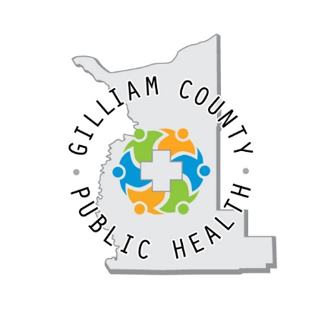Gilliam County Public Health

Referral Form

Please indicate which service the person(s) might be interested in.

WIC (Special Supplemental Nutrition Program for Women, Infants & Children)

Immunization needs

Tobacco Cessation NRT (Nicotine Replacement Therapy)

Babies First! (Nurse Home Visiting)

**Patient Name:** ________________________________ **DOB: ___________** **Age:** ______

**Phone/best way to contact:** _____________________________________

**Email: __________________________________________________________**

**Address: _______________________________________________________**

**_______________________________________________________**

Referred by: ___________________________________________________

Phone: ________________________________________________________

Date of Referral: _______________________________________________

Please return to: Gilliam County Public Health

P.O. Box 597, Condon, OR 97823

PH: 541-626-7088 FAX: 541-919-0046

info@gilliamcountypublichealth.org