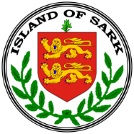

The Government of Sark

**MEDICAL & EMERGENCY SERVICES COMMITTEE**

**COMMITTEE OFFICE, LA CHASSE MARETTE, SARK GY10 1SF**

Telephone: (01481) 832118 E-mail: [medical.emergency@gov.sark.gg](mailto:medical.emergency@gov.sark.gg)

**NOTICE TO RESIDENTS REGARDING CHANGE OF DOCTOR:**

THE MEDICAL COMMITTEE WISH TO INFORM RESIDENTS THAT DR. DOINA SUTEU WILL BE LEAVING SARK ON THE 15th OCTOBER 2020.

WE WISH TO THANK DR SUTEU FOR HER CARE OF RESIDENTS AND VISITORS DURING THE LAST SEVEN MONTHS, AND ESPECIALLY THROUGHOUT THE COVID 19 RESTRICTIONS.

WE ARE VERY PLEASED TO ANNOUNCE THAT DR SIMONE BORCHARDT WILL BE TAKING OVER FROM DR SUTEU ON THE 15th OCTOBER.

DR BORCHARDT HAS WORKED IN GUERNSEY AND ALDERNEY AND UNDERSTANDS THE CHALLENGES OF WORKING IN A SMALL COMMUNITY.

WE LOOK FORWARD TO WORKING WITH DR BORCHARDT.

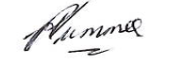

Conseiller H Plummer.

Chairman

Medical & Emergency Committee.