A Guide to Setting Up Your Ball Python Tank

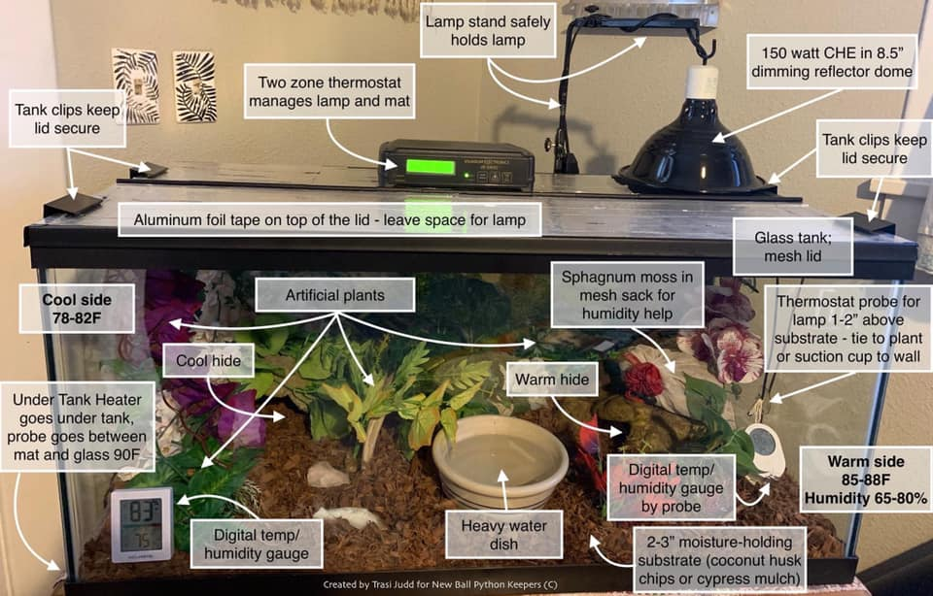

Remember that there are other ways to set up your ball python’s space but this option is the route I went when keeping in tanks and I found much success! One thing to not deviate from is the thermostat. Thermostats are an essential item to ensure that proper temps are maintained in the habitat without allowing the temps to get so high, that your new friend may be harmed.
There are alternatives that work for a tank other than the one displayed here with a lamp on the warm side and heat mat on the cool side. You can also:
- Put the lamp about 2/3 of the way toward the warm side and have the heat mat under the warm hide.
- Use two lamps and set the temps accordingly to create your gradient.
- Use just a lamp if your room’s ambient temp supports at least a 75F/25C cool side without additional help.
- Use a strip of heat tape under the tank and a lamp for the warm side.

