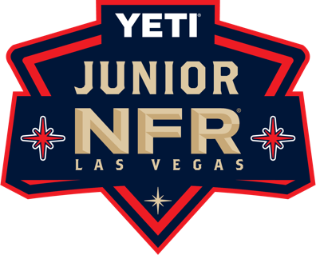
Las Vegas Events - YETI Junior NFR
770 E Warm Springs Rd, Suite 160
Las Vegas, Nevada 89119
July 1st, 2025
[Rider's School Name] Attn: [Principal's Name]
[School Address]
[City, State, Zip]
Dear [Principal's Name],
We are pleased to inform you that [Child’s Name], a student at [Child’s School Name], has qualified to compete in the YETI Junior National Finals Rodeo (Junior NFR). This prestigious event will take place at the Las Vegas Convention Center from Thursday, December 4, 2025, through Saturday, December 13, 2025.
Participants are required to arrive in Las Vegas by Wednesday, December 3, 202, at 12:00 PM for check-in. We kindly ask you to consider that some riders may require additional travel days before and after the event, with a minimum of two extra days necessary for travel.
Qualifying for the Junior NFR is a remarkable achievement, as competitors must compete throughout the year to earn their spot and a chance at the title. This event brings together the top young rodeo athletes from across the United States, Australia, New Zealand, and Canada, all vying for the prestigious Junior NFR Champion title.
Please join us in congratulating [Child’s Name] on this outstanding accomplishment. As a representative of [Child’s School Name] and the state of [Your State], [he/she] will be competing on a national stage, demonstrating skill, dedication, and sportsmanship.
Should you have any questions or require additional information, please do not hesitate to contact me.
Best Regards,
Brilynn Bentley
Junior World Finals Assistant General Manager
Brilynn@lasvegasevents.com

