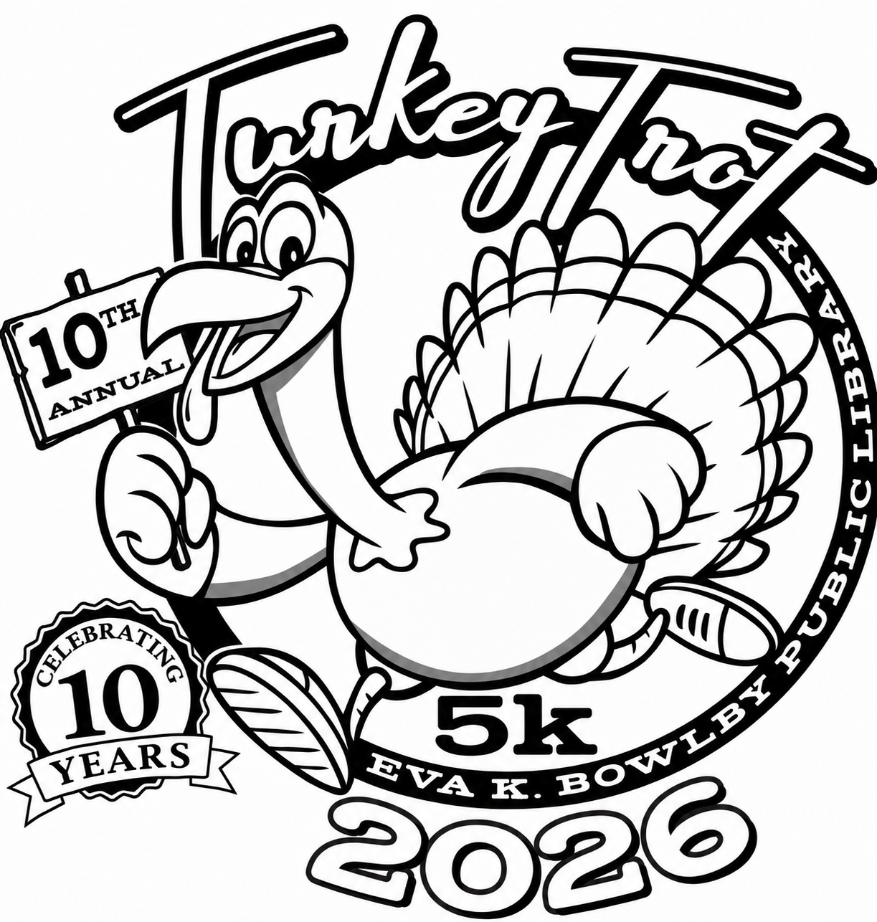
Submit this coloring page to the Eva K Bowlby Library by November 20, 2026. Winners will be chosen and announced at the Turkey Trot on November 21, 2026.
Age categories are: 1-4, 5-6, 7-8, 9-10, 11-12. The best coloring page in each category will receive a prize!
Please put your NAME, AGE, AND PHONE NUMBER on the BACK of this coloring page.

