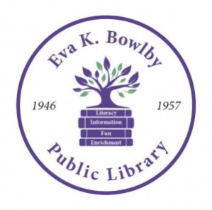
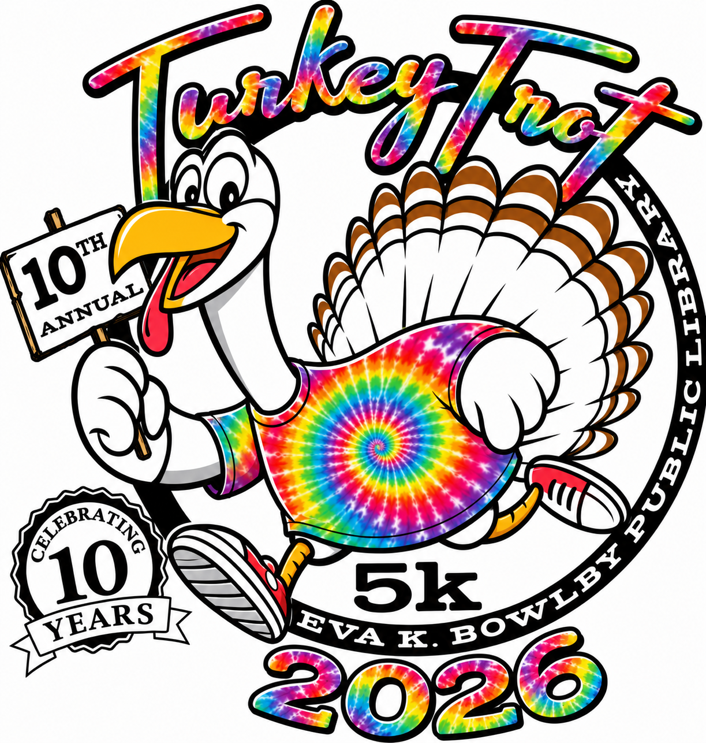10th Annual
Bowlby Library Turkey Trot Sponsorship Letter
Saturday, November 21, 2026
We cordially invite you to participate as a Sponsor of the Family & Pet Friendly 2026 Bowlby Library Turkey Trot 5K Run/Walk & 1K Children’s Fun Run. The event proceeds will provide needed support to meet the library’s mission: The Eva K Bowlby Public Library connects the community with opportunities to enrich lives through empowerment, lifelong learning, and recreation; opening windows to the world and inspiring exploration and achievement. The event will be held on Saturday, November 21st beginning at the Bowlby Library Gazebo. The Dog Walk followed by the 1K Children’s Fun Run, will begin at 9 A.M., followed by the 5K Run/Walk. Awards will be given to the top 3 male and female walkers/runners, in each age category.
Your tax deductible sponsorship helps defray the costs of organizing the event (the library is a 501c3 organization). Funds received from sponsorships will be used to purchase t-shirts for registered race participants, awards and complementary drinks and snacks for each race participant. There are several levels of sponsorship available for the Turkey Trot. Please refer to the below chart for details regarding each level.
Sponsorship | Cost | Benefits
Platinum Level | $500+ | - Large, one colored logo on the back of race t-shirt  - Opportunity to speak at the opening of the race  - Promotional materials in race packet (provided by sponsor)  - May set up a table of information at the event  - Verbal recognition on race day
Gold Level | $250 | - Medium, one colored logo on back of race t-shirt  - May set up a table of information at the event  - Verbal recognition on race day
Silver Level | $150 | - Small, one colored logo on back of race t-shirt  - Verbal recognition on race day
Bronze Level | $100 | - Company name (no logo) printed on back of race t-shirt
Friends of the 5K | $50 | - Family name printed on back of race t-shirt
Product Donation |  | - Donation of gift cards or other products for race winners or raffle prizes  - Donation of race snacks & drinks
Thank you so much in advance for your consideration of becoming a race sponsor. On the back, you will find the sponsorship form that can be completed and submitted by mail.
Please feel free to contact the 5K Turkey Trot Committee with any questions:
Kim Grimes (724) 747-0332, Lisa Belding, Tonya Martin, Lisa Murdock, Bridget Vilenica, Molly Culleton, Marla Patton, Karl Hursey. Thank you!
Eva K. Bowlby Library 10th Annual
5k Turkey Trot Sponsorship Form

Sponsorship Contact Information:
Company:______________________________ Company Website: ______________________________
Contact Name: _____________________________ Title:_______________________________________
Address: _________________________________________ City: ______________________Zip________
State: ______ Phone: ______________________________ Email: ________________________________
Sponsorship Level – Please check your level of sponsorship:
Check | Sponsorship | Cost | Benefits
 | Platinum Level | $500+ | - Large, one colored logo on the back of race t-shirt  - Opportunity to speak at the opening of the race  - Promotional materials in race packet (provided by sponsor)  - May set up a table of information at the event  - Verbal recognition on race day
 | Gold Level | $250 | - Medium, one colored logo on back of race t-shirt  - May set up a table of information at the event  - Verbal recognition on race day
 | Silver Level | $150 | - Small, one colored logo on back of race t-shirt  - Verbal recognition on race day
 | Bronze Level | $100 | - Company name (no logo) printed on back of race t-shirt
 | Friends of the 5K | $50 | - Family name printed on back of race t-shirt
 | Product Donation |  | - Donation of gift cards or other products for race winners or raffle prizes  - Donation of race snacks & drinks
Event Day Information:
Event Day Contact Name and Number________________________________________________
Do you plan to set-up a company resource table at the event? (Platinum & Gold ONLY)
YES NO
Please email company logo to be used on t-shirts to kim.grimes@hotmail.com
Mail this form with check payable to Eva K. Bowlby Library c/o 5K Turkey Trot
311 N. West St., Waynesburg, PA. 15370, Memo Line: 5K Turkey Trot
Deadline: 11/1/26

