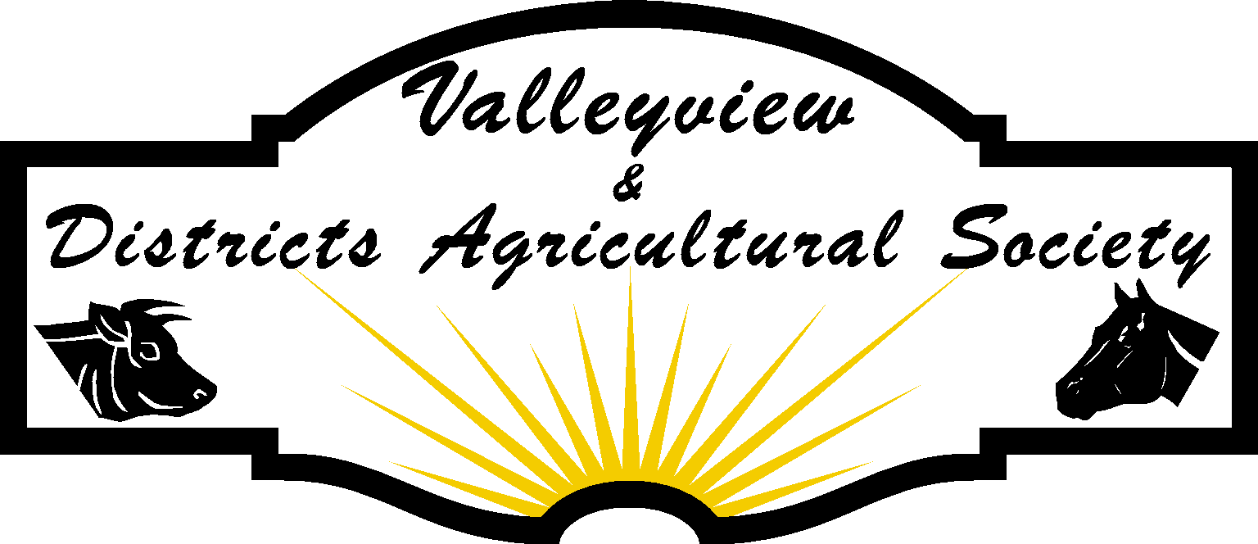

COVID RIDING RULES
Phase 1 – June 6, 2020
Phase 2 – June 12,2020

How will we keep you safe?

Perimeter gates will remain closed when the facility is not open. They will be opened only on dates that are specified. Please call voicemail to see when facility is open.

We will only be allowing members and the recommended amount of people in the space (outdoor riding arena and general parking area by outdoor arena.) at any given time. (Including staff.) This direction will be taken from updates from the Chief Medical Officer of Health. (CMOH) Currently groups are limited to 100 people or fewer.
Phase 2 – June 12 – Indoor Riding Arena – 50 People
-Outdoor Arena – 100 People
A minimum of 6 feet must be maintained by everyone in the area at all times including when you are at the truck and trailer unit. Masks recommended where appropriate physical distancing is impossible.

We aim for zero to low touch environment. Gate latches will be sanitized by members upon arrival and leaving facility. It is recommended that members bring a COVID kit with hand sanitizer, gloves and a mask. A wash stand and soap will be onsite.

During the use of the facility Agricultural Society props/jumps/tack/equipment etc. personal equipment can be used if proper protocol is followed. Use of gloves and disinfecting.

It is every individuals’ social responsibility to ensure their own and others safety. Therefore, you are required to follow the social distancing guidelines as set out by the CMOH at all times. Staff reserves the right to refuse usage of the facility to anyone not practicing guidelines as set out by CMOH.

Additional Rules
There will be no vetting, farrier work, dentals, alternative therapies (ie massage), sale of livestock/tack or any other activities outside of recreational riding. Instructional riding allowed if all riders are current Ag. Society members.

When possible, horses should arrive saddled and leave saddled. This helps move individuals through the space in a timely manner and decrease risk of contact.

Livestock can only be tied to the trailer that they were transported to the site in.

Any questions or concerns please call the office 780 524-3473
How do you book a time to use the outdoor facility & Indoor Riding Arena?
At the time of booking you must indicate how many people will be in your party as well as their names and contact information. This information is collected for the sole purpose of traceability and would be made available to the health inspector upon request.

All bookings for time slots will only be taken by the office admin during office hours from 9am – 5pm via office phone 780 524-3473 or by texting 780 255-0107.

All riders will be logged in the riding log that is to be maintained by the office admin.

I __________________________________have read the following information and agree to abide by
(print Name)

the rules as set out by the Valleyview & Districts Agricultural Society.

Date:__________________________________________________________

Signature_______________________________________________________

