April
2021
Valleyview & Districts Agricultural Society
Events  All riding that people have scheduled is highlighted and other members can still come in and ride during these times only if calling ahead and confirming. No Drop ins at this time. Please check voice mail for the most current bookings. Thank you  Board Meeting April 21, 6:30 pm | 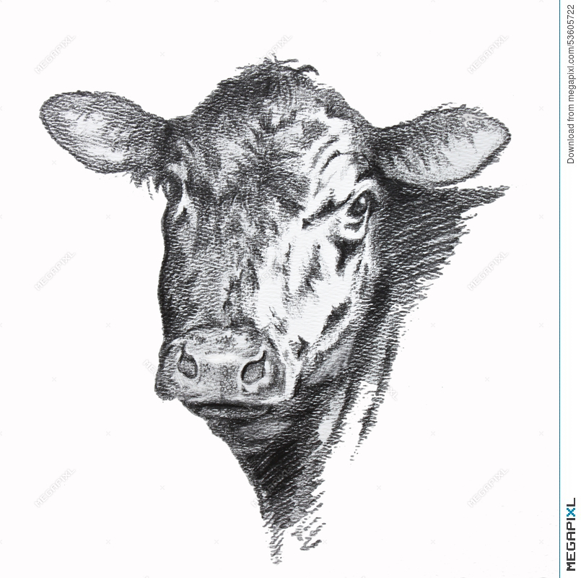
Sunday | Monday | Tuesday | Wednesday | Thursday | Friday | Saturday
 |  |  |  | 1  10-12- 12-2 | 2  10-Noon-2  2-3 KH | 3  2-3:30
4  2-5 RWRC | 5  Noon - 2  2-3:30 | 6  10-12  3:30-5:30 JR | 7  10-12  6:30-9:30-RWRC | 8  10-12  5-8 4-H  8-9:00 KH  9-9:30 | 9  2-3:30  6:30-9:30 RWRC | 10  10-12 Marcel  Ride a horse 1-5
11  2-5 RWRC | 12 | 13  7-8:00 DW  8-8:30 | 14  6:30-9:30 RWRC | 15  5-8 4-H  8-9:00 KH 9-9:30 | 16  6:30-9:30 RWRC | 17  10-1 Marcel
18  2-5 RWRC | 19 | 20  7-8:00DW  8-8:30 | 21  6:30-9:30 RWRC | 22  5-8 4-H  8-9KH 9-9:30 | 23  6:30-9:30 RWRC | 24  10-12 Marcel  12-5 W. Dressage
25  2-5 RWRC | 26 | 27  7-8:00 DW  8-8:30 | 28 | 29  5-8 4-H  8-9 KH9-9:30 | 30  6:30-9:30 RWRC

May
2021
Valleyview & Districts Agricultural Society
Events  All riding that people have scheduled is highlighted and other members can come in and ride during these times only if calling ahead and confirming. No Drop ins at this time. Thank you  Board Meeting May 19, 6:30 pm | 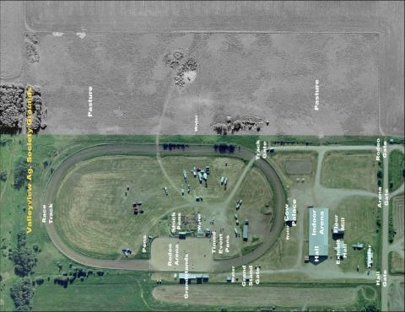
Sunday | Monday | Tuesday | Wednesday | Thursday | Friday | Saturday
1
10-1 Marcel

2 | 3 | 4  7-8 DW  8-8:30 | 5 | 6  5-8 4-H  8-9KH 9-9:30 | 7 | 8  10-12 Marcel  So you want to Ride a Horse  12-7
9 | 10 | 11  7-8 DW  8-8:30 | 12 | 13  5-8 4-H  8-9KH 9-9:30 | 14 | 15  10-1 Marcel
16 | 17 | 18  7-8 DW  8-8:30 | 19 | 20  5-8 4-H  8-9KH 9-9:30 | 21 | 22  10-1 Marcel
23 | 24 | 25  7-8 DW  8-8:30 | 26 | 27  5-8 4-H  8-9 KH 9-9:30 | 28 | 29  10-1 Marcel
30 | 31

June
2021
Valleyview & Districts Agricultural Society
Events  4-H Achievement Day – June 7  Dressage Show & Horse Show – June 11, 12 & 13 | 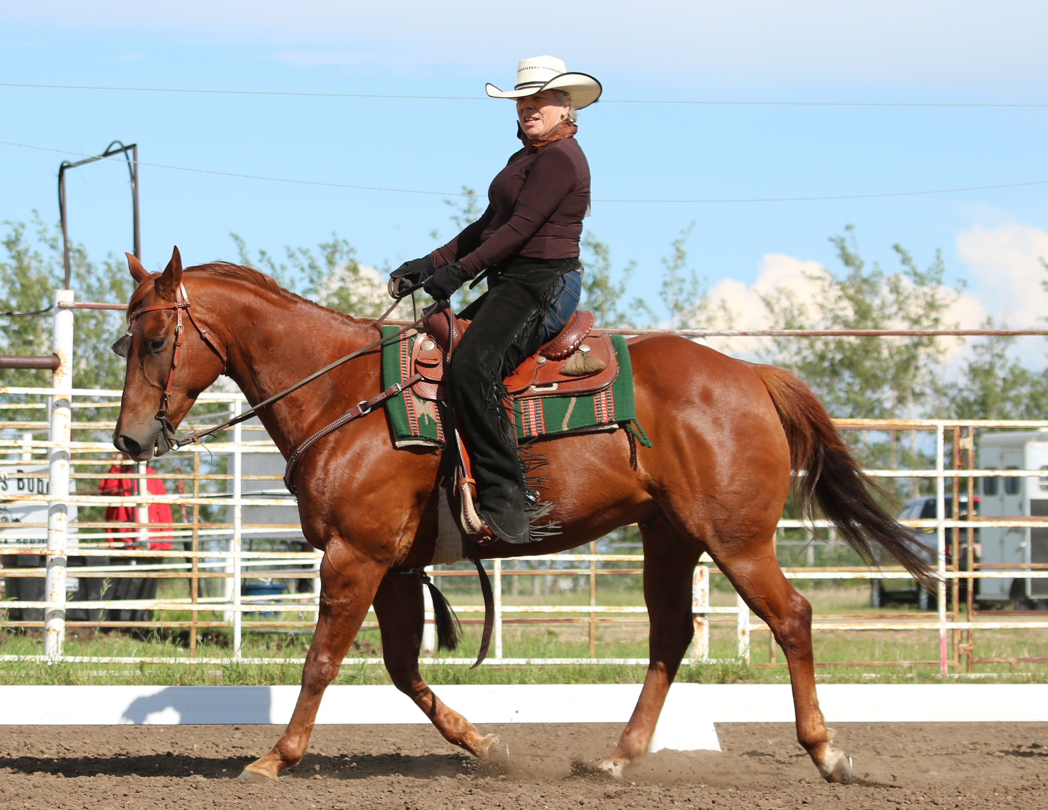
Sunday | Monday | Tuesday | Wednesday | Thursday | Friday | Saturday
 |  | 1 | 2 | 3 | 4  Gymkhana & Games | 5
6  4-H Achievement Day set up | 7  4-H Achievement Day | 8 | 9 | 10 | 11  Dressage Show | 12  Horse Show
13  Horse Show | 14 | 15 | 16 | 17 | 18 | 19
20 | 21 | 22 | 23 | 24 | 25  Drill Team Patterns | 26
27 | 28 | 29 | 30

July
2021
Valleyview & Districts Agricultural Society
Events | 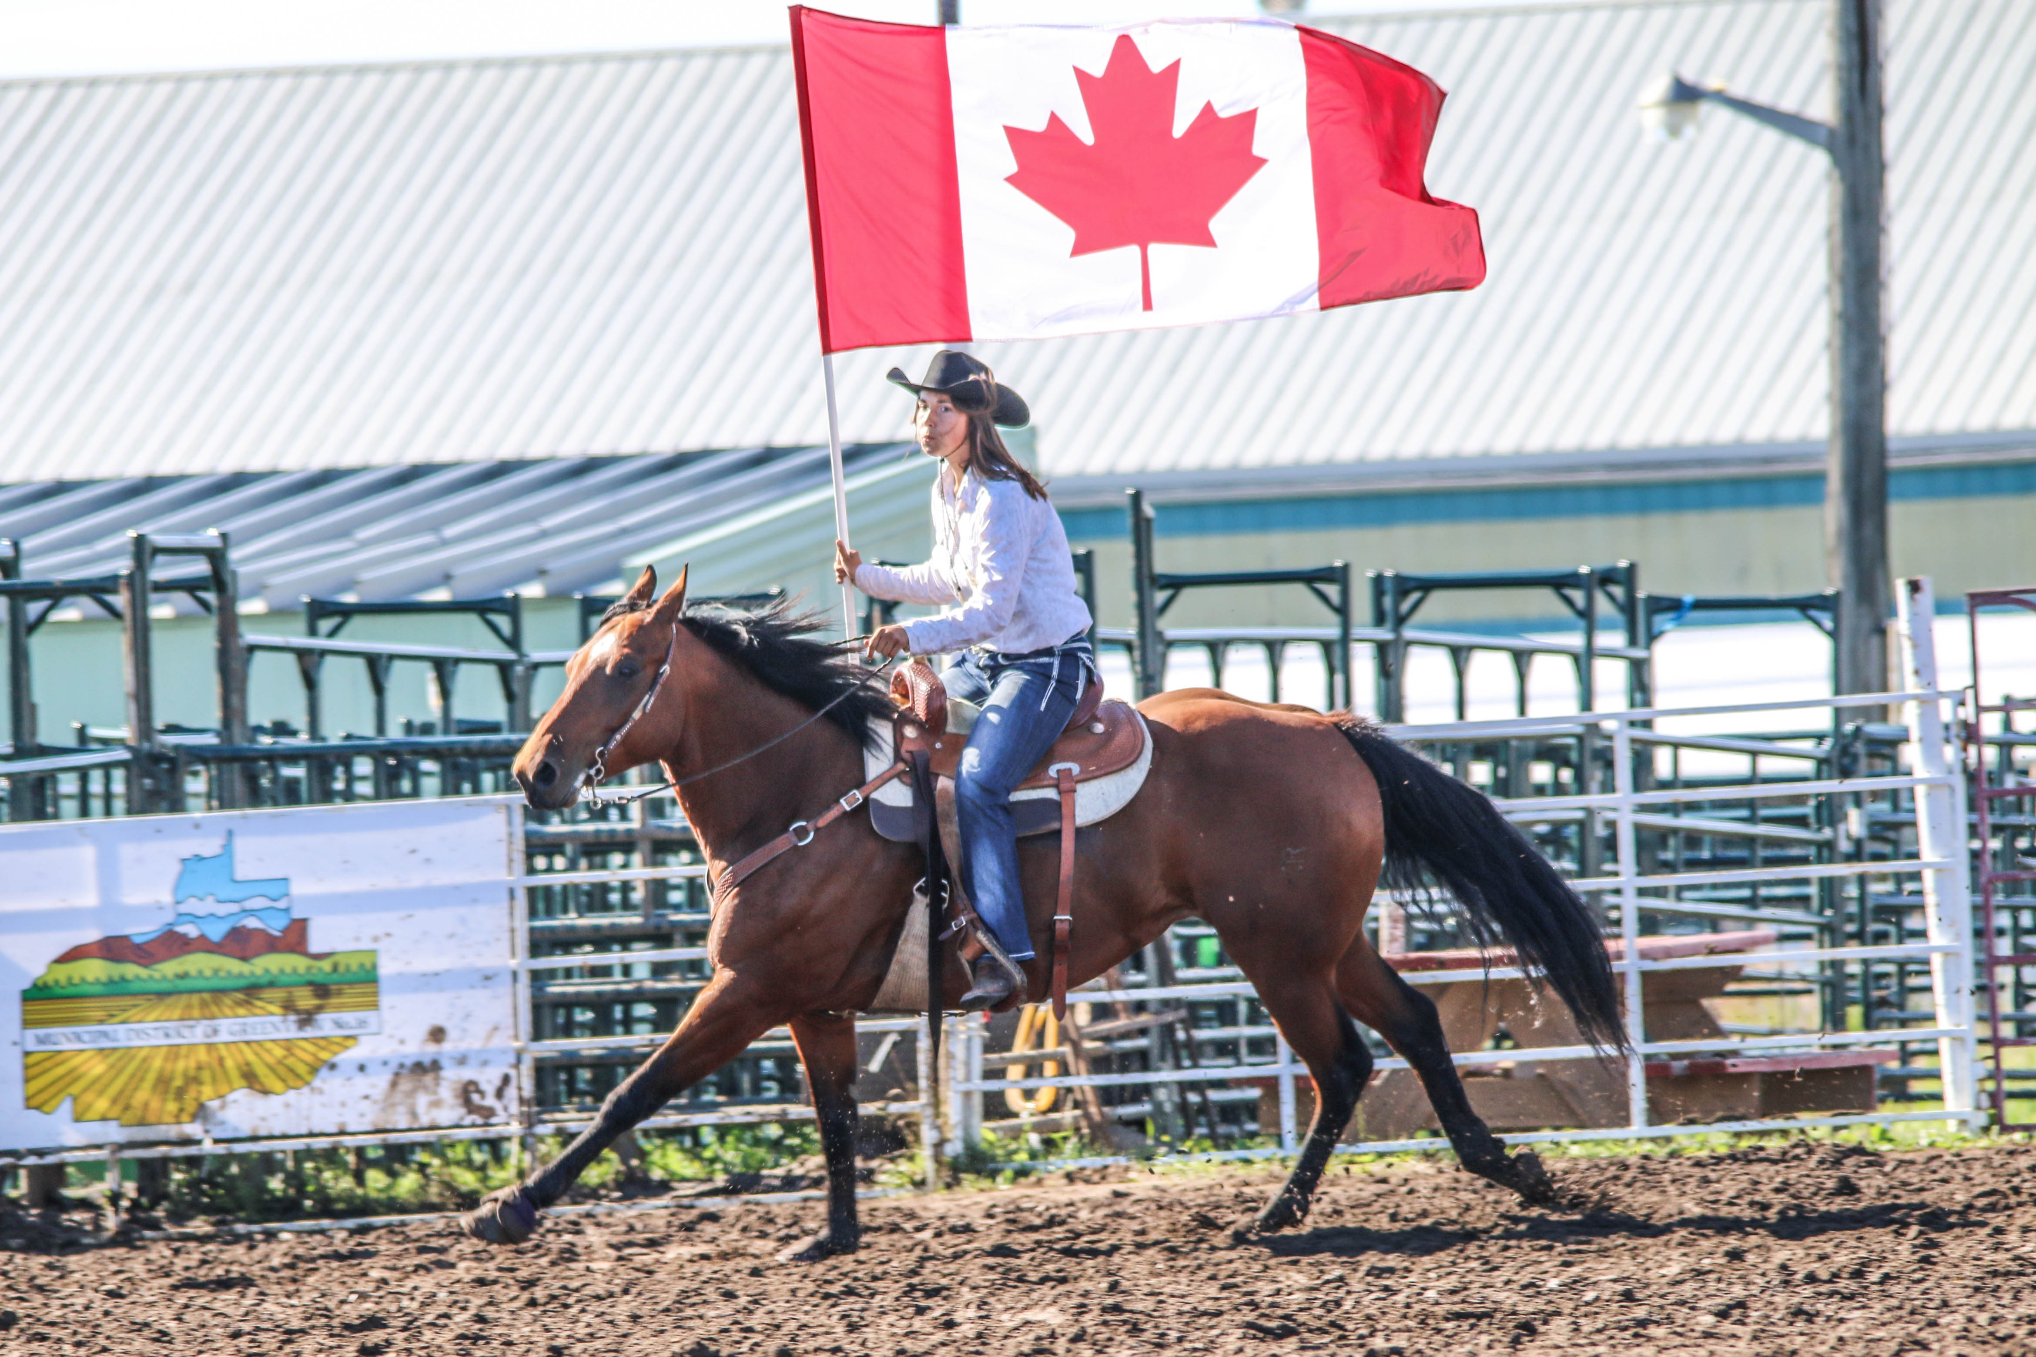
Sunday | Monday | Tuesday | Wednesday | Thursday | Friday | Saturday
 |  |  |  | 1 | 2 | 3
4 | 5 | 6 | 7 | 8 | 9 | 10
11 | 12 | 13 | 14 | 15 | 16 | 17
18 | 19 | 20 | 21 | 22 | 23 | 24
25 | 26 | 27 | 28 | 29 | 30 | 31

August
2021
Valleyview & Districts Agricultural Society
Events  Annual Fair & Rodeo August 13-15 (tentative) | 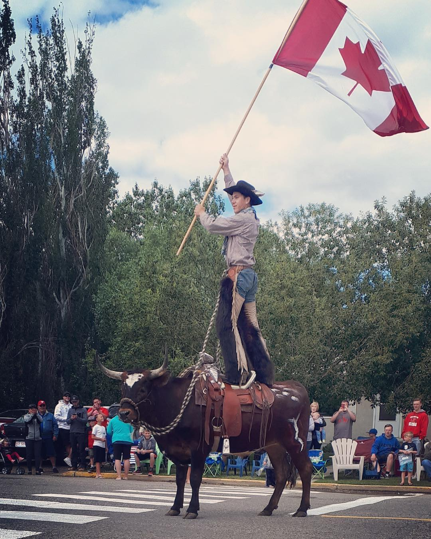
Sunday | Monday | Tuesday | Wednesday | Thursday | Friday | Saturday
1 | 2 | 3 | 4 | 5 | 6 | 7
8 | 9 | 10 | 11 | 12 | 13 | 14
15 | 16 | 17 | 18 | 19 | 20 | 21
22 | 23 | 24 | 25 | 26 | 27 | 28
29 | 30 | 31

September
2021
Valleyview & Districts Agricultural Society
Events  A BIG THANK YOU to all the Sponsors and Volunteers that help us through out the year. Your support is VERY MUCH APPRECIATED. | 
Sunday | Monday | Tuesday | Wednesday | Thursday | Friday | Saturday
 |  |  | 1 | 2 | 3 | 4
5 | 6 | 7 | 8 | 9 | 10 | 11
12 | 13 | 14 | 15 | 16 | 17 | 18
19 | 20 | 21 | 22 | 23 | 24 | 25
26 | 27 | 28 | 29 | 30

October
2021
VALLEYVIEW & DISTRICTS AGRICULTURAL SOCIETY
EVENTS | 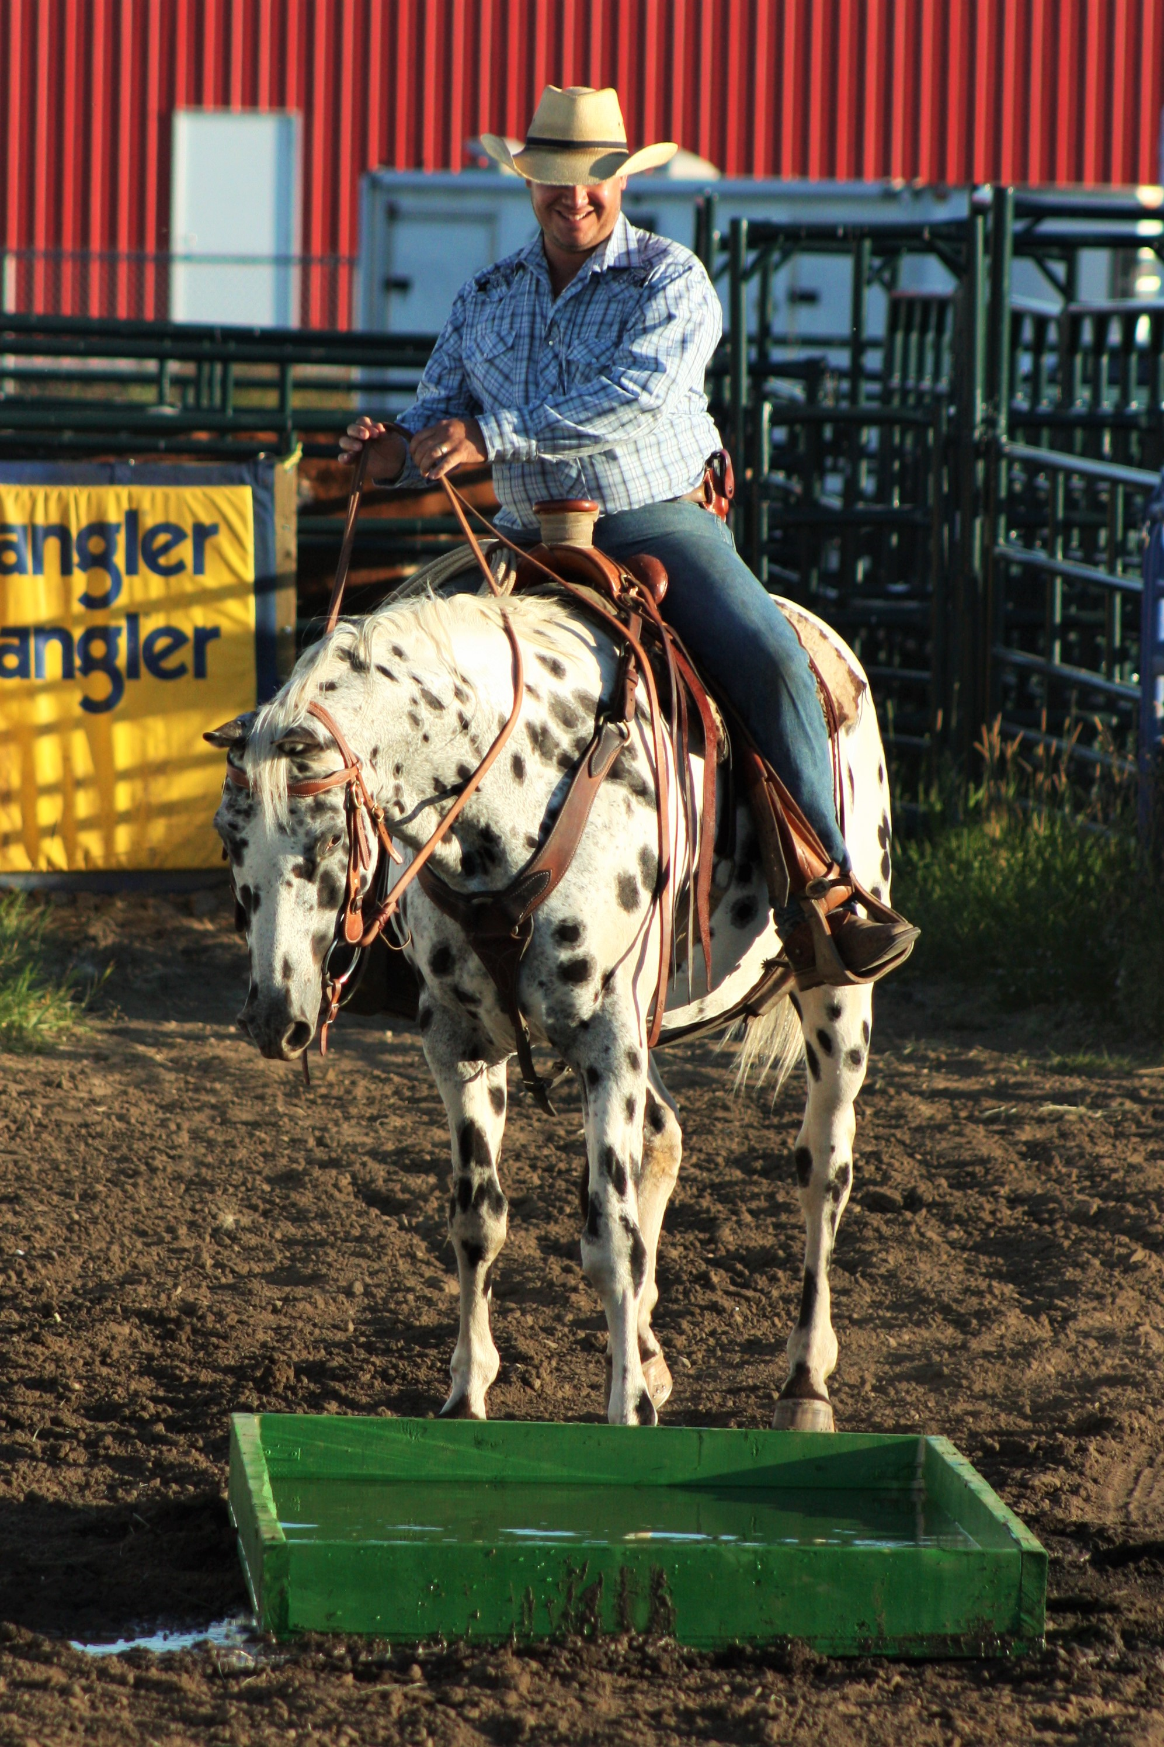
Sunday | Monday | Tuesday | Wednesday | Thursday | Friday | Saturday
 |  |  |  |  | 1 | 2
3 | 4 | 5 | 6 | 7 | 8 | 9
10 | 11 | 12 | 13 | 14 | 15 | 16
17 | 18 | 19 | 20 | 21 | 22 | 23
24 | 25 | 26 | 27 | 28 | 29 | 30
31

November
2021
VALLEYVIEW & DISTRICTS AGRICULTURAL SOCIETY
Events | 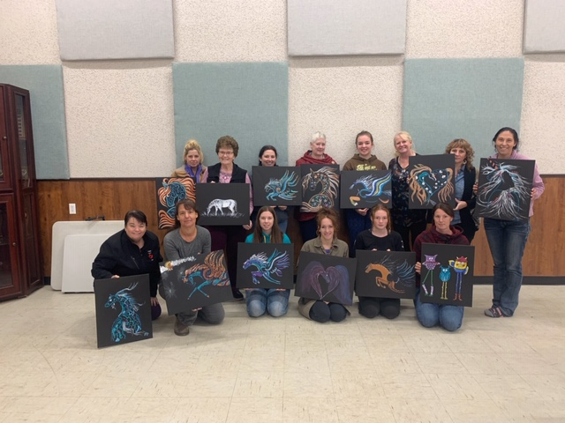
Sunday | Monday | Tuesday | Wednesday | Thursday | Friday | Saturday
 | 1 | 2 | 3 | 4 | 5 | 6
7 | 8 | 9 | 10 | 11 | 12 | 13
14 | 15 | 16 | 17 | 18 | 19 | 20
21 | 22 | 23 | 24 | 25 | 26 | 27
28 | 29 | 30

December
2021
VALLEYVIEW & DISTRICTS AGRICULTURAL SOCIETY
Events | 
Sunday | Monday | Tuesday | Wednesday | Thursday | Friday | Saturday
 |  |  | 1 | 2 | 3 | 4
5 | 6 | 7 | 8 | 9 | 10 | 11
12 | 13 | 14 | 15 | 16 | 17 | 18
19 | 20 | 21 | 22 | 23 | 24 | 25
26 | 27 | 28 | 29 | 30 | 31

