January
2021
Valleyview & Districts Agricultural Society
Events  AGM JANUARY 14  BOARD MEETING JAN. 21 | 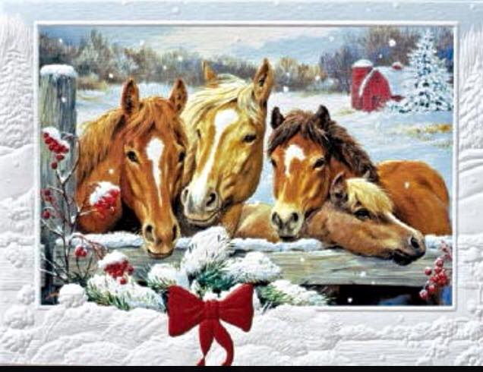
Sunday | Monday | Tuesday | Wednesday | Thursday | Friday | Saturday
 |  |  |  |  | 1  1-4 Maggie H.  4:30-6 Debbie W. | 2  10-1 Marcel
3  2-3:30 Debbie W. | 4 | 5 | 6  7-8:30 Debbie W. | 7  1-2:30 Katrin  2:30-4 Anna | 8  2-5 Maureen  7-8:30 Debbie W | 9  10-1 Marcel
10  2-3:30 Debbie W. | 11 | 12 | 13 | 14  1-2:30 Katrin  2:30-4 Anna | 15 | 16  10-1 Marcel
17 | 18 | 19  7-8:30 DW | 20 | 21  1-2:30 Katrin  2:30-4 Anna | 22  7-8:30 DW | 23  10-1 Marcel
24  2-3:30 DW | 25 | 26  7-8:30 DW | 27 | 28  1-4 Katrin, Anna | 29  7-8:30 DW | 30  10-1 Marcel
31
2-3:30 DW

February
2021
Valleyview & Districts Agricultural Society
Events  Feb. 1 – Fundraising Committee Meeting – 6pm  Meeting February,17 | 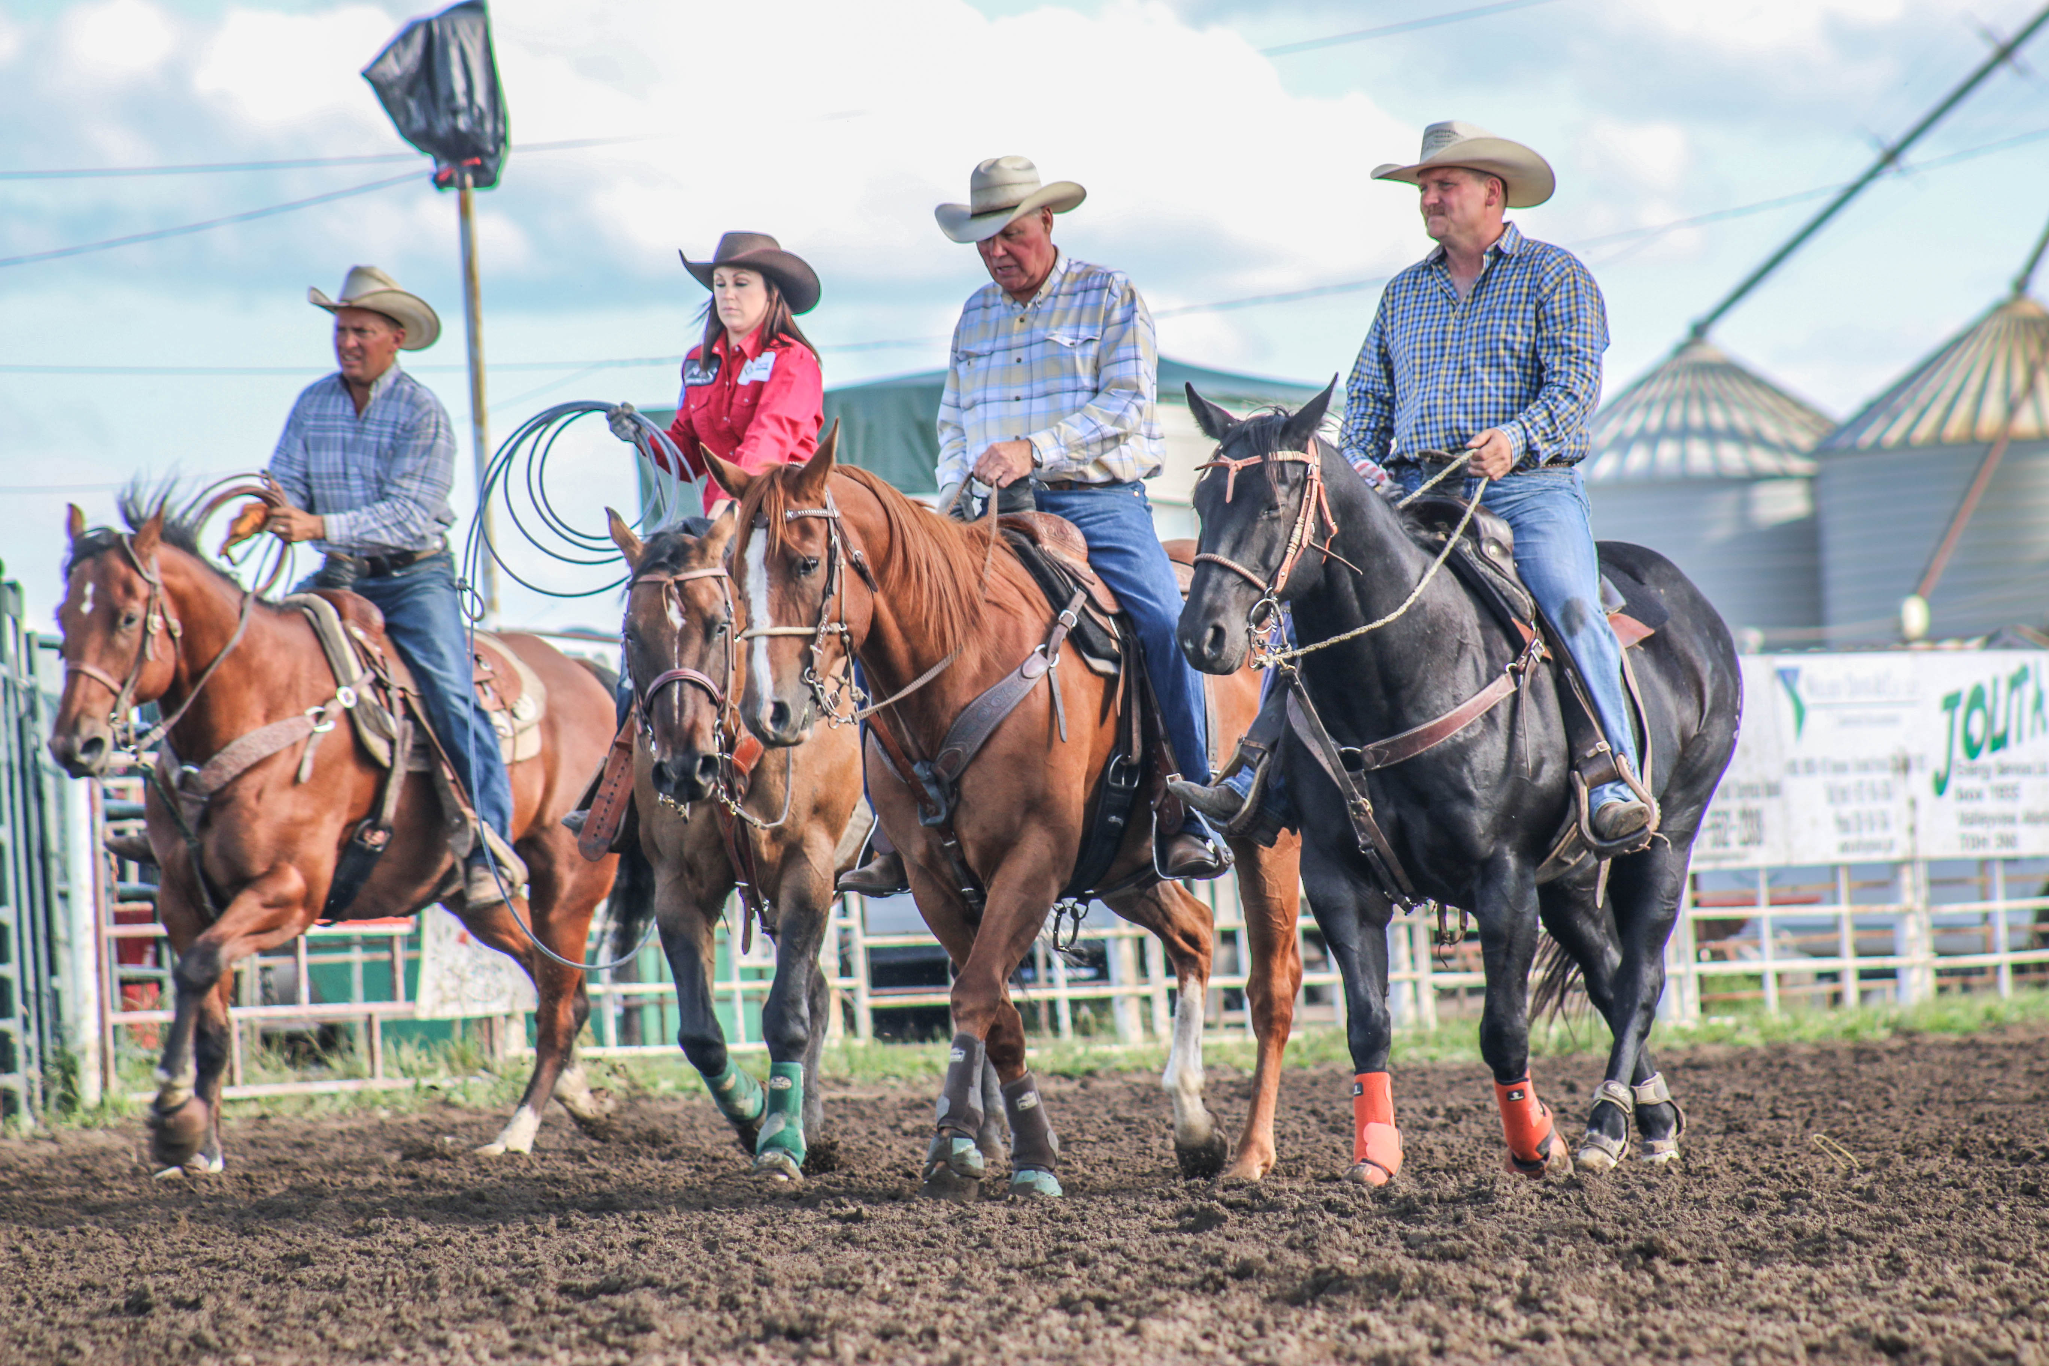
Sunday | Monday | Tuesday | Wednesday | Thursday | Friday | Saturday
 | 1 | 2  7-8 DW | 3 | 4  1-4 Katrin, Anna | 5  7-8:30 DW | 6
7  2-3:30 DW | 8 | 9  7-8:30 DW | 10 | 11 | 12  7-8:30 DW | 13
14  2-3:30 DW | 15 | 16 | 17 | 18 | 19 | 20
21 | 22 | 23 | 24 | 25 | 26 | 27
28
March
2021
Valleyview & Districts Agricultural Society
Events  Century Roping March 7 & 28  Meeting March 18 | 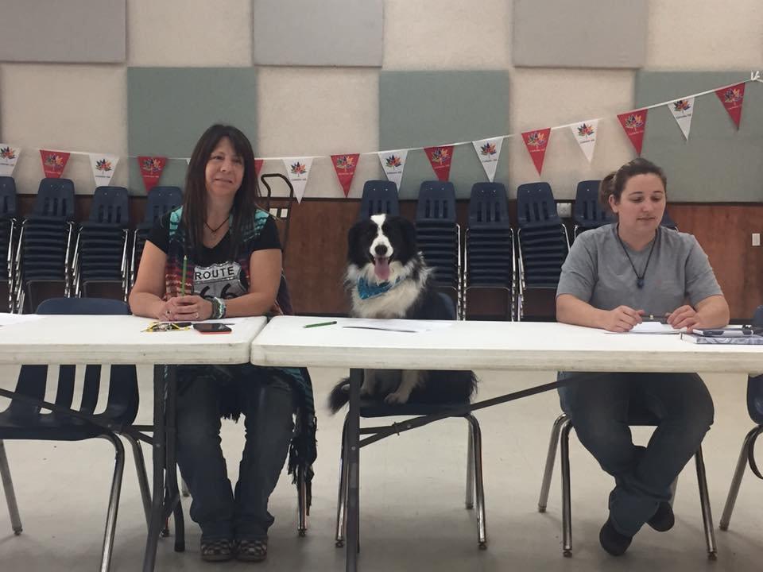
Sunday | Monday | Tuesday | Wednesday | Thursday | Friday | Saturday
 | 1 | 2 | 3 | 4 | 5 | 6
7  Century Roping  11-5 | 8 | 9 | 10 | 11 | 12 | 13  Gymkhana 1-4
14 | 15 | 16 | 17 | 18 | 19 | 20
21 | 22 | 23 | 24 | 25 | 26 | 27
28  Century Roping 11-5 | 29 | 30 | 31

April
2021
Valleyview & Districts Agricultural Society
Events  Peace Prospect Show – April 17 | 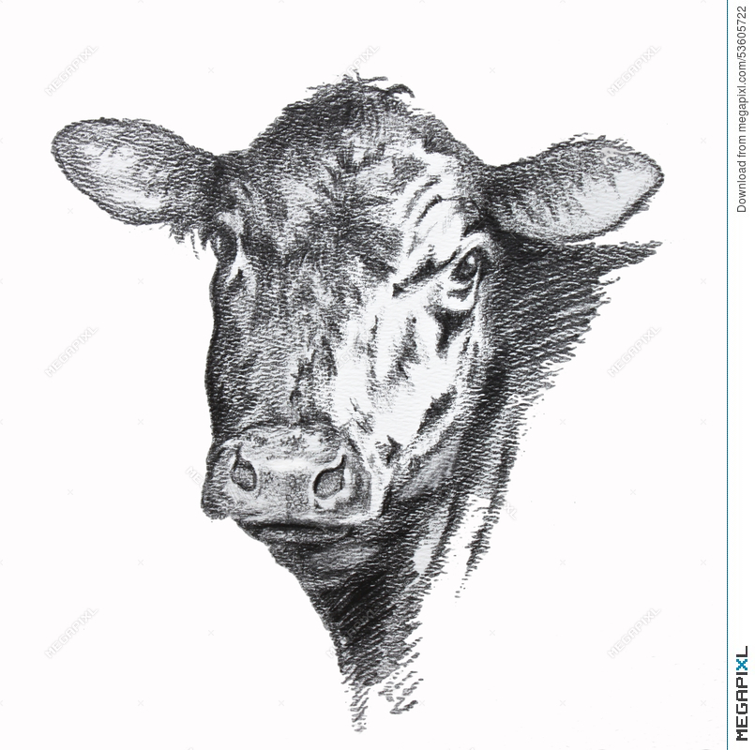
Sunday | Monday | Tuesday | Wednesday | Thursday | Friday | Saturday
 |  |  |  | 1 | 2 | 3
4 | 5 | 6 | 7 | 8 | 9 | 10  Gymkhana 1-4
11 | 12 | 13 | 14 | 15 | 16  Set up for Peace Prospect Show | 17  Peace Prospect Show
18 | 19 | 20 | 21 | 22 | 23 | 24
25 | 26 | 27 | 28 | 29 | 30

May
2021
Valleyview & Districts Agricultural Society
Events | 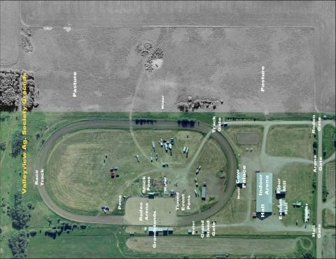
Sunday | Monday | Tuesday | Wednesday | Thursday | Friday | Saturday
 |  |  |  |  |  | 1
2 | 3 | 4 | 5 | 6 | 7 | 8
9 | 10 | 11 | 12 | 13 | 14 | 15
16 | 17 | 18 | 19 | 20 | 21 | 22
23 | 24 | 25 | 26 | 27 | 28 | 29
30 | 31

June
2021
Valleyview & Districts Agricultural Society
Events  4-H Achievement Day – June 7  Dressage Show & Horse Show – June 11, 12 & 13 | 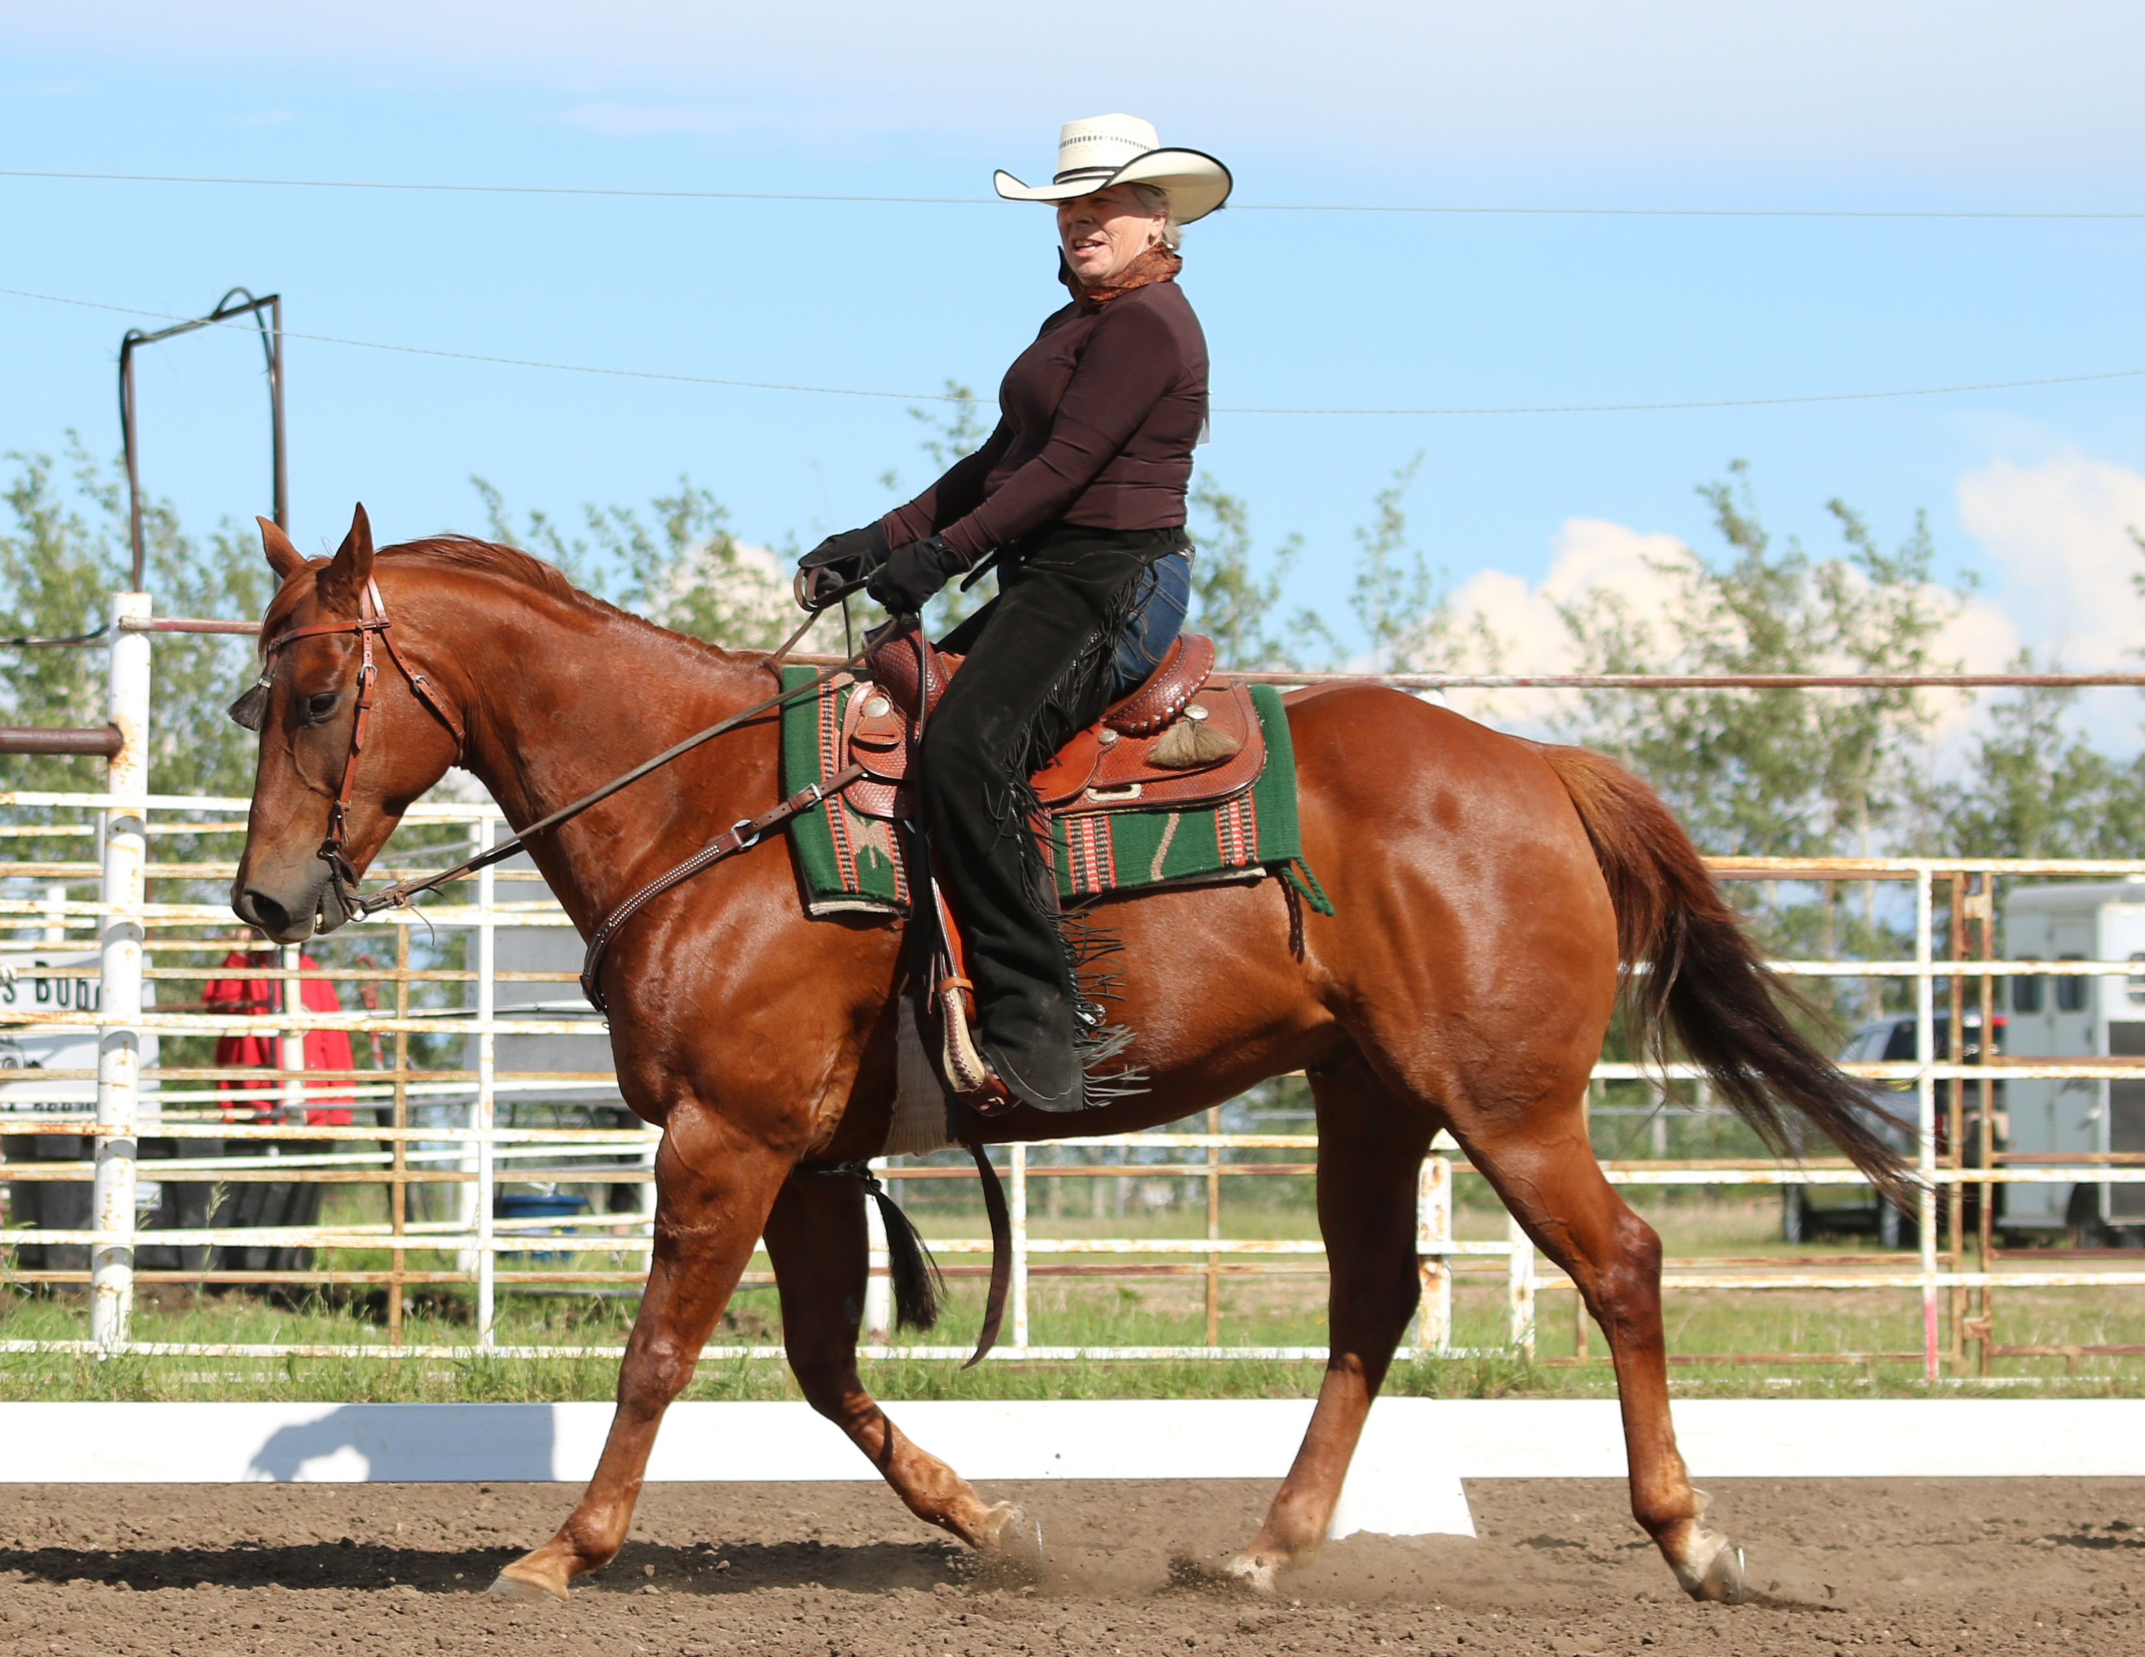
Sunday | Monday | Tuesday | Wednesday | Thursday | Friday | Saturday
 |  | 1 | 2 | 3 | 4 | 5
6  4-H Achievement Day set up | 7  4-H Achievement Day | 8 | 9 | 10 | 11  Dressage Show | 12  Horse Show
13  Horse Show | 14 | 15 | 16 | 17 | 18 | 19
20 | 21 | 22 | 23 | 24 | 25 | 26
27 | 28 | 29 | 30

July
2021
Valleyview & Districts Agricultural Society
Events | 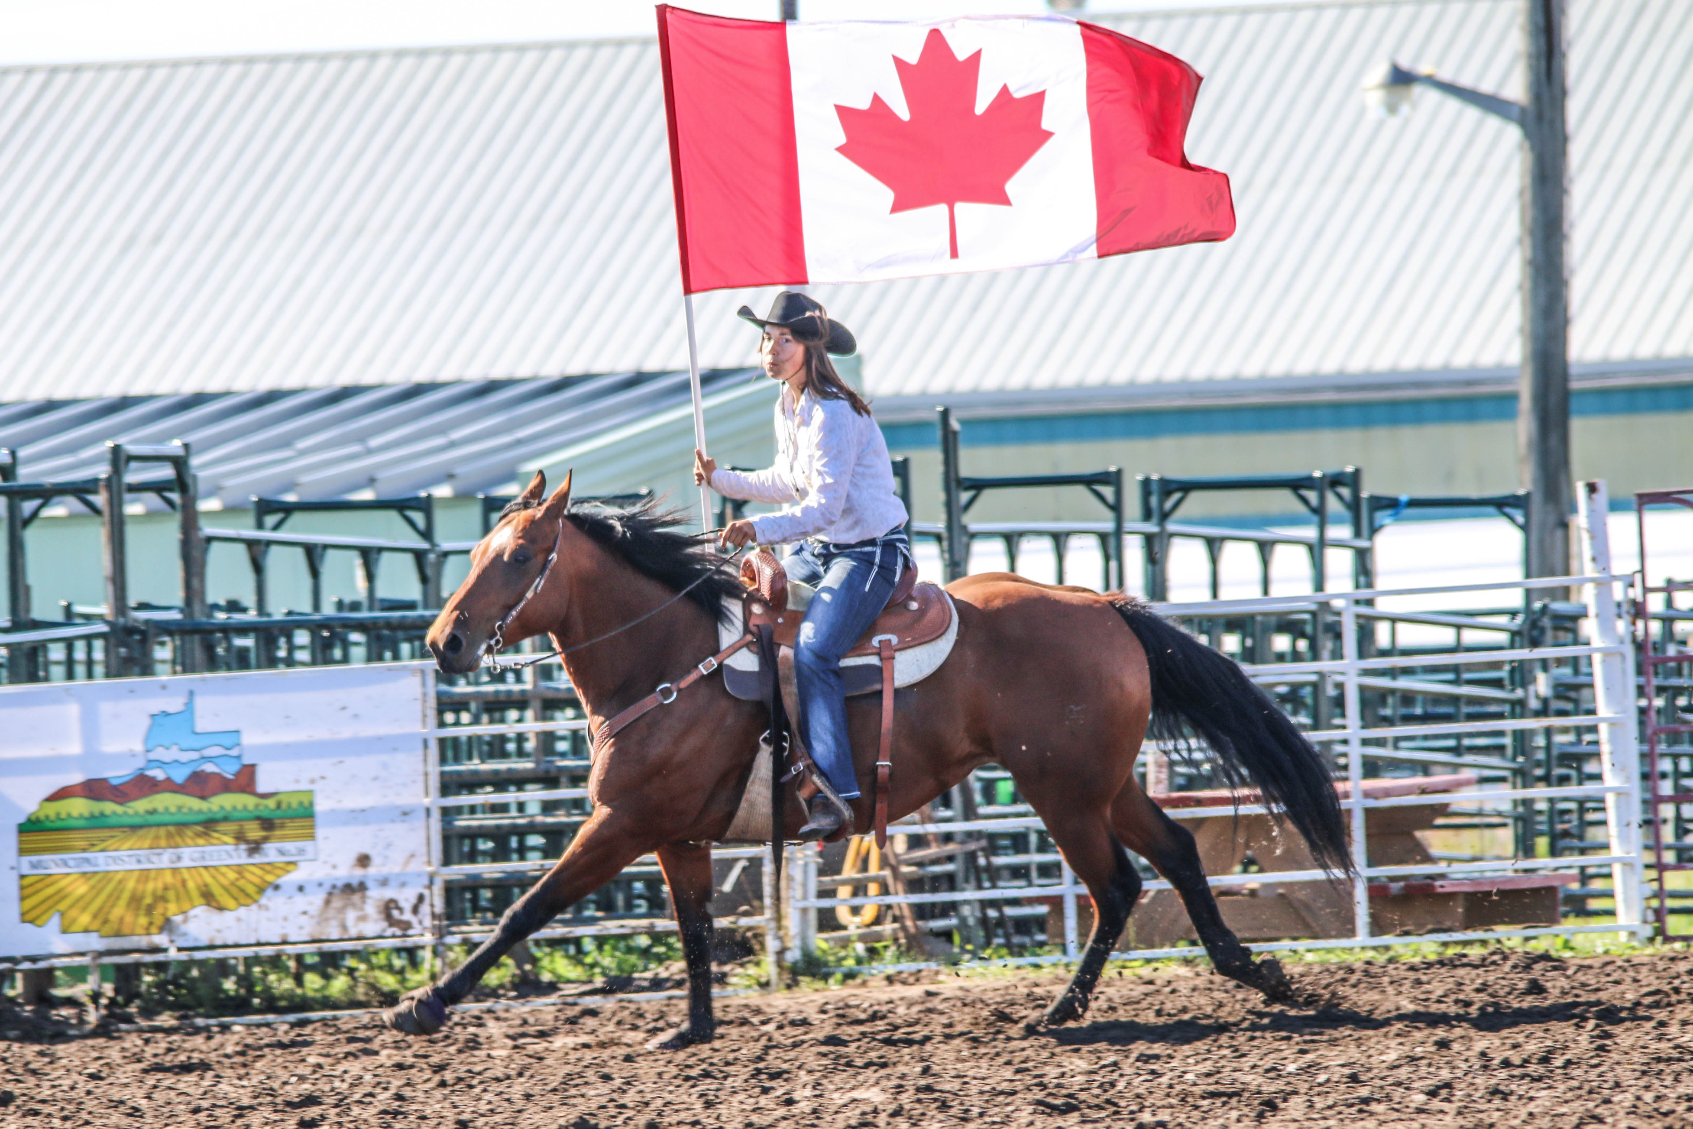
Sunday | Monday | Tuesday | Wednesday | Thursday | Friday | Saturday
 |  |  |  | 1 | 2 | 3
4 | 5 | 6 | 7 | 8 | 9 | 10
11 | 12 | 13 | 14 | 15 | 16 | 17
18 | 19 | 20 | 21 | 22 | 23 | 24
25 | 26 | 27 | 28 | 29 | 30 | 31

August
2021
Valleyview & Districts Agricultural Society
Events  Annual Fair & Rodeo | 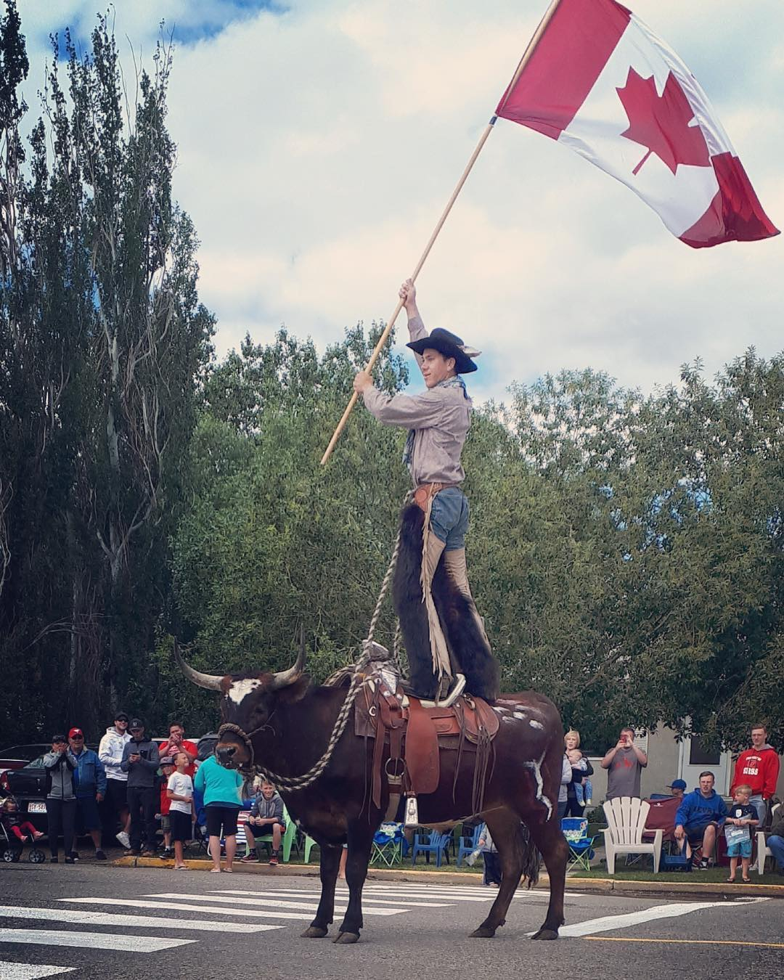
Sunday | Monday | Tuesday | Wednesday | Thursday | Friday | Saturday
1 | 2 | 3 | 4 | 5 | 6 | 7
8 | 9 | 10 | 11 | 12 | 13 | 14
15 | 16 | 17 | 18 | 19 | 20 | 21
22 | 23 | 24 | 25 | 26 | 27 | 28
29 | 30 | 31

September
2021
Valleyview & Districts Agricultural Society

Events
A BIG THANK YOU to all the Sponsors and Volunteers that help us through out the year. Your support is VERY MUCH APPRECIATED.
Sunday | Monday | Tuesday | Wednesday | Thursday | Friday | Saturday
 |  |  | 1 | 2 | 3 | 4
5 | 6 | 7 | 8 | 9 | 10 | 11
12 | 13 | 14 | 15 | 16 | 17 | 18
19 | 20 | 21 | 22 | 23 | 24 | 25
26 | 27 | 28 | 29 | 30

October
2021
VALLEYVIEW & DISTRICTS AGRICULTURAL SOCIETY
EVENTS | 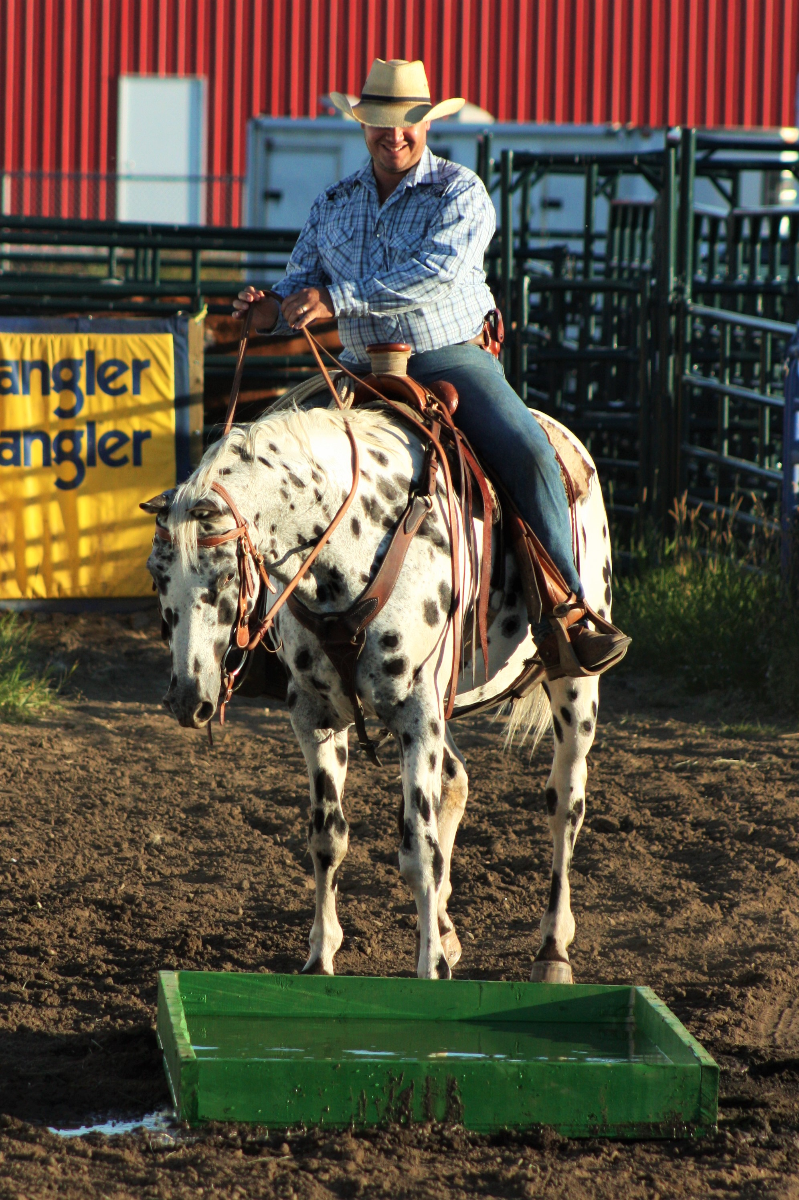
Sunday | Monday | Tuesday | Wednesday | Thursday | Friday | Saturday
 |  |  |  |  | 1 | 2
3 | 4 | 5 | 6 | 7 | 8 | 9
10 | 11 | 12 | 13 | 14 | 15 | 16
17 | 18 | 19 | 20 | 21 | 22 | 23
24 | 25 | 26 | 27 | 28 | 29 | 30
31

November
2021
VALLEYVIEW & DISTRICTS AGRICULTURAL SOCIETY
Events | 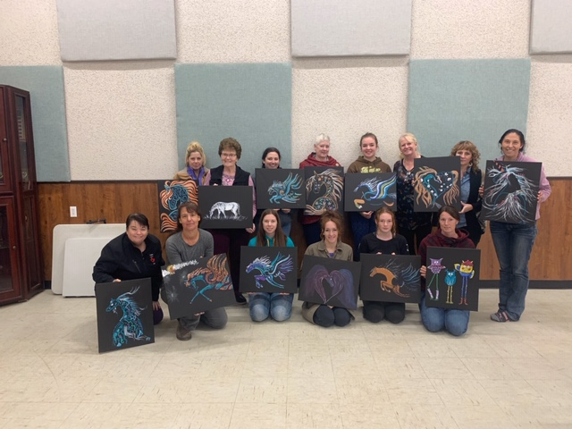
Sunday | Monday | Tuesday | Wednesday | Thursday | Friday | Saturday
 | 1 | 2 | 3 | 4 | 5 | 6
7 | 8 | 9 | 10 | 11 | 12 | 13
14 | 15 | 16 | 17 | 18 | 19 | 20
21 | 22 | 23 | 24 | 25 | 26 | 27
28 | 29 | 30

December
2021
VALLEYVIEW & DISTRICTS AGRICULTURAL SOCIETY
Events | 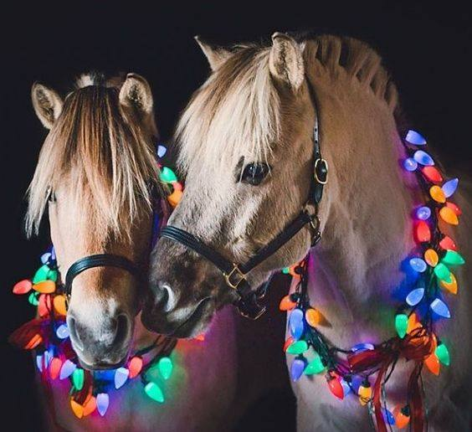
Sunday | Monday | Tuesday | Wednesday | Thursday | Friday | Saturday
 |  |  | 1 | 2 | 3 | 4
5 | 6 | 7 | 8 | 9 | 10 | 11
12 | 13 | 14 | 15 | 16 | 17 | 18
19 | 20 | 21 | 22 | 23 | 24 | 25
26 | 27 | 28 | 29 | 30 | 31

