July
2020

Valleyview & Districts Agricultural Society

Sunday | Monday | Tuesday | Wednesday | Thursday | Friday | Saturday
 |  |  | 1 | 2 | 3 | 4
 |  |  |  | 7:30-8:30 Kendra
5 | 6 | 7  5-9 Private Booking | 8 | 9  7:30-8:30 Kendra | 10 | 11
12 | 13 | 14  5-9 Private Booking | 15 | 16  7:30-8:30 Kendra | 17 | 18
19 | 20 | 21  5-9 Private Booking | 22 | 23  7:30-8:30 Kendra | 24 | 25
26 | 27 | 28  Private booking 5-9 | 29 | 30  7:30-8:30 Kendra | 31

August
2020

Valleyview & Districts Agricultural Society

Sunday | Monday | Tuesday | Wednesday | Thursday | Friday | Saturday
 |  |  |  |  |  | 1
2 | 3 | 4  5-9 Private Bookings. | 5 | 6  7:30-8:30 Private Booking | 7 | 8
9 | 10 | 11  5-9 Private Bookings | 12 | 13  7:30- 8:30 Private Booking | 14 | 15
16 | 17 | 18  5-9 Private Bookings | 19  7:30-8:30 Private Booking | 20  Ag Meeting 7pm | 21 | 22
23 | 24 | 25  5-9 Private  Bookings | 26 | 27  7:30-8:30 Private Booking | 28 | 29
30 | 31

September
2020
Valleyview & Districts Agricultural Society | 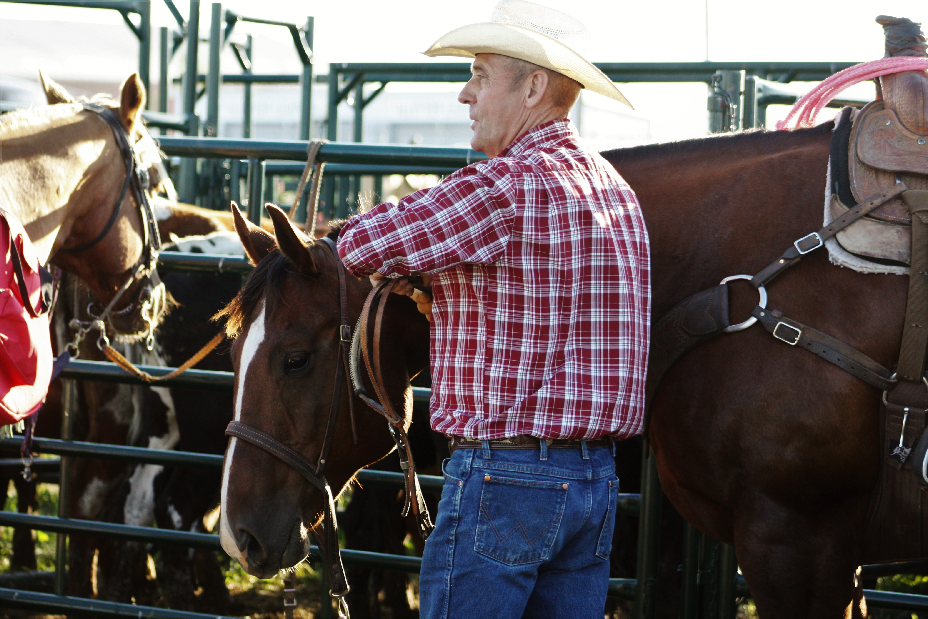
Sunday | Monday | Tuesday | Wednesday | Thursday | Friday | Saturday
 |  | 1  5-9 Private Booking | 2 | 3  7:30-8:30 Private Booking | 4 | 5
6 | 7 | 8  5-9 Private Booking | 9 | 10  7:30-8:30 Private Booking | 11 | 12
13 | 14 | 15  5-9 Private Booking | 16  7:30-8:30 Private Booking | 17  Ag. Meeting 7pm | 18 | 19
20 | 21 | 22  5-9 Private Booking | 23 | 24  7:30-8:30 Private Booking | 25 | 26
27 | 28 | 29  5-9 Private Booking | 30

October
2020

Valleyview & Districts Agricultural Society

Sunday | Monday | Tuesday | Wednesday | Thursday | Friday | Saturday
 |  |  |  | 1 | 2 | 3
4 | 5 | 6 | 7 | 8 | 9 | 10
11 | 12 | 13 | 14 | 15 | 16 | 17
18 | 19 | 20 | 21 | 22 | 23 | 24
25 | 26 | 27 | 28 | 29 | 30 | 31

November
2020

Valleyview & Districts Agricultural Society

Sunday | Monday | Tuesday | Wednesday | Thursday | Friday | Saturday
1 | 2 | 3 | 4 | 5 | 6 | 7
8 | 9 | 10 | 11 | 12 | 13 | 14
15 | 16 | 17 | 18 | 19 | 20 | 21
22 | 23 | 24 | 25 | 26 | 27 | 28
29 | 30

December
2020
Valleyview & Districts Agricultural Society | 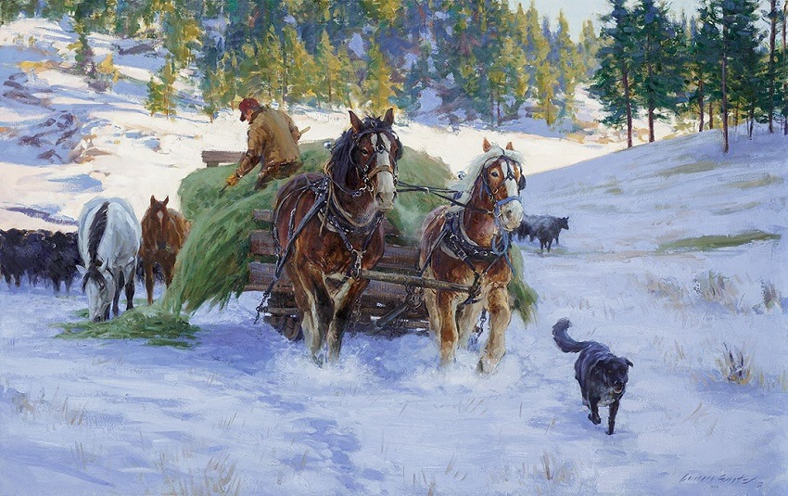
Sunday | Monday | Tuesday | Wednesday | Thursday | Friday | Saturday
 |  | 1 | 2 | 3 | 4 | 5
6 | 7 | 8 | 9 | 10 | 11 | 12
13 | 14 | 15 | 16 | 17 | 18 | 19
20 | 21 | 22 | 23 | 24 | 25 | 26
27 | 28 | 29 | 30 | 31

