October
2020
Valleyview & Districts Agricultural Society | 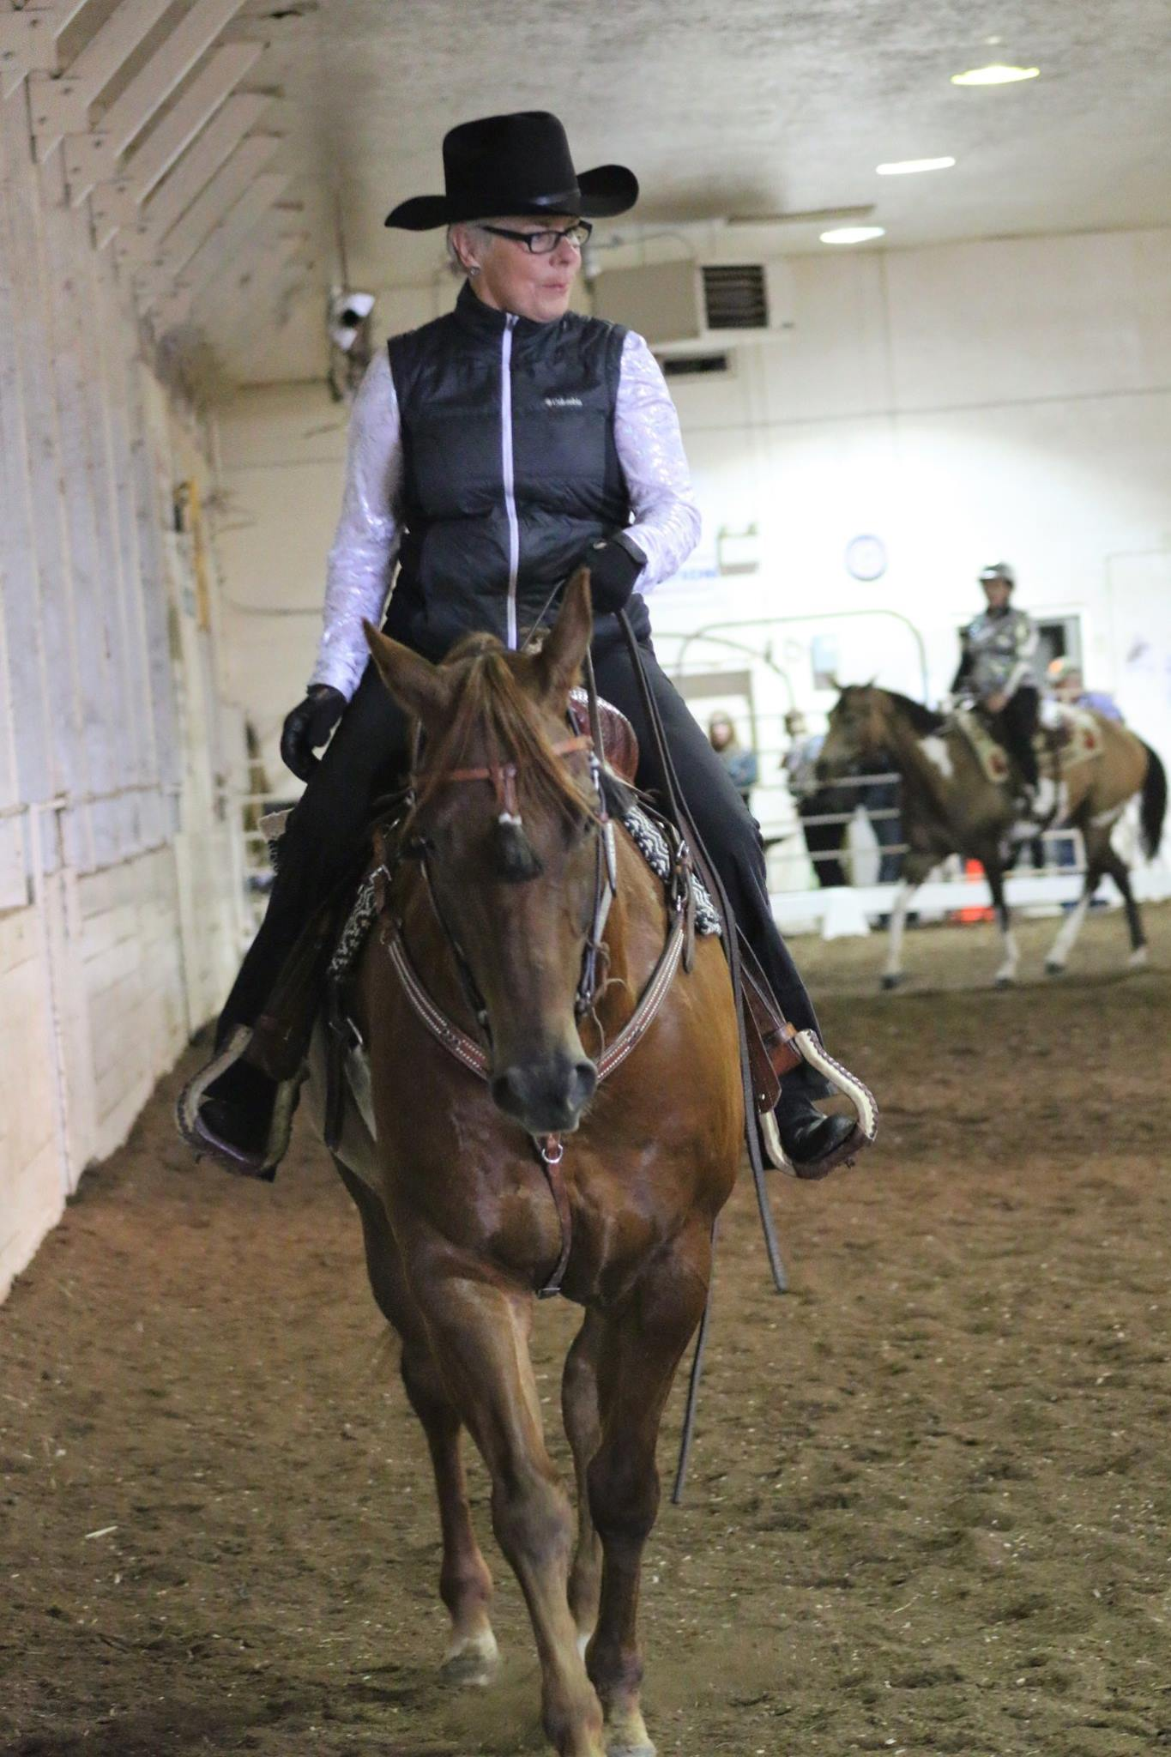
Sunday | Monday | Tuesday | Wednesday | Thursday | Friday | Saturday
 |  |  |  | 1 | 2 | 3  Cowboy Challenge Fun Day- noon  2-4 Indoor
4 | 5 | 6  5-9 Private Booking | 7 | 8  7:30-8:30  Kendra | 9 | 10
11 | 12 | 13  5-9 Private Booking | 14  7:30-8:30 Kendra | 15 | 16 | 17  Christine Painter clinic
18  Christine Painter Clinic | 19 | 20  6-7 Private | 21 | 22  5-8 4-H  8-9 Kendra | 23 | 24  Derek Shaw Horsemanship Clinic
25  Derek Shaw Horsemanship | 26 | 27  6-9 Private | 28  Roping club set- up 5pm | 29  5-8 4-H  8-9- Kendra | 30  7-9 RWRC  - | 31  Photo Event in Red Barn

November
2020
Valleyview & Districts Agricultural Society  - PAINT NIGHT IN HALL NOVEMBER 14 | 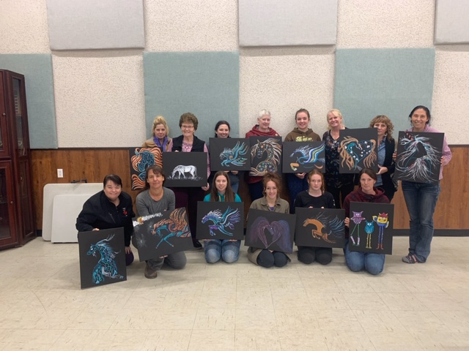
Sunday | Monday | Tuesday | Wednesday | Thursday | Friday | Saturday
1  12-5 Century Roping | 2 | 3  5-9 Private Booking | 4  6:30-9:30 RWRC | 5  5-8 4-H  8-9- Private | 6  6:30-9:30 RWRC | 7  Introduction to jumping
8  9am – 4-H  2-5 RWRC | 9 | 10  5-9 Private Booking | 11  6:30-9:30 RWRC | 12  5-8 4-H  8-9- Private | 13  5:00-9:30 RWRC | 14  Team Roping Clinic
15  Team Roping Clinic | 16 | 17  5-9 Private Booking | 18  6:30-9:30 RWRC | 19  5-8 4-H  8-9- Private | 20  6:30-9:30 RWRC | 21  Beginner roping school
22  Roping School | 23 | 24  5-9 Private Booking | 25  6:30-9:30 RWRC | 26  5-8 4-H  8-9- Private | 27  6:30-9:30 RWRC | 28
29  2-5 RWRC | 30

December
2020
Valleyview & Districts Agricultural Society | 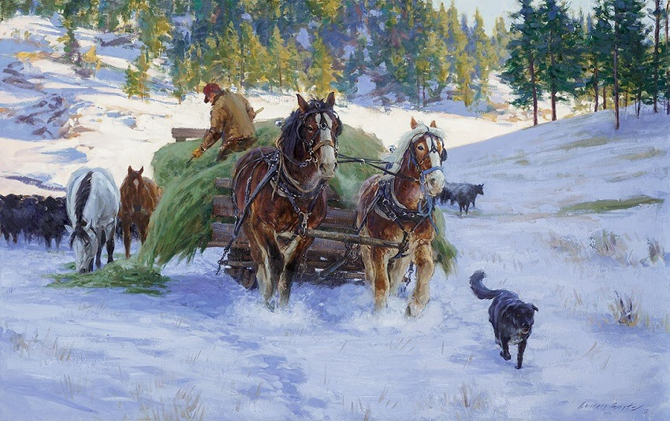
Sunday | Monday | Tuesday | Wednesday | Thursday | Friday | Saturday
 |  | 1  5-9 Private Booking | 2  6:30-9:30 RWRC | 3  5-8 4-H  8-9 Private | 4  6:30-9:30 RWRC | 5
6  12-5 Century Roping | 7 | 8  5-9 Private Booking | 9  6:30-9:30 RWRC | 10  5-8 4-H  8-9 Private | 11  6:30-9:30 RWRC | 12
13  2-5 RWRC | 14 | 15  5-9 Private Booking | 16  6:30-9:30 RWRC | 17  5-8 4-H  8-9 Private | 18  6:30-9:30 RWRC | 19
20  Roping Club Christmas Party 2-8pm | 21 | 22  5-9 Private Booking | 23  6:30-9:30 RWRC | 24  5-8 4-H  8-9 Private | 25  6:30-9:30 RWRC | 26
27  2-5 RWRC | 28 | 29  5-9 Private Booking | 30  6:30-9:30 RWRC | 31  5-8 4-H  8-9 Private

