**ATTENTION ALL HORSE SHOW COMPETITORS, REINERS, EQUITATION & HORSEMANSHIP RIDERS AND COACHES**

Valleyview & Districts Agricultural Society is excited to announce as part of our **Discovery Series** a clinic focused on improving pattern work for both English and Western riders. **August 22&23 2020** come and get instruction from Valleyview's **2021** horse show Judge **DONNA ALLEN** who is also an equine coaching examiner, accomplished rider and has 25 years of coaching experience. Come learn the nitty-gritty of competing and learn what the judge is looking for! Equitation, Horsemanship and showmanship patterns will be a main focus along with assistance offered for reining and dressage work. There will be groups for ALL LEVELS OF RIDERS

Please identify which areas of focus you would like to work on so we can place you in the appropriate groups. You may pick multiple options:

1. English flat work and equitation
2. Western horsemanship and flat work
3. Showmanship (English or Western)
4. Reining
5. Dressage (English and Western)

Aspiring coaches & Riders: Please feel free to audit the clinic for 35$/day and bring home the valuable information!

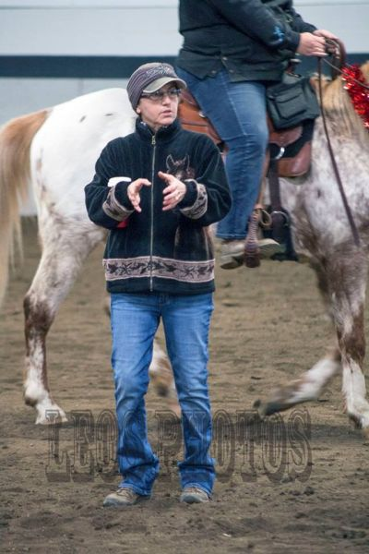

Cost is 211$ plus GST, price may decrease based on numbers of riders. Indoor stabling is available at 20$ +GST per night, shavings 10.50$. Contact Dana Murphy for accommodations and any further questions at dana_kali@hotmail.com. **100$ non refundable deposit is required to hold your spot and full payment must be made by AUG. 19TH** via cheque or eTransfer to valleyviewagsociety@gmail.com