VALLEYVIEW & DISTRICTS AGRICULTURAL SOCIETY
ALL BREED HORSE SHOW
June 30th-July 2nd, 2023

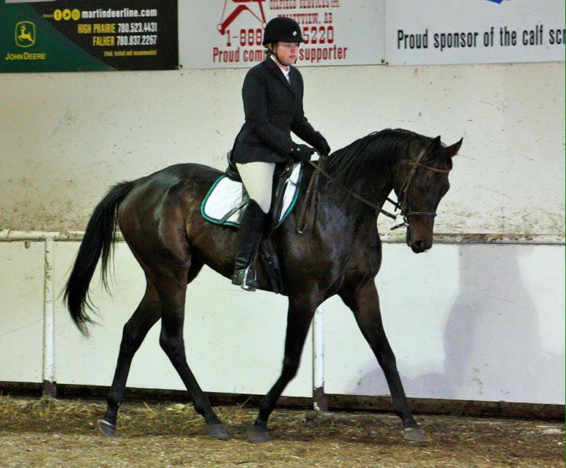

Concession on Site

Friday
Dressage
Ranch Horse Competition

Saturday
Showmanship & Halter, English Performance,
Costume & Pee Wee, Trail, 4-H Incentive Classes,
Western Performance

Sunday
Fun Classes, Jumping, Reining

Indoor and Outdoor Arenas
Were the Classes are held will be Weather Dependent
VALLEYVIEW & DISTRICTS AGRICULTURAL SOCIETY
ALL BREED HORSE SHOW
June 30- July 2, 2023

JUDGES:
JILL JARDIE
LEO MARCOTTE (Trail)

FRIDAY | ENGLISH DRESSAGE | 8am | Outdoor Arena
 | WESTERN DRESSAGE |  | Outdoor Arena
 | RANCH HORSE COMPETITION | 4pm | Outdoor Arena
SATURDAY | HALTER & SHOWMANSHP | 8am
 | ENGLISH PREFORMANCE
 | TRAIL | 10am-2pm | Lawn Outside the Indoor Arena
 | LUNCH | 11am-12pm
 | COSTUME & PEEWEE | 12pm | Indoor Arena
 | WESTERN PREFORMANCE | After Peewees
SUNDAY | REINING | 8am | Outdoor Arena
 | JUMPING |  | Outdoor Arena
 | LUNCH | 11am-12pm
**Times are approximate. Be prepared for your class**

Secretary:
Sharee Thomas
Box 1226, Valleyview, Alberta. T0H 3N0
(w.)780-524-3473
e-mail valleyviewagsociety@gmail.com
Web Site - valleyviewagsociety.ca

Show Manager:
Shelby Penner (c.) 780-552-3529
Horse Show Committee:
Darlene Corriveau, Shelby Penner, Reg Werklund, Cheri Corriveau, Wendy Babb

Welcome to our Annual All Breeds Horse Show!
The show will be held rain or shine, as we have access to an indoor arena and indoor stabling.

Thank-you to all our Sponsors!
McLeans Environmental – Porta Potty Cleaning & Dust Control
Moose Medicine Greenhouse – Flowers
PRIZES AND AWARDS
HI POINT JR RIDER | HI POINT SR RIDER
JR Showmanship | SR Showmanship
JR Western Pleasure | SR Western Pleasure
JR Trail | SR Trail
JR English Equitation | SR English Equitation
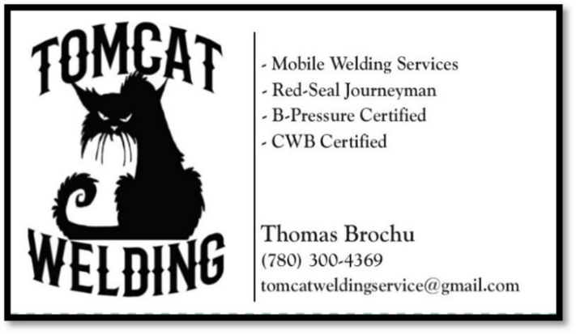

HORSE SHOW RULES AND REGULATIONS

- From the 2023 AQHA Rule Book: To enhance the humane standards to which American Quarter Horses are subjected for competition and training, uniform guidelines regarding bits and equipment are outlined in VIOLATIONS. In western classes, horses 5 years old and younger may be shown in a snaffle bit, hackamore, curb bit, half-breed or spade bit. Horses 6 years old and older may only be shown in a curb bit, half-breed or spade bit. Chin straps are required and must meet the approval of the judge, must be at least one-half inch in width, and must lie flat against the jaw of the horse. Prohibited equipment in western classes include jerklines, tiedowns with bare metal in contact with the horse’s head, extremely tight cavesson or noseband and tack collars. Prohibited equipment in English classes includes draw reins and roweled spurs. Standing or running martingales are also prohibited except in working hunter, jumping and equitation over fences.
- The Executive Committee reserves the right to decide any point not covered by the rules and to correct any error and create alternatives, if necessary, to the rules, prizes or programs. It is strongly recommended competitors carry their own insurance.
- Exhibitors must ascertain when their entries will be judged. Animals must be in the hitching ring promptly after being called as calling of the classes is a courtesy only.
- Exhibitors must know any / all patterns before entering their class. If they do not know their patterns, they will not place.
- A class that has less than three entries may be cancelled or combined with another class at the discretion of the committee members. The Judges’ decision is final. Any harassment of the judge will disqualify the exhibitor. Please approach the Committee if there are any concerns or questions.
- Horses are classified as over 14.2 hands, ponies as 14.2 hands and under, except for the case of purebred horses which may be under 14.2. Classes may be cancelled or combined with another class at the discretion of the committee. A class with a large entry may be split where size is specified.
- A horse shall be considered one year old on the 1st of January following the actual date of foaling. Age of junior horse – 5 years and under as of January 1st, 2023.
- All senior horses shown western must be shown in full bridle, one handed except in Reining classes & Western Dressage.
- The Committee reserves the right to modify any expectations of any single horse/rider combination in respect to number of classes entered. The Valleyview Show Committee is an advocate for the horses’ welfare and will limit classes.
- Jumping limited to 2 consecutive height divisions per horse.
- Abuse will not be tolerated or unruly or ill- mannered entries.
- Age of juniors: A: 15-17 years, B: 12-14 years, C: 11 & 12 years, Pee Wees: 10 and under. Ages of January 1st, 2023. If there are enough entries adult classes will be split at the discretion of the committee.
- No junior may participate in the horse show without delegated adult or parent in attendance. Parent must sign show form and waiver.
- Proper attire for horses and riders is required in all classes. Protective headgear is mandatory over fences and is mandatory for youth under 18 and is recommended for all riders in all classes. Helmets are recommended in western classes and use will not be penalized.
- No cross entries between any divisions.
- Maiden horse has never won a 1st place. Novice horse has not won 3 1st at A class shows.
- Maiden rider has never won a 1st place. Novice rider has not won 3 1st at A class shows.
- 4-H incentive – must be a current member for 2023. Proof of membership is required.

ENTRIES

- Entries must be post marked on or before June 13th, 2023. Post entries are accepted up to one hour before the start of the show @ a flat $20.00 (+GST) late charge plus any regular class fee. Class additions for pre-entered horses accepted at regular class fees.
- Entries $5.00 for all classes except for Dressage, Western Dressage and Jumping or other classes specified. An office charge of $10 per horse will be charged. A separate registration form will be required for each horse. This is to ensure that the correct horse and rider combinations are matched to the correct classes and numbers.
- Numbers will be assigned to each rider or handler and must be worn where clearly visible to the judge. A $10 number deposit will be refunded upon return of number.
- Entries to be made on Horse Show entry forms. Exhibitors canceling after the entries have been paid will forfeit entry fee except on receipt of vet certificate or medical. Other extenuating circumstances shall be considered individually by the Committee.
- Waivers must be signed and sent with entry forms presented before the show in order to be assigned a number.
- Ribbons to 6th place and payment will be awarded after each class to 4th place. These payments are the responsibility of the awardee, the show committee will not be responsible if they are lost or stolen.
- Due to sponsorship challenges, the horse show committee reserves the right to reduce class payout in accordance to sponsorship levels. This may include dropping the 4th place payout and/or reducing the amounts paid for 1st, 2nd, 3rd and 4th. Prize money to be paid to 4th place. (1st -$20, 2nd-$15, 3rd - $10, 4th - $5) excluding equitation, showmanship and trophy classes. All stakes’ classes pay outs are added money plus 75% of entry fees.
- Prize money payout for stakes classes – 40%, 30%, 20%, 10%. Costume class 40/30/20/10.

STABLING

- Bedding (shavings) are available @ $10.00(+ GST) per bag.
- A $25.00 refundable deposit is required for all box stalls. At show end your deposit will be returned upon inspection. Stalls must be left in good repair and clean. Please enclose a separate cheque for stall deposit. E-transfer together with your electronic entry is accepted and will be refunded in cash.
- There is a limited number of box stalls, registrations that have been paid in full requesting box stalls will be reserved. Please note this means first paid, first reserved.
- Box stalls are $20.00/day (plus GST) and outdoor pens are $10/day plus GST.

DISCLAIMER

Valleyview & Districts Agricultural Society, its members, volunteers, show officials or committee shall not be responsible for loss of injury to persons, livestock or property.
Enter show at your own risk. Ride with care and consideration for others at all times.

Safety First!

CLASS DESCRIPTIONS

DRESSAGE - *Wild Rose Approved Show. All Dressage riders must have AEF membership. Day Membership can be purchased @show. *Any level past First Level can only ride in 3 tests English & Western combined. Same horse/rider combination. Riders responsible for their own readers. All tests done in 20x60 arena using EC tests.
WESTERN DRESSAGE - Western Style Dressage Association of Canada website to download tests.
http://westernstyledressage.ca/tests.html.

RANCH HORSE COMPETITION - A ranch horse is a horse of any breed that is capable of efficiently completing the tasks that are required of it on a working ranch; such a horse is also confident with a rope around him and comfortable with cattle. These animals are obedient, attentive, quiet, and highly athletic.
RHC Rules: There is a separate document with the details regarding the Ranch Horse Competition.

HALTER - the horse is judged based upon its conformation, overall appearance, and usefulness. Conformation is defined as the physical appearance of a horse due to the arrangement of muscle, bone, and other body tissues.
SHOWMANSHIP- English or Western - Horses to be shown in hand. Handler, to be judged on ability to show horse and on the appearance of the horse (grooming and condition). Tack should be neat, clean and in good repair. Exhibitor should be in suitable attire for the discipline shown. A pattern will be posted.
SHANKLESS SHOWMANSHIP -This fun in hand class is the ultimate test of your showmanship skills! You must perform a regular showmanship pattern WITHOUT a lead. It can be a beautiful class to watch when handler and horse are totally in sync but it can also be extremely entertaining when things go the other way.

4-H INCENTIVE CLASSES – This is not a sperate class, If the rider would like to be recognized, please check off the 4-H Incentive option with the class.
Note: In all 4-H incentive classes the 1st place 4-H member will be awarded a prize.
ENGLISH PLEASURE- The horse shall give the distinct appearance of being a pleasure to ride. To perform at a walk, trot and canter. English attire and tack used with emphasis on informality. Since this is a pleasure English riding horse- performance (45%), manners (40%) and conformation (15%) are desired in that order.
ENGLISH PLEASURE MAIDEN HORSE - For horses who have not won an English Pleasure class prior to January 1, 2023. To be judged same as the English Pleasure class.
OLDER THAN GOD ENGLISH PLEASURE - Rider must be 50 years of age or older. To be shown at a walk, trot and canter. To be judged on performance, manners and apparent ability to give a good pleasure ride.
ENGLISH EQUITATION- To be shown at a walk, trot and canter both ways. Individual work may be required at judges’ discretion. Riders to be judged on seat, hands, and ability to control the horse. This class is to determine the ability of the rider. Results shown by the performance of the horse are not considered more important than the method used to obtain them. There will be a pattern posted to be memorized and ridden at individual times.
PEEWEE PLEASURE & EQUITATION – This is a new class for Peewee’s 10 & under whom are able to walk, tort and canter on their own in a safe manner.
Note: ** No cross entries with Peewee Leadline, Peewee Walk / Trot or Pony and Pal.**
DRAFT or DRAFT CROSS ENGLISH or WESTERN PLEASURE – for Draft or Draft Cross breeds. To be shown at the walk, jog/trot and lope/canter. The lope/canter may be asked to be preformed individually if there are high entries. The confirmation and quality of the Draft Horse will be taken into consideration for judging the gates.

TRAIL- Trail Class will be open from 10am-2pm.
This class will be judged on the performance of the horse over obstacles, with emphasis on manners, response to the rider and quality of movement. Credit will be given to horses negotiating the obstacles with style and some degree of speed, providing correctness is not sacrificed. Horses should receive credit for showing attentiveness to the obstacles and the capability of picking their own way through the course when obstacles warrant it, and willingly responding to the rider’s cues on more difficult obstacles. Attire to be English or Western. Class to be posted a minimum of one hour before class.

COSTUME – To be judged on a creative, unique costume. Horses are to be well mannered. Shown at a walk. Peewee’s can be led by an adult. Judged on originality, quality, suitability and safety. Must have equine as part of the costume. Payout for this class 1st -40%, 2nd – 30%, 3rd – 20%, 4th – 10%.
PEEWEE LEAD LINE – Shown English or Western. Ages 10 and under. Peewee’s are to be led at the walk by an adult.
Note:** No cross entries with the Peewee flat classes**
PEEWEE WALK / TROT – Shown English or Western. Ages 10 and under. Peewee’s are to be led at the walk and trot/jog around the arena.
Note: ** No cross entries with the Peewee flat classes**
PONY & PAL – Shown English or Western. Ages 10 and under. Pony to be 14.2 hands and under. Judged on showmanship, performance and attire. Riders are to ride independently at the walk/jog.
Note: **No cross entries with Pee Wee Lead Line Classes**

WESTERN PLEASURE- A good western pleasure horse has a free- flowing stride of reasonable length in keeping with his conformation. The horse should cover a reasonable amount of ground with little effort. Ideally, the horse should have a balanced, flowing motion, while exhibiting correct gaits that are of proper cadence. The quality of movement and the consistency of gaits is a major consideration. The horse should carry its head and neck above the level of the withers. The horse should not carry its head behind the vertical, giving the appearance of intimidation, or be excessively nosed out, giving a resistant appearance. The horses head should be level with its nose slightly in front of the vertical, having a bright expression with its ears alert. The horse should be shown on a reasonably loose rein, but with light contact and control. The horse should be responsive, yet smooth, in transitions when called for. When asked to extend, the horse should move out with the same flowing motion. Maximum credit should be given to the flowing, balanced and willing horse which gives the appearance of being fit and a pleasure to ride.
WESTERN PLEASURE MAIDEN HORSE – For horses who have not won a Western Pleasure class prior to January 1, 2022. To be judged same as the Western Pleasure class.
OLDER THAN GOD WESTERN PLEASURE - Rider must be 50 years of age or older. To be shown at a walk, jog and lope. To be judged on performance, manners and apparent ability to give a good pleasure ride.
WESTERN EQUITATION- To be shown at walk, jog, lope, both ways. Individual work may be required at the judges’ discretion. Riders to be judged on seat, hands, and the ability to control the horse. This class is to determine the ability of the rider. Results shown by the performance of the horse are not considered more important than the method used to obtain them. There will be a pattern posted to memorized and ridden at individual times.

PAIRS- Open to English & Western, pairs must be same discipline. Riders are to be judged on synchronization of the horses and riders. Open to all breeds. Shown at a flat-foot walk, normal jog or trot, and easy lope or canter.
COMBINATION SENIOR/JUNIOR - One entry fee per pair. Can be ridden either English or Western. Open to all breeds. Shown at a flat-foot walk, normal jog or trot and easy lope or canter. Same horse first half ridden by senior rider and second half ridden by junior. If there are enough entries the class will be split into English and Western.
TWO- WAY VERSATILITY - Horses to enter ring under Western tack at a walk and be judged as in a Western Pleasure class. Then line up, change to English tack and be judged as an English Pleasure class. Only one rider is permitted and one groom is mandatory. Each of two ways counts equally. A prize may be offered to the fastest groom!
RIDE-A $5’ER - Bring a $5 bill which will be placed behind your leg. Rider to ride bareback. The last person with the $5.00 remaining will win all the 5’s in the class!
FAMILY CLASS – to be ridden English or Western. A minimum of 2 generations to be entered. The family will be judged on synchronization of the horses and riders. Open to all breeds. Shown at a flat-foot walk, normal jog or trot, and easy lope or canter.

REINING – The Reining Horse should be guided or controlled with little or no apparent resistance and dictated to completely. Any movement of his own must be considered lack of control. Deviations from the exact pattern will be faulted according to the severity of the deviation. Credit will be given for smoothness, finesse, quickness and authority in preforming the various maneuvers while using controlled speed. Patterns will be posted. Boots and leg wraps are allowed.
HUNTER- Disobedience will be elimination (2 refusals, fall of horse or rider, off course)
Eliminated competitors may jump one fence already jumped or the attempted fence for schooling purposes before leaving the arena. **No courtesy jump after a fall of a horse or rider.
Requirements are the same for JUMPER division EXCEPT:
Horse boots and bandages NOT permitted.
Figure eight/flash nosebands are not permitted.
Standing martingales are optional and may only be used in the ‘over fence classes, not permissible in Hunter Hack or under saddle classes.
No white or colored brow bands, hunting breastplates are optional.
A.S.T.M. Approved riding helmets with secure harness mandatory for all jumping classes.
JUMPER – English attire must be worn. A.S.T.M. approved riding helmets are mandatory with a fitted safety harness. English bridles and bits are permitted. Bridles must be leather. Brow bands must be made of leather and not colored. Saddle must be English or forward seat. Boots and Bandages are optional. Whip shall not be longer then 30cm and not weighted. Open to horses and ponies. The event is judged on faults and/or time. In the event of a tie for first place, a timed jump off will be held. Jumpers to be scored as follows:
Knockdown – 4 Faults
1st Refusal – 3 Faults
2nd Refusal – Elimination
Off Course – Elimination
Fall of horse / Rider – Elimination
Jump off is scored same as above. Eliminated competitors may jump one fence already jumped, or the attempted fence for schooling purposes before leaving the arena. **No curtesy jump after a fall of the horse or rider**. Junior riders must have a parent or guardian in attendance. A Parent must sign the waiver and show form. Table A is a single round with a timed jump off.

Show Office
Show office hours are Friday 4-8pm, Saturday 7am for duration of show

Entry Information
Make entries payable to Valleyview & Districts Agricultural Society and include with your entry. Entries are not valid until all paperwork completed, waivers signed and payment received. E-transfers will be accepted as payment to valleyviewagsociety@gmail.com
Entries postmarked no later than June 23th, 2023.
No phone or fax entries.

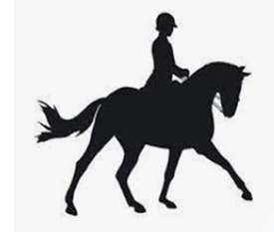
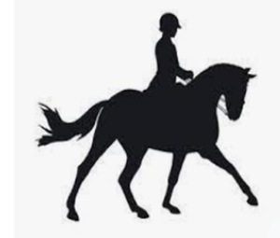
DRESSAGE – Friday 8 am
JUDGE: Jill Jardie

1. | Walk/Trot C Open | Sponsor – Fulcrum Group Chartered Accountants
2. | Training Level Test 1 Open | Sponsor – MD of Greenview
3. | First Level Test 1 Open | Sponsor – CK Vet Services
4. | First Level Test 2 Open | Sponsor – Above & Beyond Oilfield Services
5. | Test of Choice | Sponsor – Steve’s Pumpjack Services

WESTERN DRESSAGE
JUDGE: Jill Jardie

6. | Introductory Level Test A Open | Sponsor – McLean Environmental
7. | Basic Level Test A Open | Sponsor – Fulcrum Group Chartered Accountants
8. | Level 1 Test A Open | Sponsor – MD of Greenview
9. | Level 2 Test A Open | Sponsor – CK Vet Services
10. | Test of Choice | Sponosr – Above & Beyond Oilfield Services

RANCH HORSE COMPETITION – Friday 4 pm
JUDGE:

11. | Ranch Horse Competition | Sponsors – ARDY Rigging

SHOWMANSHIP & HALTER CLASS – Saturday 8:00 am
JUDGE – Jill Jardie

HALTER CLASSES
12. | Foals & Yearlings | Sponsor – Steve’s Pumpjack Services
13. | 2 & 3 Yr Olds | Sponsor – McLean Environmental Services
14. | Open Stallions – 4 yrs and older (More than 3 entries split class) | Sponsor – Keddies Tack & Western Wear
15. | Open Geldings & Mares – 4 Yrs and older | Sponsor–Wheelers Round-A-Bout Restaurant GC

SHOWMANSHIP CLASSES
16. | Senior Showmanship | Sponsor – Above & Beyond Oilfield Service
17. | Junior A Showmanship (4-H Incentive) | Sponsor – Steve’s Pumpjack Services (Diamond Hitch Contracting)
18. | Junior B Showmanship (4-H Incentive) | Sponsor – McLean Environmental Services (HiLine Dist.)
19. | Junior C Showmanship (4-H Incentive) | Sponsor – Fulcrum Group Chartered Accountants (Tomcat Welding)
20. | Shankless Showmanship - Open | Sponsor – Diamond Hitch Contracting

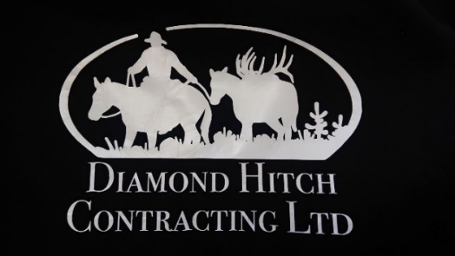
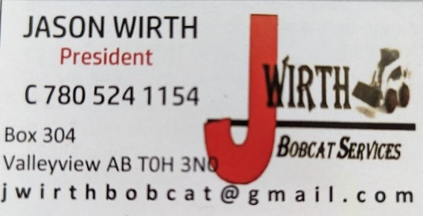

ENGLISH PERFORMANCE Following Showmanship
JUDGE – Jill Jardie
21. | Senior English Pleasure | Sponsor – HiLine Distributors
22. | Junior A English Pleasure (4-H Incentive) | Sponsor – Tomcat Welding (MD of Greenview)
23. | Junior B English Pleasure (4-H Incentive) | Sponsor – 7 Point Contracting (Above & Beyond)
24. | Junior C English Pleasure (4-H Incentive) | Sponsor – Tyler & Shelby Penner & Family (Steve’s Pumpjack Services)
25. | Peewee English Pleasure | Sponsor – J. Wirth Bobcat Services
26. | English Pleasure Maiden Horse | Sponsor – Leo & Marlene Marcotte
27. | Older Than God English Pleasure | Sponsor – Tyler & Shelby Penner & Family
28. | Draft English/Western Pleasure | Sponsor – Lois Goodrich
29. | Senior English Equitation | Sponsor – McLean Environmental Services
30. | Junior A English Equitation (4-H Incentive) | Sponsor – MD of Greenview (Above & Beyond)
31. | Junior B English Equitation (4-H Incentive) | Sponsor – Above & Beyond Oilfield Services (Steve’s Pumpjack Services)
32. | Junior C English Equitation (4-H Incentive) | Sponsor – Steve’s Pumpjack Services (MD of Greenview)
33. | Peewee English Equitation | Sponsor – Fulcrum Group Chartered Accountants
34. | Draft/Draft Cross English/Western Equitation | Sponsor – Diamond Hitch Contracting

WESTERN CLASSES – 10:00 am
JUDGE – Jill Jardie

35. | Senior Western Pleasure | Sponsor – Keddies Tack & Western Wear
36. | Junior A Western Pleasure (4-H Incentive) | Sponsor – Keddies Tack & Western Wear (Metz Vet Services)
37. | Junior B Western Pleasure (4-H Incentive) | Sponsor – Keddies Tack & Western Wear (Metz Vet Services)
38. | Junior C Western Pleasure (4-H Incentive) | Sponsor – Keddies Tack & Western Wear (Metz Vet Services)
39. | Peewee Western Pleasure | Sponsor – Keddies Tack & Western Wear
40. | Western Pleasure Maiden Horse | Sponsor – Keddies Tack & Western Wear
41. | Older Than God Western Pleasure | Sponsor – Keddies Tack & Western Wear
42. | Senior Western Equitation | Sponsor – HiLine Distributors
43. | Junior A Western Equitation (4-H Incentive) | Sponsor – Tomcat Welding (Metz Vet Services)
44. | Junior B Western Equitation (4-H Incentive) | Sponsor – 7 Point Contracting
45. | Junior C Western Equitation (4-H Incentive) | Sponsor –McLean Environmental Services
46. | Peewee Western Equitation | Sponsor –MD of Greenview
TRAIL CLASSES (Open Gate 10am – 2pm)
JUDGE – Leo Marcotte
47. | Senior Trail | Sponsor – Above & Beyond Oilfield Services
48. | Junior A Trail (4-H Incentive) | Sponsor – Steve’s Pumpjack Services
49. | Junior B Trail (4-H Incentive) | Sponsor – Fulcrum Group Chartered Accountants
50. | Junior C Trail (4H Incentive) | Sponsor – Diamond Hitch Contracting
51. | Peewee Trail | Sponsor -HiLine Distributors
**Horse and rider combination can compete in 2 classes only**

COSTUME CLASS @ NOON
JUDGE – Jill Jardie

52. | Senior Costume $100 added plus 75% entry fees | Sponsor –
53. | Youth Costume 17 & Under | Sponsor –
There will be a short break for tack changes after the costume class

PEE WEE DIVISION (10 YEARS & UNDER) following Costume Class
JUDGE – Jill Jardie
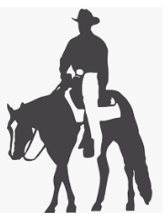
54. | Pee Wee Lead Line | Sponsor – Tomcat Welding
55. | Pee Wee Walk / Trot | Sponsor – 7 Point Contracting
56. | Pony & Pal **No cross entries with 59&60** | Sponsor – McLean Environmental
** No Cross Entries with Peewee Flat Classes**
Whatever Western Performance classes are remaining will continue

SUNDAY 8AM - FUN CLASSES
JUDGE: Jill Jardie

57. | Pairs | Sponsor – MD of Greenview
58. | Combination Sr/Jr | Sponsor – Above & Beyond Oilfield Services
59. | Two-Way Versatility | Sponsor – PineRiver Clydesdales (Kendra Harris)
60. | Ride-a-$5’er | Sponsor – Riders!
61. | Family Class | Sponsor -Steve’s Pumpjack Services
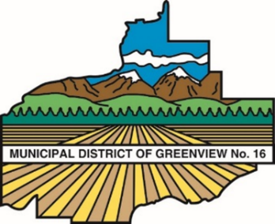

JUMPING – Following Fun Classes
JUDGE – Jill Jardie

62. | Senior Cross Rails | Sponsor – CK Vet Services
63. | Youth Cross Rails 17 Yrs & Under | Sponsor – CK Vet Services
64. | Hunter 2’-2’6” | Sponsor – CK Vet Services
65. | Hunter 2’-2’6” Equ. | Sponsor – CK Vet Services
66. | Hunter 2’6”-2’9” | Sponsor – CK Vet Services
67. | Hunter 2’6”-2’9” Equ | Sponsor – CK Vet Services
68. | Jumper 2’9”-3’ Table A | Sponsor – CK Vet Services
69. | 4 Bar | Sponsor – CK Vet Services
** Only enter 2 consecutive divisions**

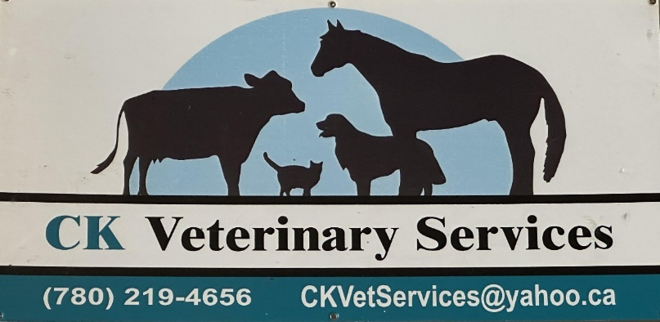

REINING – Following Jumping
Judge: Jill Jardie

70. | Youth Reining | Sponsor – Keddies Tack & Western Wear
71. | Ranch Reining | Sponsor - Keddies Tack & Western Wear
72. | Short Stirrup (10 yrs and under) | Sponsor - Keddies Tack & Western Wear
73. | Open Reining | Sponsor - Keddies Tack & Western Wear
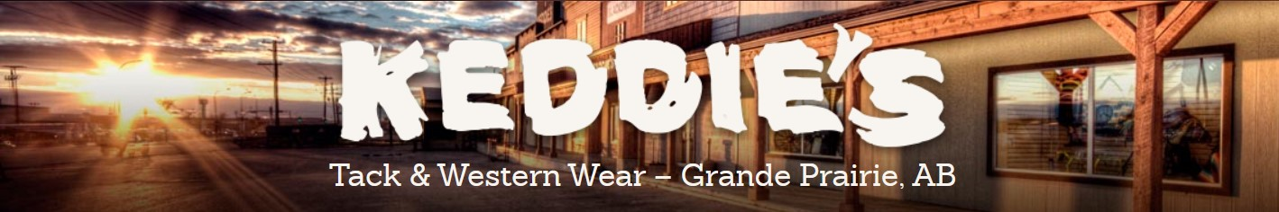

Valleyview & Districts Agricultural Society
All Breed Horse Show June 30 – July 2, 2023
Registration Package
*******Please complete separate form for each Horse/Rider combination*******

Rider |  | Show Number
AEF #
Horse Name
Horse Owner  (If Different) |  | AEF#
Riders Address
Phone # |  | Age if Junior
E-mail

FEES
Total Entry Fee |  |  | $
Post Entry Fee ($20/Horse) |  |  | $
Shavings ($10/Bag) | # of Bags: |  | $
Outdoor Pens ($10/Day) | # of Days: |  | $
10x10 Box Stall ($20/Day) | # of Days: |  | $
Please check which days you need a stall/pen | Thurs: | Fri: | Sat: | Sun:
Box Stall Deposit (Separate cheque)(Returned when cleaned) | $25 ea.  # of Stalls: |  | $
Administration Fee (Mandatory) |  |  | $10.00
Number Deposit (Refunded on Return) |  |  | $10.00
TOTAL |  |  | $
GST 5% |  |  | $
Grand Total |  |  | $

Cheques made payable to: Valleyview & Districts Agricultural Society
Mailing address: Box 1226 Valleyview, AB T0H 3N0
Electronic registration & E-transfers: valleyviewagsociety@gmail.com

I have read the rules and regulations governing the Valleyview & Districts Agricultural Society All Breed Horse Show and agree to be bound by them. The Valleyview & Districts Agricultural Society, its executive, directors, members, volunteers, and officials accept no liability for any loss, accident, damage, or illness to spectators, horses or participants or their property.

Rider Signature: |  | Date:
Parent/Guardian Signature: |  | Date:
Horse Owner if Different: |  | Date:

Permission is hereby granted for the above-named junior exhibitor to participate. It is agreed that they shall be bound by the conditions set forth in the show book.
Children under 18 must have adult supervision while participating in the show.

Valleyview & Districts Agricultural Society
All Breed Horse Show
June 30 – July 2, 2023

ENGLISH DRESSAGE Friday 8am |  |  |  | WESTERN DRESSAGE Friday
$15 | 1. |  | Walk/Trot Open | $15 | 6. |  | Introductory Level Test A Open
$15 | 2. |  | Training Level Test 1 Open | $15 | 7. |  | Basic Level Test A Open
$15 | 3. |  | First Level Test 1 Open | $15 | 8. |  | Level 1 Test A Open
$15 | 4. |  | First Level Test 2 Open | $15 | 9. |  | Level 2 Test A Open
$15 | 5. |  | Test of Choice | $15 | 10. |  | Test of Choice
 |  |  | Total English Dressage |  |  |  | Total Western Dressage

RANCH HORSE COMPETITION Friday 4pm
$100 | 11. |  | Ranch Horse Competition

HALTER Saturday 8am |  |  |  |  | SHOWMANSHIP Saturday
$5 | 12. |  |  | Foal & Yearling | $5 | 16. |  | SR Showmanship
$5 | 13. |  |  | 2 & 3 Year Old | $5 | 17. |  | JR A Showmanship
$5 | 14. |  |  | Open Stallions, 4 Years & Over, |  |  |  | JR A 4H Incentive
$5 | 15. |  |  | Open Geldings & Mares, 4 Year Olds & Over | $5 | 18. |  | JR B Showmanship
 |  |  | TOTAL HALTER |  |  |  |  | JR B 4H Incentive
 |  |  |  |  | $5 | 19. |  | JR C Showmanship
 |  |  |  |  |  |  |  | JR C 4H Incentive
 |  |  |  |  | $5 | 20. |  | Shankless Showmanship
 |  |  |  |  |  |  |  |  | TOTAL SHOWMANSHIP

ENGLISH PREFORMANCE Saturday |  |  |  | WESTERN PREFORMANCE Saturday
$5 | 21. |  | SR English Pleasure | $5 | 35. |  | SR Western Pleasure
$5 | 22. |  | JR A English Pleasure | $5 | 36. |  | JR A Western Pleasure
 |  |  | JR A 4H Incentive |  |  |  | JR A 4H Incentive
$5 | 23. |  | JR B English Pleasure | $5 | 37. |  | JR B Western Pleasure
 |  |  | JR B 4H Incentive |  |  |  | JR B 4H Incentive
$5 | 24. |  | JR C English Pleasure | $5 | 38. |  | JR C Western Pleasure
 |  |  | JR C 4H Incentive |  |  |  | JR C 4H Incentive
$5 | 25. |  | Peewee English Pleasure | $5 | 39. |  | Peewee Western Pleasure
$5 | 26. |  | English Pleasure Maiden Horse | $5 | 40. |  | Western Pleasure Maiden Horse
$5 | 27. |  | English Pleasure Older Than God | $5 | 41. |  | Western Pleasure Older Than God
$5 | 28. |  | Draft E/W Pleasure | $5 | 42. |  | SR Western Equitation
$5 | 29. |  | SR English Equitation | $5 | 43. |  | JR A Western Equitation
 | 30. |  | JR A English Equitation |  |  |  | JR A 4H Incentive
$5 |  |  | JR A 4H Incentive | $5 | 44. |  | JR B Western Equitation
 | 31. |  | JR B English Equitation |  |  |  | JR B 4H Incentive
$5 |  |  | JR B 4H Incentive | $5 | 45. |  | JR C Western Equitation
 | 32. |  | JR C English Equitation |  |  |  | JR C 4H Incentive
$5 |  |  | JR C 4H Incentive | $5 | 46. |  | Peewee Western Equitation
$5 | 33. |  | Peewee English Equitation
$5 | 34. |  | Draft E/W Equitation
 |  |  | TOTAL ENGLISH PREFORMANCE |  |  |  | TOTAL WESTERN PREFORMANCE

TRAIL Open Gate Saturday 10am-2pm |  |  |  | COSTUME & PEEWEE Saturday 12 Noon
$5 | 47. |  | SR Trail | $5 | 52. |  | Sr Costume
$5 | 48. |  | Jr A Trail | $5 | 53. |  | Youth Costume
$5 | 49. |  | JR B Trail | $5 | 54. |  | Peewee Lead Line
$5 | 50. |  | JR C Trail | $5 | 55. |  | Peewee Walk / Trot
$5 | 51. |  | Peewee Trail | $5 | 56. |  | Pony & Pal
 |  |  | TOTAL TRAIL |  |  |  | TOTAL COSTUME & PEEWEE

FUN CLASSES Sunday 8am |  |  |  |  |  | REINING Sunday Following Jumping
$5 | 57. |  |  |  | Pairs | $5 | 70. |  | Youth Reining
$5 | 58. |  |  |  | Combination JR & SR | $5 | 71. |  | Ranch Reining
$5 | 59. |  |  |  | Two-Way Versatility | $5 | 72. |  | Short Stirrup (10 & Under)
$5 | 60. |  |  |  | Ride-a-5’er | $5 | 73. |  | Open Reining
$5 | 61. |  |  |  | Family Class
 |  |  |  |  | TOTAL FUN CLASSES
JUMPING Sunday Following Fun Classes
$15 |  | 62. |  | Crossrails Over Fences
$15 |  | 63. |  | Crossrails Over Fences
$15 |  | 64. |  | Hunter 2’-2’6”
$15 |  | 65. |  | Hunter 2’-2’6” Equitation
$15 |  | 66. |  | Hunter 2’6”-2’9”
$15 |  | 67. |  | Hunter 2’6”-2’9” Equitation
$15 |  | 68. |  | Jumper 2’9”-3’ Table A
$15 |  | 69. |  | 4 BAR
 |  |  |  | TOTAL JUMPING |  |  |  |  | TOTAL REINING

TOTAL EVENTS
Dressage | Friday
Western Dressage | Friday
Ranch Horse | Friday
Halter | Saturday
Showmanship | Saturday
English Performance | Saturday
Western Performance | Saturday
Fun Classes (Costume, Leadlines, Trail, Fun Classes, Reining)
Jumping | Sunday
TOTAL

VALLEYVIEW & DISTRICTS AGRICULTURAL SOCIETY
LIABILITY WAIVER
This document will affect your legal rights and liabilities
**PLEASE READ CAREFULLY**

I acknowledge that the sport of horses is a high risk sport and that I am participating at my own risk and in full knowledge of the hazards and potential hazards inherent in this sport. I further acknowledge the inherent risk in riding and working around horses, which risks include bodily injury to both horse and rider which can result from normal use, competition or schooling.

In consideration of being allowed to participate in this event, I hereby assume all risk and hereby absolve the Valleyview & Districts Agricultural Society, their directors, officers, employees, volunteers, agents and their representative from all responsibility, liability or claims of any nature which I may have arising from my activities in this activity, including but not limited to bodily injury or death to myself or my horse(s) and damages to property arising from any cause whatever, including the negligence of one or more individuals and organizations referred to herein.

I hereby declare that in signing this document, that I have read and fully understood and agree to the terms and conditions stated herein and that is binding upon my executors, heirs or assigns.

Signature of Rider___________________________ Date_____________
(If rider is under 18 years of age, the Parent/Guardian must also sign)

I acknowledge as Parent/Guardian of __________________________that I have read
(Riders’ Name)
and fully understood and agree to the terms and conditions stated herein on behalf of
___________________________and myself.
(Rider’s Name)

Signature of Parent/Guardian_____________________ Date____________

PERMISSION FOR PUBLICATION OF NAME AND/OR PHOTOGRAPH

I hereby give permission for my name and/or photograph to be used for advertising as deemed necessary by the Valleyview & Districts Agricultural Society. This can include newspaper results, Thank You’s, newsletters, on the website and in the prize list, horse show promotion.

Childs’ Name: ____________________________________________________

Parent Signature (if child under 18)___________________________________

Adult Name: _____________________________________________________

Adult Signature: __________________________________________________

Date: ___________________________________________________________

