Looking for a Halloween Solution?
TRY A HORSEY HALLOWEEN
A Spooktacular Family Photo Event
at the Valleyview Ag Plex 3-8 on October 31, 2020

Choose from 8 different Photo booths with horses in costumes:
Paw Patrol Dragon and Castle
Superheroes Headless Horseman
Unicorn Country Fall Scene
Wizard of Oz or Dinosaur theme HYPO ALLERGENIC- 3D Fall festival Frame
(Horse themed but no live horse)
Each memorable background is $20/spot + $1.00 GST. 5 pics per background so you can add/delete people. NO charge for extra people in the pic for 2020.
Avoid line ups on the day. Book your time to guarantee your spot. The horses are waiting!
Pay by etransfer to valleyviewagsociety@gmail.com
Call Joanne at 780-524-3473 or Crystal at 587-985-6595 to book and confirm time.
This event will follow current COVID Protocols. Due to social distancing requirements, spots are limited to 4 groups per hour per booth so book early to get the spot or spots of your choice.
We will be gifting candy to the children at the end of the photo shoot.
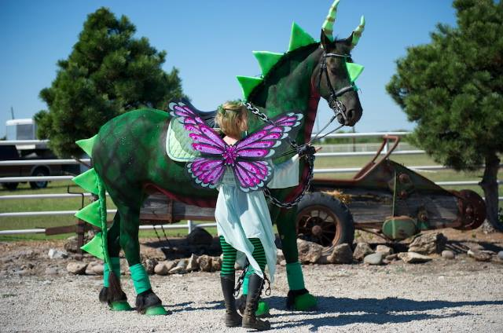

ALL AGES WELCOME!
We can make “on the horse” or “off the horse” options available so include gran and the newborn!

