May
2021
Valleyview & Districts Agricultural Society
Events  Only scheduled Drop ins at this time. Please call  780-524-3473 to book a time. Thank you  Board Meeting May 19, 6:30 pm | 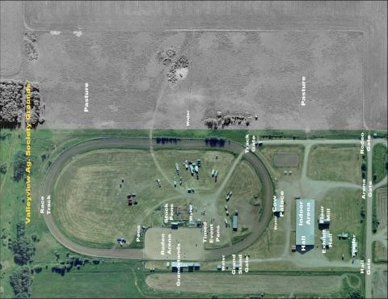
Sunday | Monday | Tuesday | Wednesday | Thursday | Friday | Saturday
1
11-12 Marcel

2 | 3 | 4 | 5 | 6  5-8 4-H  8-9KH | 7 | 8  11-12 Marcel  So you want to Ride a Horse  Postponed
9 | 10 | 11  6-7 DW | 12 | 13  5-8 4-H  8-9KH | 14 | 15  11-12 Marcel
16 | 17 | 18  6-7 DW | 19  4-6 | 20  4-6 | 21 | 22  11-12 Marcel
23 | 24 | 25  4-6 | 26  4-6 | 27  4-6 | 28 | 29  11-12 Marcel
30 | 31

June
2021
Valleyview & Districts Agricultural Society
Events  Only scheduled drop ins allowed at this time. Please call ahead to book your time.  780 524-3473. Members can ride with a scheduled drop in when the arena is not booked. Indoor and outdoor arena available.  Please contact Chrystal @ 587-985-6595 to book Discovery Series  Next Board Meeting: June 16 @ 6:30 p.m. | 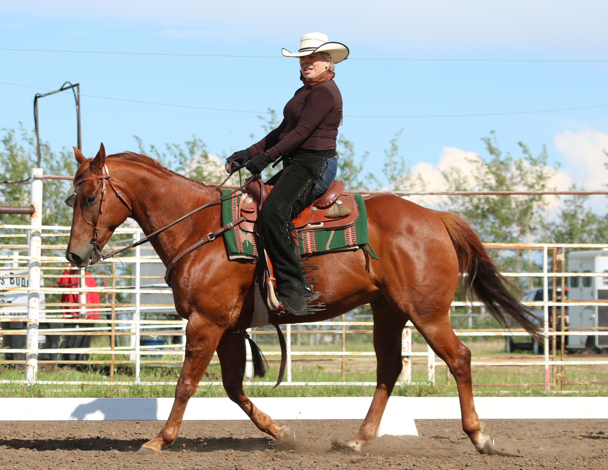
Sunday | Monday | Tuesday | Wednesday | Thursday | Friday | Saturday
 |  | 1  6-7 DW | 2 | 3  5-8 4H  8-9 KH | 4  Gymkhana & Games | 5  11-12 Marcel  1pm-8pm 4-H Set-up
6 | 7 | 8  6-7 DW | 9 | 10  5-8 4-H  8-9 KH | 11 | 12
13 | 14 | 15  7-8 DW | 16 | 17  5-8 4-H  8-9 KH | 18 | 19
20 | 21 | 22  7-8 DW | 23 | 24  5-8 4-H  8-9 KH | 25 | 26  So You Want to ride a horse
27 | 28 | 29  7-8 DW | 30

July
2021
Valleyview & Districts Agricultural Society
Events  Please contact Chrystal @ 587-985-6595 to book Discovery Series | 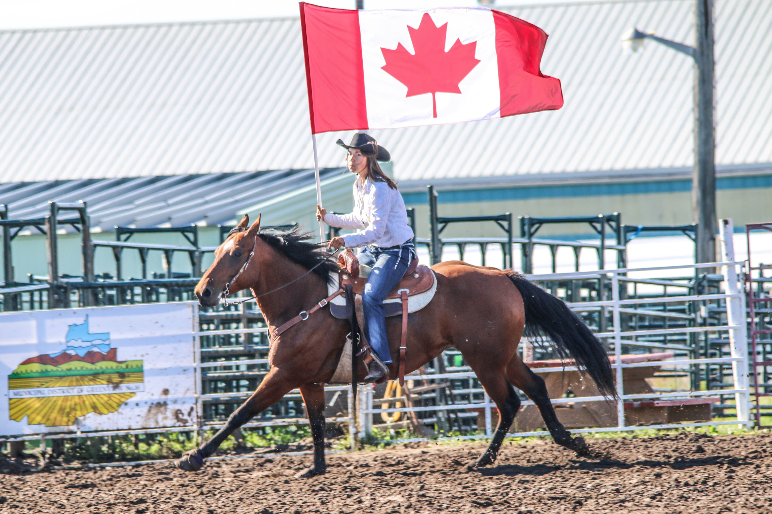
Sunday | Monday | Tuesday | Wednesday | Thursday | Friday | Saturday
 |  |  |  | 1 | 2 | 3
4 | 5 | 6 | 7 | 8 | 9 | 10
 |  | 7-8 DW |  |  |  | So you want to try Western Dressage
11 | 12 | 13 | 14 | 15 | 16 | 17
18 | 19 | 20 | 21 | 22 | 23 | 24
 |  |  |  |  |  | So you want to ride a horse
25 | 26 | 27 | 28 | 29 | 30 | 31

August
2021
Valleyview & Districts Agricultural Society
Events  Annual Fair & Rodeo August 13-15 (tentative)  Horse Show August in person or online depending on approval  Please contact Chrystal @ 587-985-6595 to book Discovery Series | 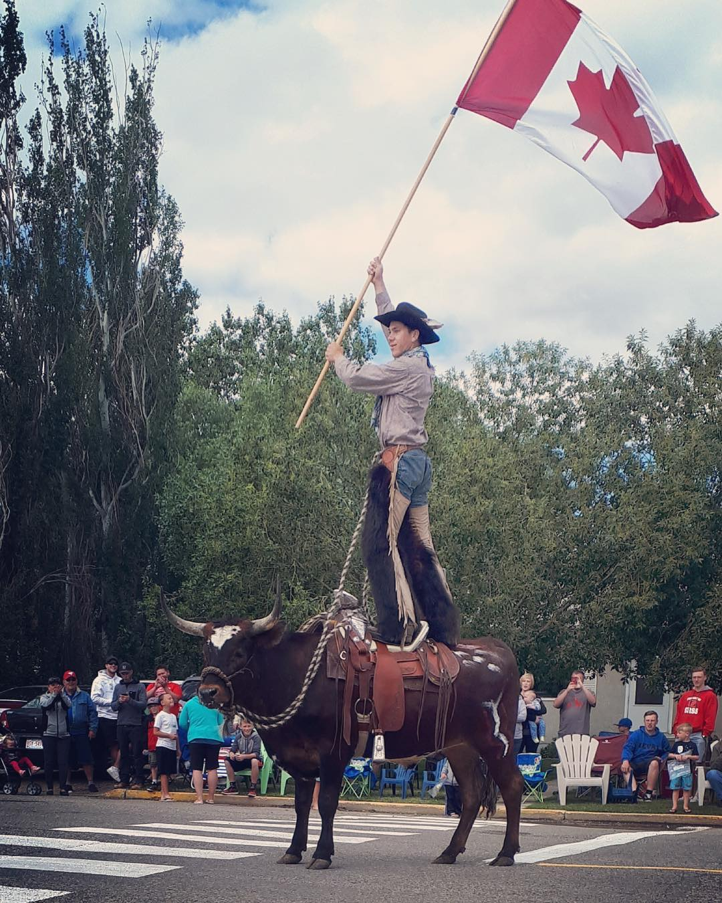
Sunday | Monday | Tuesday | Wednesday | Thursday | Friday | Saturday
1 | 2 | 3 | 4 | 5 | 6 | 7
 |  |  |  |  |  | So you want to Try Gymkhana
8 | 9 | 10 | 11 | 12 | 13 | 14
 |  |  |  |  | Rodeo | Rodeo
15 | 16 | 17 | 18 | 19 | 20 | 21
Rodeo |  |  |  |  |  | Horse Show
22 | 23 | 24 | 25 | 26 | 27 | 28
29 | 30 | 31

September
2021
Valleyview & Districts Agricultural Society

Events
A BIG THANK YOU to all the Sponsors and Volunteers that help us through out the year. Your support is VERY MUCH APPRECIATED.
Sunday | Monday | Tuesday | Wednesday | Thursday | Friday | Saturday
 |  |  | 1 | 2 | 3 | 4
5 | 6 | 7 | 8 | 9 | 10 | 11
 |  |  |  |  |  | Mounted Archery Clinic
12 | 13 | 14 | 15 | 16 | 17 | 18
Mounted Archery Clinic |  |  |  |  |  | Ladies Retreat
19 | 20 | 21 | 22 | 23 | 24 | 25
26 | 27 | 28 | 29 | 30

October
2021
VALLEYVIEW & DISTRICTS AGRICULTURAL SOCIETY
EVENTS | 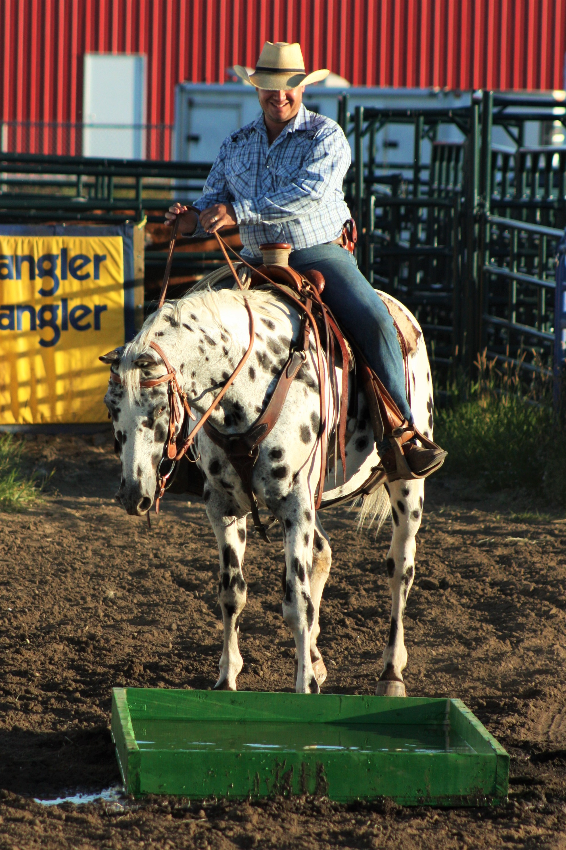
Sunday | Monday | Tuesday | Wednesday | Thursday | Friday | Saturday
 |  |  |  |  | 1 | 2
3 | 4 | 5 | 6 | 7 | 8 | 9
10 | 11 | 12 | 13 | 14 | 15 | 16
17 | 18 | 19 | 20 | 21 | 22 | 23
24 | 25 | 26 | 27 | 28 | 29 | 30
31

November
2021
VALLEYVIEW & DISTRICTS AGRICULTURAL SOCIETY
Events | 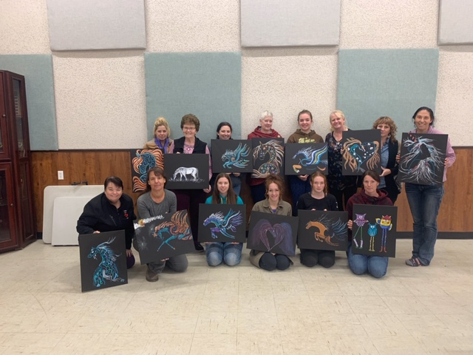
Sunday | Monday | Tuesday | Wednesday | Thursday | Friday | Saturday
 | 1 | 2 | 3 | 4 | 5 | 6
7 | 8 | 9 | 10 | 11 | 12 | 13
14 | 15 | 16 | 17 | 18 | 19 | 20
21 | 22 | 23 | 24 | 25 | 26 | 27
28 | 29 | 30

December
2021
VALLEYVIEW & DISTRICTS AGRICULTURAL SOCIETY
Events | 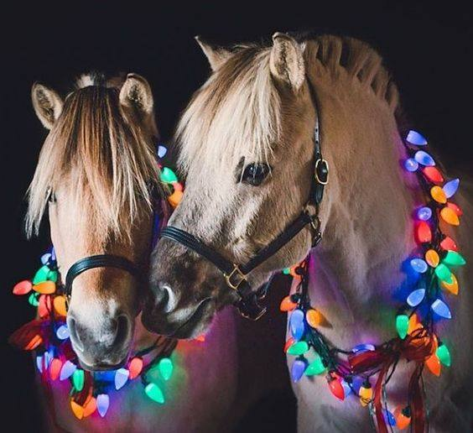
Sunday | Monday | Tuesday | Wednesday | Thursday | Friday | Saturday
 |  |  | 1 | 2 | 3 | 4
5 | 6 | 7 | 8 | 9 | 10 | 11
12 | 13 | 14 | 15 | 16 | 17 | 18
19 | 20 | 21 | 22 | 23 | 24 | 25
26 | 27 | 28 | 29 | 30 | 31

