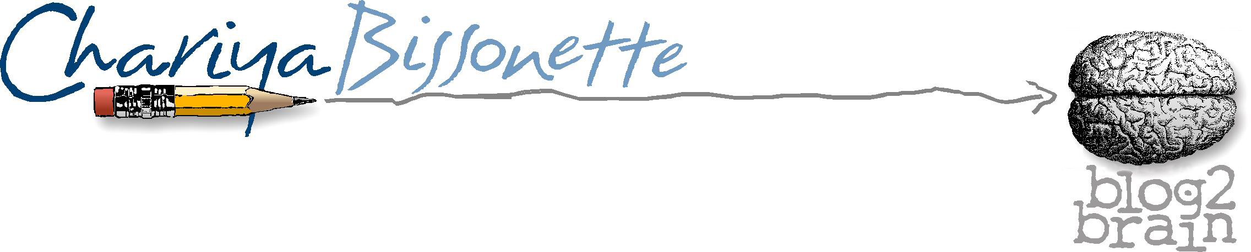
ONE PAGERS FOR THOUGHT: LIGHT IS NOT FORGOTTEN

When learning the Israeli self- defense discipline Hisardut, our instructor spoke to us specifically about knowing the location of all light switches. This small awareness could give an advantage in a fight. Immediately, everyone thought about every light they knew.

Light is never forgotten.

Sometimes life presents the kind of struggles and challenges that can make you feel as though morning will never come. You’re burning the candle on both ends. You’ve contacted everyone you know only to have silence in return. You find yourself tired but unable to stop. You look for answers from employers, teachers, doctors and friends. You search for something, anything to get you out of the desert…and still the season you find yourself in is dark and quiet.
Then you force yourself to think a positive thought. For a moment you think “I found the light once, I can find it again.”
You do your best and flail about like a blind bird searching for food. You outstretch your arms, your hands feeling the wall of life until you get to the switch. You flip it on. You get light.

Light is never forgotten.

Light is the break you get that takes you to the next place. Light is that kind word from a stranger as they open a door or pass you your morning brew. Light is the smile from a small child that reminds you to keep going and light is the memory of conquering difficult things in the past. Light is a mentor encouraging your strengths or a quote, sent to you by a friend that lightens the load. Light is the voice of a parent long gone or an invisible tap on the shoulder that reminds you to choose differently.

Though the darkness of night can be deep and engulfing, clarity comes in the morning.

Light is never forgotten.

