The Chateau Charly Summer Trumpet Break
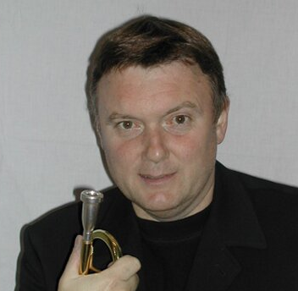
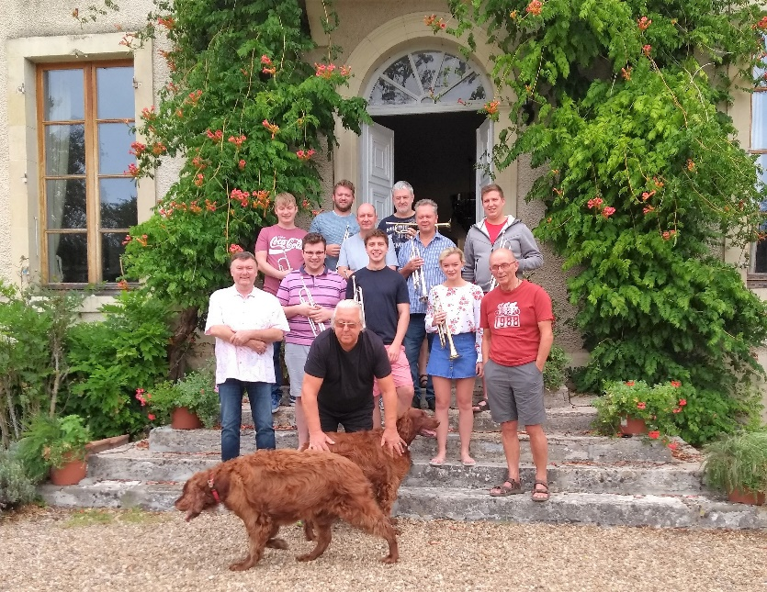

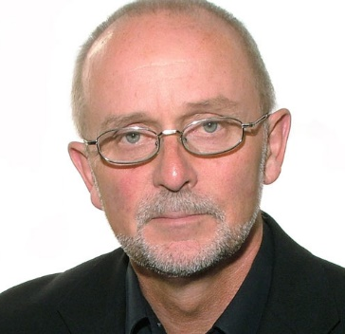

August 24th – August 31st 2019

A chance to enjoy a week of music making at the fabulous
Chateau Charly, in the beautiful Loire region of France
With International Trumpet Legends: Gareth Bimson (Co principal BBCSO),
Paul Cosh (Ex BBCSO & GSMD Prof.), Course Director & Host Phil Lawrence.
The Charly Summer Trumpet Break team places a high priority on creating a welcoming spirit of learning and sharing of ideas amongst all participants irrespective of age (18+ to 100+) or ability. We embrace trumpet & cornet players from across the world, from those in music institutions to passionate amateurs to semi-professional performers, Brass Band Cornet or Flugel players, and teachers.

Course Structure
The course has been designed for a limited number of participants (maximum 14) and is built on a variety of activities to provide personal attention to all participants and enable participants to explore performance and practice issues through;
- Warm ups and work on basic technical attributes,
- Fully interactive workshops and discussions with topics based on themes set by the coaches as well as participants
- Personal tutorials,
- Guided Listening to recorded trumpet repertoire, both solo, orchestral and other styles
- Orchestral & band repertoire sectionals
- Masterclasses including participants chosen solo repertoire
- Ensemble sessions with coaches in preparation for the final concert
These activities will be led by Paul Cosh, BBC Symphony Orchestra 1987 – 2005 and Professor at the Guildhall School of Music and Drama 1984 - 2014, Gareth Bimson Co-principal Trumpet BBC Symphony Orchestra. Ensembles Phil Lawrence.

All performance activities will be held in a supportive
and encouraging atmosphere.

The course will be conducted in English.

Participants
The minimum standard of performance required can be measured using the repertoire list from the ABRSM trumpet grading repertoire, as listed on their website for grades VI, VII & VIII
http://shop.abrsm.org/shop/syllabus/
For participants we suggest you prepare at least two contrasting pieces of your own choice, or pieces from the ABRSM lists (single movements of concerti are acceptable) or that are of a similar standard. These are for use in the masterclasses. Most of the playing will on the Bb or C trumpet/cornet/flugel with opportunities for Eb and piccolo in some of the repertoire for ensembles and classes.
As the course has a limited number of participants there is an applicant selection process. We ask that you submit a short CV, stating your age, playing experience and aspirations. Application form at end of this information pack. Closing date for applications, via email please, will be on May 1st 12pm 2019. Applicants will be advised whether they have been accepted on the course on May 8th.

Chateau Charly
Chateau Charly (www.chateaucharly.com) is set in 32 tranquil acres of garden, parkland, orchard and fields and is located in the beautiful Berry area of the Central Loire valley, just 2 hours south of Paris.
There are 6 airports within 1 ½ to 2 ½ hours drive; Paris, Chateauroux, Tours, Limoges, Poitiers & Clermont Ferrand. There are direct trains from Paris to 2 mainline stations just 30 minutes drive away (Bourges or Nevers). There are direct trains from Tours to Bourges.
Many guests have commented that travelling by Eurostar/SNCF from London to Bourges is quicker and easier than flying to France. It can also be just as cheap as Ryanair etc. if you want to take a lot of luggage and book well in advance.
From the ferry port of Calais it is about 5 ½ hours drive.
Budget travel options are buses, such as Flixbus, which travel from London to Paris to Bourges. There are a number of different operators. Typical charges if purchased in advance; c. €40 single London to Bourges via Paris, c €15 single Paris to Bourges.
We offer a pickup service from Bourges or Nevers at 5pm Aug 24th and a drop off at 9am on Aug 31st. A request for this service needs to be indicated at least 1 week before commencement, i.e. August 17th, 2019.

Course Cost
The course provides a full 6 days of music activity with 24th Aug & 31st Aug designated travel days. The cost of this summer trumpet break course is £700 including breakfast, lunch & dinner. Chateau Charly also offers an "honesty" bar. You can help yourself to wine, beer or soft drinks and record what you have taken so that you can pay at the end of the week.
For accepted course applications (as advised May 8th ) a deposit of £175 (25%) is payable by May 31st through bank transfer. The balance £525 (75%) is due 4 weeks before the course commences, July 28th, 2019.

Chateau Charly Accommodation
Participants will be accommodated in the fabulous Chateau Charly (www.chateaucharly.com) which has luxury rooms with ensuites. Participants are expected to share the room with 1 or 2 other participants.
For further information on Chateau Charly see our facebook pages and www.chateaucharly.com

Chateau Charly Summer Trumpet Break 2019 APPLICATION
Please provide the following info:
Name
Age
Address
Email address
Telephone / Mobile
Short CV with information on playing experience/ teachers/ achievements and goals. Attach CV or summarise in brief here
The likely pieces you want to play in Masterclasses
Any dietary requirements

Would you like to be added to the participant chat group if selected | Yes / No

Closing date for applications May 1st, 2019.
SEND YOUR APPLICATION TO the course email address: philw.lawrence@gmail.com
If you have any questions please do not hesitate to ask via the course email address

