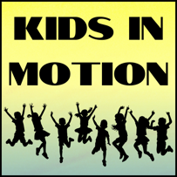

**Photography Authorization Form**  
**Kids In Motion Physical Education Program**

**Dear Parents,**

With the widespread use of digital and video cameras, we can document our activities and all the fun we have in our program. These images may be used for promotional purposes (both online and in print) or kept as part of our records. Occasionally, we may also invite the press to cover events, which could result in your child’s photograph appearing in newspapers or other media.

To comply with the Data Protection Act 1998, we are required to obtain written parental consent before taking or using photographs of your child. Without your consent, your child will not be included in any photographs or videos, which may limit their participation in certain activities or events when filming.

We understand that this may seem like additional paperwork, but it is essential that we adhere to legal requirements. Please complete and return the form below to indicate your consent.

Yours Sincerely,

Kids In Motion

__________________________________________________________________________________________

I, ______________________________ (Parent/Guardian Name), the parent/guardian of _________________________________________(Child’s Name), authorize for my child to have their photograph taken during the Kids In Motion program/events and for these photographs to be used in any promotional literature for the program.

Signature: _______________________________________________Date: _____________________________