

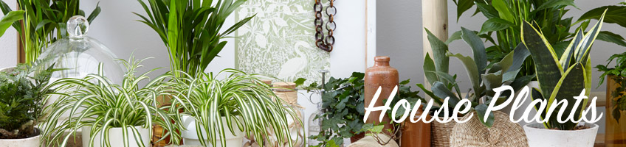
2107 Hwy 691 Denison, Texas 903-463-2205

Tips for Bringing In Your HousePlants
Bring houseplants in well before the first frost: Some House Plants need to be inside when temperatures fall into the 40’s at nights
Check plants thoroughly for pests
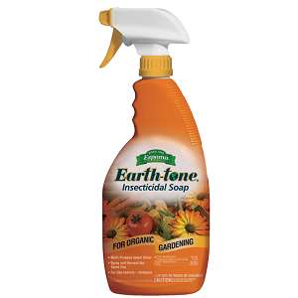
Clean - Wash foliage thoroughly with plain water – or –Soil Mender “PLANT WASH” (A natural cleanser for all plants) Be sure to clean BOTH TOP AND BOTTOMS OF LEAVES...... you don't want to bring unwanted guests like spiders or aphids into the house.
Use an Insecticidal Soap - such as "Espoma Earth Tome" Insecticidal Soap - Just spray on the plant - NO MIXING !! Spray on top & on the Bottom of the Leaves. * Pests can hide in many places on the plants, especially on the undersides of the leaves. Don’t bring the plant inside with other plants until you are sure it is pest-free.
Clean Pots: Use Scrub the outside of the pots thoroughly with Steel Wool Pad( Terra Cotta Pots) and a Nylon Scouring Pad(Glazed Pots) dipped in a mild soap and water solution to remove dirt, mold & any hidden insects.
Water & Light: AVOID OVER WATERING .... Plants that you watered every day while outside will not need as much water inside the house. WAIT UNTIL THE SOIL IS DRY TO THE TOUCH BEFORE WATERING. Keep Plants away from heat registers & cold Drafts. Provide plenty of light.
** INVEST IN A MOISTURE METER IF UNSURE ABOUT WATERING.
More Houseplants Die from OVERWATERING than from lack of water.

