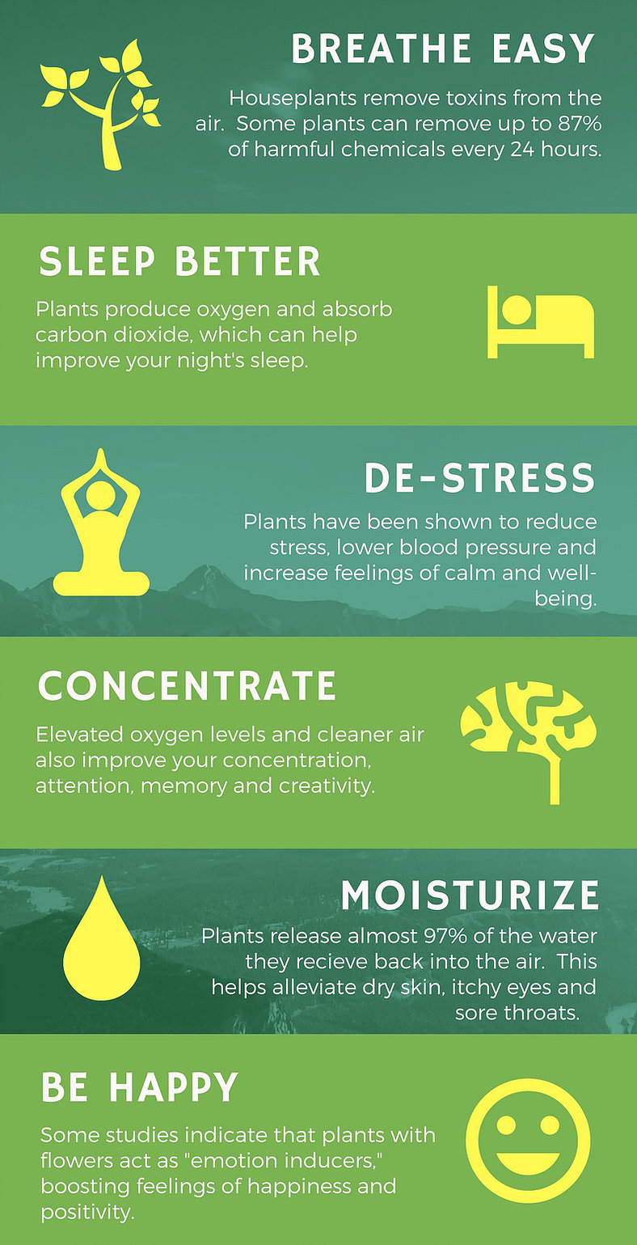

HOUSEPLANTS

Houseplants are more
than just pretty decorations.

Study after study has
shown that living with
plants provides real,
measurable health benefits.

Houseplants can improve
your health, lift your mood
and even
make you more productive.

With a houseful of plants
around you,
you'll be able to.......

