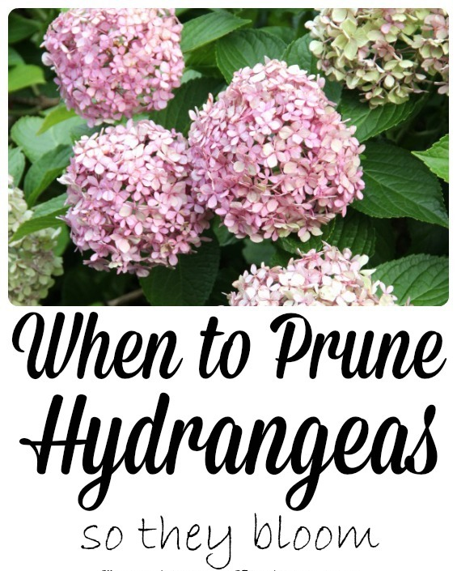

There are 3 Types of Hydrangeas

** Old Wood Hydrangeas
Mophead, Lacecap & Oakleaf Hydrangeas bloom on old wood meaning that their buds start to form in the fall for next summer’s blooms.
If they are trimmed in the fall, winter or spring, all of those precious buds will be removed and your summer hydrangeas will be flowerless.
. Prune just after the blooming peak. Since these types of hydrangeas start producing buds soon after blooming, It is essential to prune them just as the blooms begin to fade. This way you can trim the shrub before it begins to produce the buds that will turn into next year's flowers. The longer you wait, the likelier it will be that you'll cut off some of next year's growth

** New Wood Hydrangeas
PeeGees and Annabelle hydrangeas bloom on new wood meaning they can be pruned in the Late Fall /Early Winter and will bloom on new stems next year. You can cut back all the stems by 1/3 in the winter. Pruning at this time will help the shrub produce bigger, showier flowers.

** Everbloomer Hydrangeas
There is a group of mopheads that bloom on Old & New Wood – one common type is called Endless Summer.
Endless Summer hydrangeas require very little pruning day-to-day, so you are able to simply enjoy the beautiful plants. These perennial hydrangeas bloom on growth from the current year as well as previous years, which allows for the re-blooming throughout the summer.

Twin Oaks Nursery – 2107 Hwy 691 Denison, Texas

