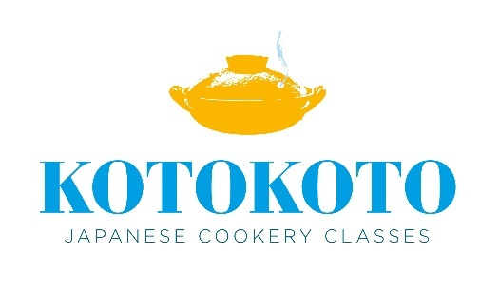

KOTOKOTO’s Terms and Conditions

Thank you very much for your inquiry. Please read the following before booking. Before you book, please ensure that everyone in your party agrees to these Terms & Conditions.

1. Bookings need to be made at least 21 days in advance as I might need to organise an assistant to accompany me.
2. Bookings will be confirmed upon receipt of full payment.
3. One payment per booking (party) only to be made.
4. Any cancellation is non-refundable.
5. If you are unable to attend a class due to adverse weather conditions, illness or other personal circumstances, cancellation will be transferrable to a later date within a 12month period. You can transfer the class only once.
6. Please inform me of any food allergies, intolerances or anything else that I should be aware of, at time of booking.
7. Please pay by BACS. I would really appreciate it if you could send me a quick email once you’ve made the payment. Many thanks.

Bank Name: Triodos Bank

Account Name: Mrs Y Lewis

Sort Code: 16-58-10

Account Number: 22229515

If you have any questions or request, please do not hesitate to contact me on [kotokotocookery@gmail.com](mailto:kotokotocookery@gmail.com)