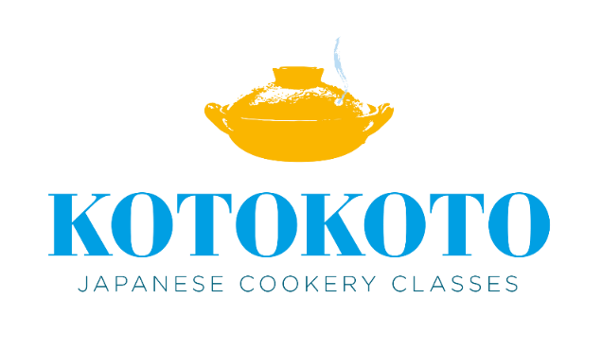

KOTOKOTO’s Terms and Conditions for open classes

Thank you very much for your inquiry. Please read the following before booking.

1. Bookings need to be made 7 days in advance.
2. Bookings will be confirmed upon receipt of full payment.
3. Any cancellation is non-refundable.
4. If you are unable to attend a class due to adverse weather conditions, illness or other personal circumstances, cancellation will be transferrable to a later date within a 12month period. You can transfer the class only once.
5. The minimum number for each class is two. If the number doesn’t reach the minimum at 12pm on the closing date, the class will be cancelled and you’ll be contacted to reschedule to a different date or have a refund.
6. Please inform me of any food allergies, intolerances or anything else that I should be aware of, at time of booking.
7. Please pay by BACS. I would really appreciate it if you could send me a quick email once you’ve made the payment. Many thanks.

Bank Name: Triodos Bank

Account Name: Mrs Y Lewis

Sort Code: 16-58-10

Account Number: 22229515

If you have any questions or request, please do not hesitate to contact me on [kotokotocookery@gmail.com](mailto:kotokotocookery@gmail.com)