LIBBE colon hydrotherapy open system
At EMMALAFON Wellness Center we use the LIBBE colon hydrotherapy open system (U.S. FDA approved) that effectively and safely cleanses the colon (large intestine) of waste and toxins. The procedure involves a soothing flow of purified, temperature-regulated water, instilled gently into the colon (large intestine) through a pencil-thin, sterile and disposable rectal tube. As the water gently circulates, it stimulates the colon’s natural peristaltic (action of the muscles of the colon) and this provides an excellent workout for the colon.
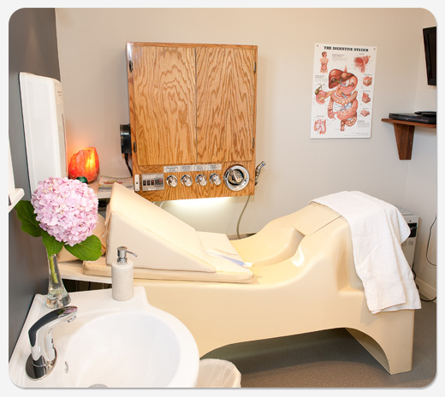
With its modern, safe, hygienic and very comfortable design, colonic irrigation LIBBE open system is considered as the "Rolls-Royce" of colon hydrotherapy. The specially designed bed allows you to easily insert the lubricated rectal tube by yourself. Your personal hygiene and privacy are maintained at all times. The LIBBE colonic irrigation open system is comfortable, painless and entirely odorless. The continuous inflow of water during the treatment provides natural, gentle and subsequent releases.
Anthony Robbins prefers the Libbe systems in his Fiji Wellness Centre.

Colonic treatment - what happens?
On your visits you will be warmly welcomed by Inka who is experienced, certified and internationally trained colon hydrotherapist.
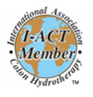Inka holds the qualification in the profession as Colon Hydrotherapist gained with the International Association of Colon Hydrotherapist (I-ACT).
I-ACT is the largest and longest established association for this profession in the world with 2500 members.

Treatment Information
The first visit includes consultation which covers health questionnaire review, digestive health discussion and full explanation of colonic treatment. You will follow the insertion procedure in the privacy of your treatment room. When ready and covered with the towel provided you will ring the bell and the therapist will enter the room to begin treatment. Your session will be monitored in person and a light massage may be applied to the abdomen to help dislodge toxic waste. Alternatively you can enjoy the treatment in your own privacy using a personal electronic massager, listening to soothing music or you can choose a DVD from our library to watch on screen if you wish.
Throughout the treatment you will receive the support and personal attention you deserve so your body can relax as much as possible. The treatment is painless, however some people may experience cramping or diarrhea feeling. This is a sign that the body is trying to shift some matter or to release gas.
After the treatment you will be given an electrolyte drink and probiotic supplementation to help re-establish the good bacteria.
Most people leave with a feeling of lightness, cleanliness, and happiness.

Frequently Asked Questions
What is the colon?
The colon (large bowel) is the final part of the digestive tract; it is about 1.5 m long and has an average diameter of 6 centimeters. Colon muscle moves digested food along by a wave-like motion known as peristalsis. The colon has an array of different functions. The major function of the large intestine is the formation and elimination of waste matter from our body. Additionally the colon also plays an essential role in protecting the body from infection and disease and is responsible for absorption large amount of water into the body. Beside water the colon absorbs mineral salts and vitamins mainly K and Bs. The colon helps to balance, oxygen, bacteria and pH of the body.
A healthy colon is essential to a healthy body. When the colon is working properly, its peristaltic motions move food through the system and eliminate unassimilated substances in the form of waste within 16-24 hours of eating (that means 2-3 bowel movements per day).
Will laxatives or enemas accomplish the same results as colon hydrotherpy?
Enema does not cleanse the entire colon. In contrast, during a colonic, the water goes all the way through the bowel to the illeocecal valve (this is where the small and large intestine meet). If you do not have access to a colonic, however, an enema can be a good option for immediately removing toxins.
Laxatives are an irritant. They produce a thin, watery substance full of toxins and waste that can accumulate on the walls of the colon. Our advanced LIBBE device can cleanse hard to reach places, such as the appendix area. We use 100% double purified water only that hydrate and tone the colon muscle walls.
Can one become dependent on it?
Colon hydrotherapy retrains the muscle of the bowel to regain strength. The bowel muscle is forced to work against the water, providing resistance much like a weight provides resistance against a muscle in bodybuilding. After the bowel has regained its strength, it works better on its own.
Is the procedure painful?
Rarely. Sometimes during the procedure, the muscles of the colon can contract suddenly, expelling considerable liquid and waste into the rectum. The contraction may feel like cramping or gas with pressure in the rectum. Most of the process however is mild and gentle, producing a light and empty sensation.
How much does it cost?
- Initial consultation - $35
- Initial consultation & treatment - $95
- Single treatment - $85
- Prepaid treatments - 3 sessions - $255
- Prepaid treatments - 6 sessions - $485
- Maintenance treatments after 6 sessions - $75 each
How should I prepare for a colonic?
We recommend you wait two hours after a meal before visiting us. It is more comfortable if you have an empty stomach. If possible, avoid processed food, dairy food, and animal protein for 2 days prior receiving a Colonic Hydrotherapy session. Eat lightly and plenty of fresh fruits and vegetables. Drink plenty of fluids, especially water several days before your treatment.
Arrive early, allowing time to relax before a colonic. It will facilitate better results. It may be more comfortable for you to wear a two-piece garment to your appointment.
What should I do after the colonic?
For best results, we recommend that you drink plenty of fluids and consume easily digestible food such as herbal teas, unsweetened fruit, or vegetable juices, steamed vegetables, fish, and soup. It is highly recommended that your everyday diet should include Probiotics, Fibre Mix, and Digestive Enzymes. This will help you to maintain proper bowel function. These products are available at our clinic.
What to expect after the colonic?
Most people feel a significant change. Probably you will feel lighter and enjoy a sense of wellbeing. Some people feel an immediate relief and experience a decrease in size and softening of the abdominal area. For some, the colonic treatment may trigger several bowel movements. A slight delay in bowel movements is the most common experience.
Will one cleansing completely empty the colon?
One session rarely accomplishes the desired result. Middle-age people often have 5 or more kilograms of impacted faecal matter in their colon. Substantial work must be done to remove this hardened, rubbery material. One cleansing typically only removes a portion of this material. Usually 6-12 sessions are required and should be completed within 6-8 weeks to meet each individual's needs.
How long does the session last?
Please allow 1 1/2hr (for the first treatment) and 1 hour for each subsequent visit.
To insure our next client is not inconvenienced, we will always finish your treatment on time, regardless of the time of your arrival.
What are the contraindications for Colon Hydrotherapy?
Abdominal Hernia, Abdominal Surgery (recent), Abnormal Distension, Acute Liver Failure, Anemia, Aneurysm – All Types, Cancer of the colon, Cardiac condition, Crohn`s Disease, Colitis, Dialysis Patient, Diverticulitis, Fissures & fistulas, Haemorrhaging, Hemorrhoidectomy, Intestinal Perforation, Lupus, Pregnancy, Rectal/colon surgery (recent), Renal Insufficiencies, Taking medication, which may weaken intestinal wall, Undiagnosed Abdominal Pain.

History of Colon Hydrotherapy
From Ancient Egypt to Modern Hollywood
Colonic irrigation is a brilliant ancient wisdom first recorded 1500B.C. in ancient Egyptian documents called “Ebers Papyrus”. Hypocrites, Galen and Pare also recognized use of enema for health benefits. Before the departure of the Lewis and Clarke expedition in 1804 a physician instructed them in the appropriateness of using enemas in cases of fever and illness. In the early 1900's in Battle Creek, Michigan Dr. John Harvey Kellogg, the famous surgeon father of Kellogg's Corn Flakes, used enemas on a regular basis. After he performed over 22,000 colon surgeries, Dr. Kellogg said he never saw a single normal healthy colon. In 1917 he reported in the Journal of the American Medical Association — that in all but 20 cases - he used no surgery for the treatment of gastrointestinal disease in his patients!
The popularity of colon therapy in the United States reached its apex in the 1920's and 1930's. At that time, colonic irrigation machines were commonly seen, and regularly used as a standard practice, in hospitals and physician's offices. According to several pioneers in this field, such as Bernard Jenson DC, PhD, Norman Walker DSc, PhD, Max Gerson MD, Leon Chaitow ND, Richard Anderson ND and others, the intestinal tract reflects and effects every organ of the body. Actually, every one of our organs reflects every part of the body. But it is most obvious and very much accessible to us to alter the health of our organs through the colonic procedure.
But in the ensuing 60 to 70 years the public's use and access to this valuable health treatment greatly decreased due to wide use of laxatives.
In recent years, getting a colonic treatment has again become increasingly popular. Princess Diana was an outspoken fan - British newspapers reported that she regularly used colonic to cleanse her colon. For many Hollywood celebrities both male and female colon hydrotherapy is the preferred cleansing procedure.
Such a long history of colonic irrigation proves how valuable this therapy is to overall ongoing maintenance of health. With the development of modern colon hydrotherapy machines, colonics are now safe and convenient.

Benefits of Colon Hydrotherapy
Scientific research shows that 80% of the immune system actually lives right in the digestive tract (60% in the colon and another 20% in the lower part of the small intestine). If unhealthy bacteria are ruling the digestive system, there is a good chance that the immune system will be suppressed as a result.
Emotion and digestion are strongly linked, as we can clearly see from the kind of language that we use to describe our responses to extreme emotional situations. If we are nervous, we have "butterflies in our stomach", if we find something unmanageable we "can't stomach it", if we suffer a loss we are “gutted". The digestive system can be an incredibly good barometer of our state of mind, and a wide array of acute and chronic digestive problems can stem from stress, creating an extremely unpleasant vicious circle that can be difficult to break out of.
Approximately 80 to 90 percent of the human body’s total serotonin is found in specialized cells in the gut, not in the brain. Serotonin is a chemical that helps maintain a "happy feeling. That could explain why so many people report a feeling of well being and uplifted mood after colonic hydrotherapy treatment.
The colon and the liver are responsible for excess hormones especially oestrogen. This is the reason why blocked colon and constipation can have an impact on hormonal health. Many naturopaths prescribe colonics to help reduce breast pain.
The state of the gut has a profound influence upon our health. It is from the healthy gut that we enjoy neurological and psychological as well as immunological health.
Similar to reflexology, colonics stimulate colon reflex points and then affect the corresponding body part in a beneficial way.
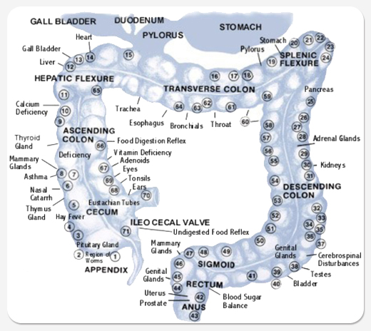
The primary goals of colon hydrotherapy are:
- Empty the bowel completely in order for lymph system to drain
- Remove mucous plague from the inner intestinal lining and relieve intestinal stress.
- Allow the liver to flush and release.
- Stimulate reflex points, exercise and reshape the colon muscle.
Experience has shown that colon hydrotherapy can also provide some of the following benefits:
- A general sense of wellbeing and rejuvenation
- Improved bowel function
- Regained muscle tone in the colon
- Improved digestion / metabolism
- Elimination of parasites
- Smaller and softer abdomen
- Improved absorption of nutrients
- Relieve from allergies
- Skin clearing and tightening
- Relief from headaches
- Improved mental alertness
- Increased energy
- Prevention of cancer and other diseases
All those who take advantage of colon hydrotherapy can be divided into two major groups:
- Those suffering from some digestive disorder or other health issue
- Those who see colonics as a way of toxin removal to maintain their health
Many clients use colonics as an important and specific tool:
- In place of laxatives for certain diagnostic tests involving the colon, as well as pre- and post-surgical procedures.
- for the athletes prior to intensive training and immediately after a sports event to improve metabolic efficiency or loosing weight before game
- models before photo shoot and stage performers to release toxicity and flatten the stomach
- taxi/ truck drivers, real estate agents and other professionals forced to neglect the urge to eliminate
- cancer patients, enhancing the elimination of toxins.
Colon Hydrotherapy works best when combined with a healthy diet and regular exercise.
“I place incredible demands on my body and I need to be sure my body continues to deliver. Regular cleansing is a crucial part of vibrant health and peak performance. Colon Hydrotherapy plays an essential role in sustaining my internal health and keeping my body in peak condition.” - Anthony Robbins

Contraindications
A contraindication is a condition or factor that serves as a reason to withhold a certain treatment.

Colon Hydrotherapy Contraindications
Abdominal Hernia, Abdominal Surgery (recent), Abnormal Distension, Acute Liver Failure, Anemia , Aneurysm – All Types, Cancer of the colon, Cardiac condition, Crohn`s Disease, Colitis, Dialysis Patient, Diverticulitis, Fissures & fistulas, Haemorrhaging, Hemorrhoidectomy, Intestinal Perforation, Lupus, Pregnancy, Rectal/colon surgery (recent), Renal Insufficiencies, Taking medication, which may weaken intestinal wall.

Colon disorders

Constipation
Constipation is clogging up of the large intestine and packed accumulated waste in the bowel makes evacuation difficult or infrequent. State of constipation can also exist regardless of daily movements when only part of the bowel contents is being emptied. One autopsy revealed a colon to be 9 inches in diameter with a passage through it no larger then a pencil!
Accumulated waste mater can stretch the bowel wall into enormous proportions called ballooned colon.
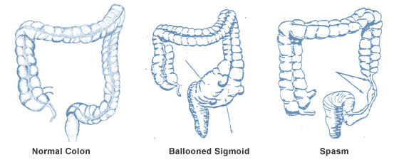
Intestinal constipation causes cellular constipation. The cellular metabolism become sluggish, repair and growth are delayed. It also increases the workload of the other excretory organs; kidney, skin, liver, and lymph. Constipation is a very common health issue where you may look to Colon Hydrotherapy for immediate relief. Because constipation involves the unnecessary retention of waste matter in the rectum and throughout the first half of the colon series of colonics is required.
Typical treatment of constipation is use of Laxatives, which act as colon irritant to promote bowel movement. Laxatives contribute nothing to restoration of the normal or natural process of defecation. Overuse of laxatives destroys the normal ability of the Bowel to eliminate on its own.

Diarrhea
Diarrhea is reverse of constipation. If the colon is damaged, inflamed or impacted, absorption of water is inhibited and watery stool results. Chronic diarrhea is most often due to the presence of irritation in the colon. Harmful bacteria, parasites, and the accumulation of stagnant mucous are generally high and they irritate the bowel. Chronic diarrhea will often respond remarkably to colon-cleansing program.

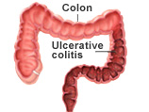Irritable Bowel Syndrome (IBS)
IBS it is also known as mucous colitis, spastic colon, and spastic constipation. IBS is commonly characterized by abdominal pain and altered constipation or/and diarrhea. Colon hydrotherapy combined with good nutrition and exercising can help to relieve these symptoms.

Bloating/Excessive gas
Bloating occurs, when pathogenic bacteria and yeast over growth, because of faecal compaction. Digestion always results in certain amount of fermentation. The quality, quantity and combination of food determine the amount of gas released into the body. The cells absorb released gas and must enlarge to accommodate excessive gas pressure. This fermentative gas can damage cells. Colon Hydrotherapy helps to remove the compaction and gas.

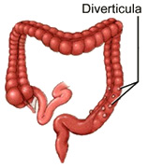Diverticulosis
Diverticulosis is the presence of multiple balloon-like sacs (diverticula) typically forms in an individuals suffering from constipation and excessive gas. These little diverticula usually form in the weakest area of the bowel and become source of powerful toxins. When infection develops condition is know as diverticulitis and can be dangerous. For those who wish to eliminate diverticula, series of colonic treatments should be taken combined with dietary changes.

Parasites
Parasites are organisms that live inside us so that we become their hosts. Since these parasites are unable to produce food for themselves, they depend on us for their survival. Unfortunately, parasites harm human beings because they consume our food and nutrients, they can destroy our tissues and cells, and they produce toxic waste products that can make people very ill. Parasitic infections can cause digestive disorders (bloating, constipation, diarrhea, gas, and irritable bowel and can also lead to allergies, anemia, chronic fatigue syndrome, immune dysfunction, joint and muscle pain, organ damage, skin problems, sleep disturbances, and teeth grinding. Colon hydrotherapy and Triplex herbal parasite cleanse are very effective way to get rid of parasites.

Candida
Candida develops over time as a side effect from taking antibiotics and indulging on cooked-starches and refined sugars. It is type of fungus that begins in the colon. When levels of good intestinal bacteria (probiotics) are low candida proliferates and extracts toxic waste that can get into the bloodstream and cause symptoms of bloating, diarrhea, headaches, depression, thrush, fungal nail condition.
The colon cleanse, probiotics supplementation and dietary changes will help remove the overgrowth of yeast, the toxic waste that it produces, as well as keep your system running normally again.

