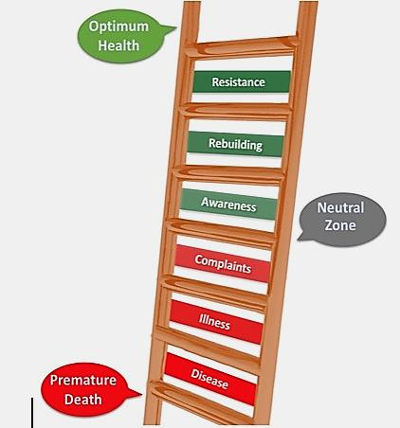

If diet is **WRONG,** medicine is of no use. If diet is **CORRECT,** medicine is of no need.

**Ancient Ayurvedic Proverb**

Where are you in here? Where do you want to be?

If you want to know more, please join us at our “life changing”

**FREE** “FRESH START” Cleanse Class

Register Now! Please call 206-354-2383!

**The Ladder of Health**