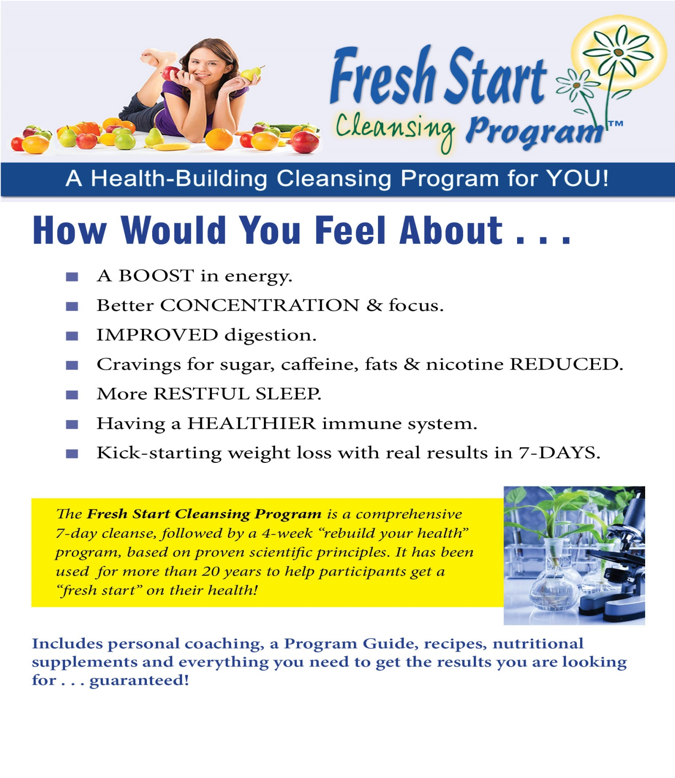

“You have all to gain and all to LOSE (“+lbs) by attending the class!” I can never eat or appreciated raw red onions—now it is sweet and sooo delicious!

Sue/ LA, CA

“I have learned so much n how and what to eat in the class, that I knew now what to buy when I do grocery. It is actually saving me money and no more rotted veggies and fruits in my fridge!

**By: DR. NEDRA SAHR** -- Board Certified Nutritionist, Masters in Clinical Nutrition, Science Team-Shaklee, Functional Medicine, American Nutrition Academy

**Are you willing to give *7 days of your life* for a lifetime of health & well-being?**