20 Young Terrace
Millstone, NJ 08510
FEATURES AND UPGRADES

COMMUNITY
- Most Desired Community in Millstone
- Abate Park located within community (walking distance)
- All Homes Luxury and immaculately maintained (huge for resale)

THE HOME
- Nearly 5000sf of finished space including
- 1400sf Newly Renovated Full Finished Basement with Wet Bar
- Upgrades galore with craftsman built ins and custom moldings throughout
- Wide Open Floor Plan
- Bosche Appliances in the Gourmet Kitchen
- Granite Countertops
- Award Winning Designer designed backyard Oasis Featuring:
- Heated, Saltwater, Self Cleaning Pool with Brand New Liner
- 1800sf 3 Level Paver Patio
- Sunken year round Hot Tub
- Amish Pool House with Kitchen, ½ Bath and Outdoor Shower
- New Roof (2024)
- New Pool Liner (2024)
- New Well (2023)
- New Oversized Septic System (2021)
- New A/C (2021)

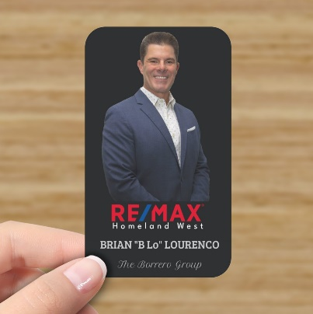
Brian Lourenco – ReMax Homeland – 732-266-5520

