Urgent & Serious Pathogen Checklist
For Charge Nurse, Shift supervisor or Administrator Enter name of person/s completing
Resident/Room # | Precautions | Date
Enter name and room number | Choose an item. | Click or tap to enter a date.
Task | Resource
☐Verify case -lab, report, history, colonization, infection, identify site Click or tap here to enter text. | Organism Click or tap here to enter text.  or Choose an item.
Initiate precautions  ☐Enhanced Barrier ☐Contact ☐Droplet ☐ Airborne  ☐ Isolation signs in place  Roommate status  ☐moved ☐screened  ☐ no medical devices in roommate  ☐if more than one case, cohort, or cluster  ☐set up PPE cart outside of room  ☐gown ☐gloves ☐mask  ☐ABHS available  ☐N95 respirator  ☐eye protection  ☐dedicate equipment, bp cuff, stethoscope, glucometer, Or disposable  ☐assign staff/dept. responsible for stocking PPE cart each shift or day Enter dept/person responsible | CDC Link EBP  - Implementation of Personal Protective Equipment (PPE) Use in Nursing Homes to Prevent Spread of Multidrug-resistant Organisms (MDROs) (cdc.gov)  Pocket Guide for Staff EBP  - Enhanced Barrier Precautions (EBP) – Pocket Guide (cdc.gov)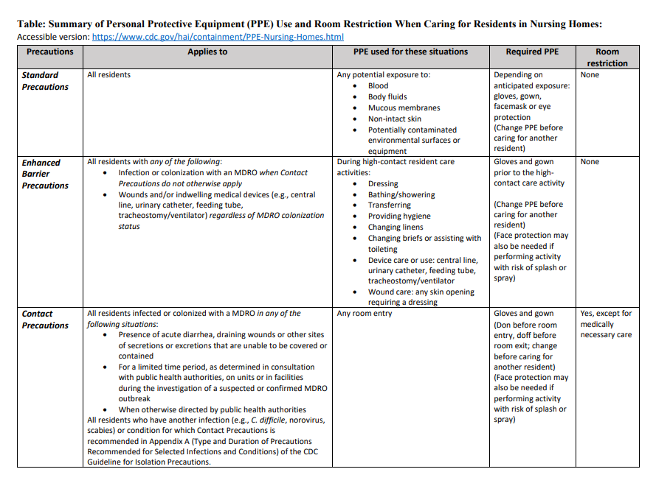  EBP Signage  - enhanced barrier precautions final rev3 (cdc.gov)  - Contact Precautions Signage  contact precautions final rev3 (cdc.gov)  5. C. auris outbreak response  https://www.corha.org/wp-content/uploads/2021/08/Candida-auris-Recommendations-for-Healthcare-Outbreak-Response.pdf
Notifications made  ☐ administration_____________  ☐ public health/doh/epi_______  ☐ notify previous facility and transportations if applicable  Enter who was notified if applicable  Notify/ educate all individuals involved in care  ☐dietary ☐maint. ☐EVS ☐therapy ☐Activities  ☐Hospice ☐Social Worker ☐Other  Notifications made: (Cont.)  ☐visitors ☐contracted  ☐staff ☐ other Enter Who  Process  ☐start line list Enter online location  ☐dedicate staff to resident/unit  ☐provide education to staff  ☐provide education to family/visitors  Y/N changes in dishes? (not usually)  Y/N changes in laundry? Check if applicable  ☐wash separately, ☐hot water, ☐bleach ☐sanitizer ☐sour ☐ozone ☐end of shift  ☐ dedicate linens  ☐terminal clean area case had occupied  ☐Terminal clean room daily  Disinfectant product required Enter Disinfect name and contact time  ☐ curtains clean ☐daily ☐weekly  ☐Perform EVS audits: ☐visual inspection ☐fluorescent markers, ☐ATP  ☐ Cohorting must occur with an uninfected or colonized patient-  ☐separate mops, rags, for each side of the room | Administrator on call contact info  Admin name and #  DPH/DOH/EPI 505-827-0006, Fax 505-827-0013  Enter names and facilities notified/ time/date if applicable--------------------------------------------------------------------------------------------------------------------------  Ensure all departments understand the PPE needed  Provide education in Break Rooms, to the supervisors, at change of shift, stand up  Document education provided to staff and family  6.. Line List example https://hip.phila.gov/document/1085/CandidaAuris_LineList.pdf/  Ensure the correct EPA disinfectant is used for the correct contact time (List P link)  Dedicate cart, EVS staff, deep clean daily  Replace privacy curtains and clean all areas resident has been  7. CDC Environmental Checklist for Monitoring Terminal Cleaning  8. https://www.epa.gov/pesticide-registration/list-p-antimicrobial-products-registered-epa-claims-against-candida-auris  9. Environmental Evaluation Working Group (cdc.gov)
Testing  ☐Coordinate with epi/public health recommendations for testing  ☐AR lab network often performs the testing (NM uses Utah)  ☐Prioritize testing for those who require a higher level of care (e.g. Ventilation) or were in contact with the case for three days  ☐Point prevalence surveys are conducted every 2-4 weeks until two rounds are negative in conjunction with Public Health authorities normally. | Health Care Workers are often omitted from testing as colonization of the skin has not been common. (in the absence of poor core infection prevention practices)  Screen roommates even if discharged  AR performs screening free of charge  Axilla and groin screening common, or skin sponge  10. Testing guidance Candida Auris: Recommendations for Healthcare Outbreak Response | CORHA

Urgent & Serious Pathogen Checklist

(Without links)
Resident/room # Precautions Date
_______________ _____________ _____________

☐Verify case lab, report, history, colonization, infection, identify site Click or tap here to enter text.
Initiate precautions
☐ Enhanced barrier ☐Contact ☐Droplet ☐ Airborne
☐ Isolation signs in place
Roommate status
☐moved ☐screened
☐ no devices in roommate
☐if more than one case, cohort, or cluster
☐Set up PPE cart outside of room
☐gown ☐gloves ☐mask
☐hand hygiene gel
☐n95 respirator
☐eye protection
☐red bag waste ☐shoe covers
☐dedicate all equipment, bp cuff, stethoscope, glucometer, etc. Or use disposable
☐Hand sanitizer (if not soiled)
☐other____
☐assign staff/dept. responsible for stocking PPE cart each shift or day Enter dept/person responsible
Notifications made
☒administration_____________

☒ public health/doh/epi_______
☒notify previous facility and transportations if applicable Enter who was notified if applicable

Notify/ educate all individuals involved in care
☐dietary ☐maint.☐EVS☐therapy
☐visitors ☐contracted ☐staff
☐ other Enter Who
Process
☐start line list Enter online location
☐dedicate staff to resident/unit
☐provide education to staff
☐provide education to family/visitors
Y/N changes in dishes? (not usually)
Y/N changes in laundry? Check if applicable
☐wash separately, ☐hot water, ☐bleach ☐sanitizer ☐sour ☐ozone ☐end of shift
☐ dedicate linens
☐terminal clean area case had occupied
☐Terminal clean room daily
Disinfectant product required Enter Disinfect name and contact time
☐Priv. curtain cleaned; ☐daily ☐weekly
☐Perform objective audits of EVS: ☐glo-germ, ☐bioluminescence, ☐ATP
☐ Cohorting must occur with an uninfected or colonized patient-
☐separate mops, rags, everything for each side of the room
Testing
☐Coordinate with epi/public health recommendations for testing
☐AR lab network often performs the testing (NM uses Utah)
☐Prioritize testing for those who require a higher level of care(e.g. Ventilation) or were in contact with the case for three days
☐Point prevalence surveys are conducted every 2-4 weeks until two rounds are negative in conjunction with Public Health authorities normally.

Additional Notes:

