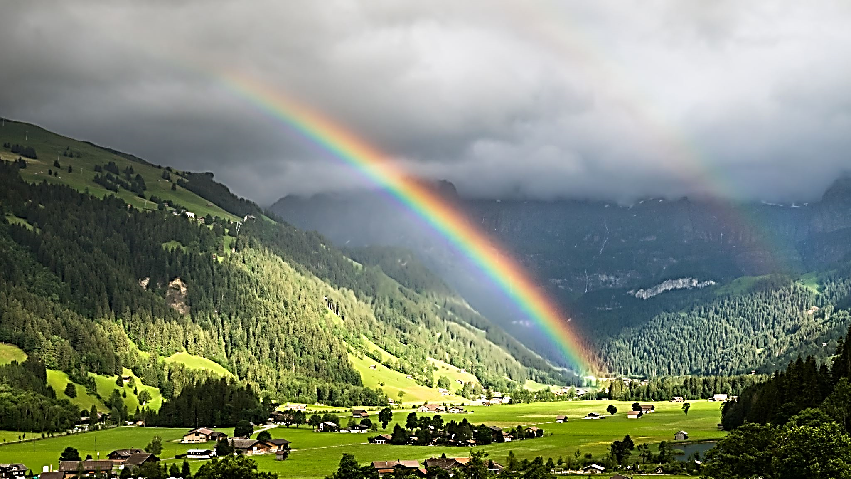
Please read out loud at a normal volume:

Rainbow Passage

When the sunlight strikes raindrops in the air, they act like a prism and form a rainbow. The rainbow is a division of white light into many beautiful colors. These take the shape of a long round arch, with its path high above, and its ends apparently beyond the horizon. There is, according to legend, a boiling pot of gold at one end. People look, but no one ever finds it. When a man looks for something beyond reach, his friends say he is looking for the pot of gold at the end of the rainbow.

