Diving Chuuk (Truk) Lagoon
Chuuk Lagoon, also known as Truk Lagoon, is a sheltered body of water in the central Pacific. It lies approximately 972 nautical miles (1,800 km) northeast of New Guinea, halfway between the Philippines and Hawaii. The lagoon is part of the Federated States of Micronesia (FSM) and is considered the mecca for wreck divers. The name “Chuuk” means mountains in the Chuukese language, and you’ll see why upon arrival—the mountain Tonnachau rises above Chuuk International Airport (TKK). Historically, the lagoon was known mainly as Truk (a mispronunciation of Ruk) until 1990. These days, most people use the word “Truk” for the lagoon, dive sites, and the wrecks, while “Chuuk” refers to the state and the land.
Siren Fleet Combo (Chuuk combined with Philippines or Palau)
Combine your liveaboard safari in Chuuk Lagoon with one of the liveaboard trips in the Philippines or Palau with Siren Fleet. Siren Fleet trip itineraries are scheduled to enable you to experience one or more of our superb diving destinations with just the need for a short connecting flight with United Airlines. Options available are dependent on the flight schedule via Guam to Manila or Koror.
In addition, Master Liveaboards and Odyssey Adventures also have some great charters and prices for Truk!!
When to dive in Chuuk (Truk) Lagoon
The area can be dived on a year-round basis, but the best conditions are during December to April. Water temperature is typically warm with a range of 82-84°F (28-29°C).
There are many wrecks to choose from and many are easily accessible to recreational divers as they lie in depths of 100-130ft (30-40m). The visibility ranges from 40-100ft (12-30m) so at times, you might have a stunning view of entire wrecks.
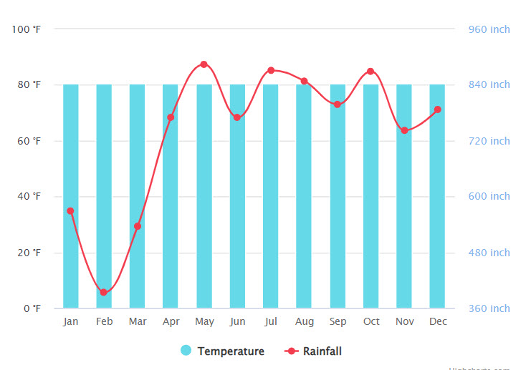
Truk Lagoon Water Temperatures

Common marine life sightings for Chuuk (Truk) Lagoon
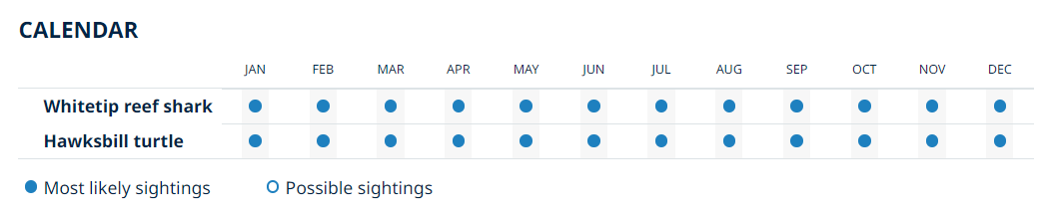

How to get there
Situated in the middle of the Pacific Ocean, Chuuk Lagoon is hard to access. You can get a direct flight from Guam which takes 1 hour and 46 minutes or fly from Papua New Guinea which is a 3 hour flight to Chuuk International Airport in Weno. From Weno you get a diving boat to the lagoon.
Fly to Chuuk International Airport via United Airlines which has connecting flights from Guam or Papua New Guinea.

Other useful information
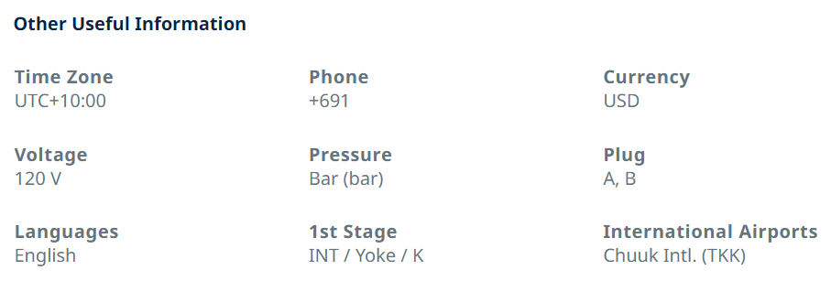

Dive sites of Truk Lagoon
During World War II Truk Lagoon was the Empire of Japan's main base in the South Pacific theatre. Known as the “Gibraltar of the Pacific,” Truk Lagoon was a heavily fortified base for Japanese operations against Allied forces in New Guinea and the Solomon Islands. Truk served as the forward anchorage for the Japanese Imperial Fleet. February 17-18, 1944, Truk was devastated in one of the most important naval attacks of the war, "Operation Hailstone", Task Force 58 strikes resulted in the loss of 250 airplanes and 61 ships, in total 10 naval vessels (two cruisers, four destroyers and four auxiliary vessels), but mostly "Maru" or merchant vessels which had been left at anchor whilst some 200 other vessels were safely evacuated to Palau. Truk is eliminated as a major fleet anchorage for the IJN. The event is often referred to as the Japanese equivalent of Pearl Harbor. The result of this attack is now a collection of shipwrecks closely packed into a coral lagoon, many of which lie at depths easily reached by recreational divers. Making Truk Lagoon among the top wreck diving spots of the world with the world’s biggest ship and aircraft graveyard.
Fujikawa Maru - a signature dive of Truk Lagoon, this 132m (436ft) auxiliary armed aircraft transport or ferry ship sits perfectly upright on the sandy bottom at a depth of 34m (111ft) whilst the forward king post reaches up to 5m(15ft). The "Fuji" offers 6 holds, 4 of which are open, in which can be found parts of Zero Fighter Aircraft including engine parts, propeller blades and fuel cells. Deeper inside the wreck, at least nine disassembled fighter aircraft can be found. One Mitsubishi A5m “Claude” (the sole known survivor of the type) & eight Mitsubishi A6M “Zeke or Zero” in the forward holds. The 6-inch (152mm) bow gun is encrusted with corals and the outer wreck supports sea fans, soft corals & anemones. Diving the "Fujikawa" is suitable for divers of all levels. However, deeper penetration into the engine room will only be permitted to certified tec/ wreck divers.
Fumizuki - A 97.5m (320ft) long Mutsuki class Japanese Destroyer. While at Truk on 17 February 1944, Fumizuki received a near miss bomb from Grumman TBF Avengers during Operation Hailstone, when carrier-based US Navy aircraft attacked the Imperial Japanese Navy fleet anchorage. The near miss to port amidships disabled her only usable turbine and caused gradual flooding, which the crew could not control, and Fumizuki sank on 18 February at 07°24′N 151°44′E, with 29 crewmen killed. She sits upright in 38m (125ft) of water rising up to 21m (70ft). Covered in marine life she is a pleasure to dive.
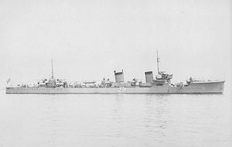
Fumizuki in July 1926
Submarine I-169 – A Japanese Type KD6 344 ft (104.7m) submarine assigned to the Truk-based Submarine Division 12, a part of Submarine Squadron 3, was lost during an air attack on Truk on 4 April 1944. I-169 was at her anchorage in Truk Lagoon northwest of Dublon, taking on supplies with some workmen aboard and her commanding officer and 20 other members of her crew ashore. At about 09:00 Japan Standard Time, an air raid warning sounded. I-169′s watch officer ordered her to dive immediately to avoid attack by approaching U.S. Navy PB4Y-1 Liberator patrol bombers. She submerged with most of her deck hatches still open and her main induction valve unsecured, causing her after compartments to flood immediately. An immediate attempt to resurface failed, and although surviving crewmen sealed off the flooded compartments, the I-169 sank to the bottom and came to rest on her port side at a depth of 38m (125ft). In May 1944, the Japanese believed that an invasion of Truk was imminent, and they detonated depth charges around I-169 in an attempt to demolish her before she could fall into enemy hands. The depth charges heavily damaged her bow and conning tower. The Allies chose to bypass Truk, which remained in Japanese hands until the end of World War II.
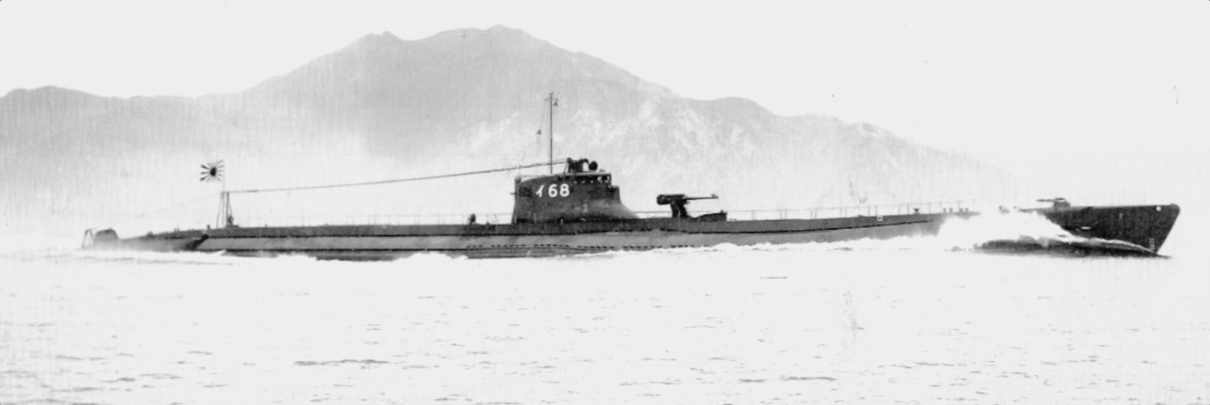
Yamigari Maru - Resting on her port side, though almost completely intact despite repeated bombings, the Yamigari freighter still contains many artillery shells and ammunition.
Shinkoku Maru - A large oil tanker, now rests upright on the bottom encrusted with corals, sponges & hydroids. Highlights include the telegraph room on the bridge, a spacious engine room and a galley that still features many utensils on the large stove. Small guns mounted fore and aft are also covered with corals making this one of the most colorful and spectacular wrecks to be found in Truk.
Nippo Maru -With a depth range of 18m - 48m (59ft-157ft) the Nippo is an intriguing dive site for recreational divers and tee divers alike tee divers. With a tank and howitzer guns on deck, and 5-inch guns in the holds, the Nippo is not to be missed.
Heian Maru - The largest ship in the lagoon, the Heian, originally used as a cargo ship, is 165m (540ft) in length and lies on her port side in 34m (111ft) of water. Within her holds diver may find torpedoes, shells and even the occasional periscope.
Susuki Destroyer- Best known for its engine room, this patrol boat once boasted an array of gas masks and other fascinating artifacts, many of which have been removed. However, some can still be found scattered about the deck and it remains a stunning wreck dive site. The bow is in just 3m (10ft) of water, shallow enough to see whilst snorkeling, with the stern propeller at 15m (50ft).
San Francisco Maru - The passenger & cargo ship, weighing 5,831 tons, lays upright at a depth of 63m (207ft). Here divers can see the remains of many well preserved war-relics including three large tanks which rest on the deck at between 46-53m (150-175ft). NOTE: Due to the depth of the San Francisco Maru, this dive will be offered only to those divers possessing the necessary training and experience to plan and safely execute technical dives.
Hoki Maru - This 30m (98ft) long freighter lies upright from 53m (174ft) and is only partially intact. The aft hold carries trucks and road supplies whilst sake bottles can be found here too. The superstructure is awe-inspiring and covered with brightly colored sponges.
Gosei Maru - A submarine tender carrying torpedoes starts in just 3m (1Oft) and drops to 33m (108ft) within which can be found many personal artifacts, serving as a reminder of those who lost their lives during the battle.
Rio de Janeiro Maru- 140m (460ft) long she lays on her port side in 34m (111ft). Once a luxury passenger vessel she was converted to a cargo vessel in wartime. Exploration of her holds turns up a range of supplies from beer bottles to guns. The upper deck reaches to an easily dive able depth of 1Om (33ft).
Betty Bomber - A Mitsubishi G4M "Betty" Bomber lies on the seabed at 20m (66ft) and is surrounded by schooling fish.
Shark Island- possibly the most famous reef dive in Truk, is a fantastic cleaning station for reef sharks and at just 18m (60ft) is perfect for some "off-gassing" in the afternoon after a morning of wreck diving.
The majority of shipwrecks within Chuuk Lagoon are deemed suitable for recreational divers and offer varying depths for multi-level profiles. Some sites do however lie beyond, or have interesting features deeper than, the recognized recreational diving depth limit of 40m (130ft). As such they may not be suitable for divers without with deep diver or technical diving qualifications.

List of ships in Truk during Operation Hailstorm - 17-18 Feb 1944
Warships
Sunk
- Cruiser (CL)
  - Katori (香取) 5,800 tons
  - Naka (那珂) 5,195 tons
- Destroyer (DD)
  - 1 modern
    - Maikaze (舞風) 陽炎型 2,000 tons
  - 3 obsolescent
    - Fumizuki (文月) 睦月型 1,320 tons
    - Oite (追風) 神風型 1,270 tons
    - Tachikaze (太刀風) 峯風型 1,215 tons
- Submarine chaser
  - CH-29, 440 tons
  - CH-24, 440 tons
- Auxiliary submarine chaser Shonan Maru #15 (第15昭南丸), 355 tons
- Motor torpedo boat #10, 85 tons
Damaged
- Repair ship Akashi (明石) 10,500 tons
- Seaplane tender Akitsushima (秋津洲) 4,650 tons
- Destroyer (DD)
  - Matsukaze (松風) 神風型 1,400 tons
  - Shigure (時雨) 白露型 1,685 tons
- Submarine
  - I-10 (伊10), 2,919 tons
  - RO-42, 1,115 tons
- Submarine chaser CH-33, 440 tons
- Target ship Hakachi (波勝) 1,641 tons

Merchant ships
Sunk
- Auxiliary cruiser
  - Aikoku Maru (愛国丸) 10,348 tons
  - Akagi Maru (赤城丸) 7,367 tons
  - Kiyosumi Maru (清澄丸) 6,983 tons
- Navy transport
  - Hoki Maru (伯耆丸) 7,112 tons
  - Yamagiri Maru (山霧丸) 7,112 tons
  - Auxiliary Armed Aircraft Transport or Ferry Fujikawa Maru (富士川丸) 6,938 tons
  - Navy transport/freighter San Francisco Maru (桑港丸) 5,831 tons
  - Reiyo Maru (麗洋丸) 5,446 tons
  - Seiko Maru (西江丸)? 5,385 tons
  - passenger/cargo ship Kensho Maru (乾祥丸) 4,862 tons
  - freighter Hanakawa Maru (花川丸) 4,739 tons
  - passenger/cargo ship Sankisan Maru or Yamakisan Maru (山鬼山丸) 4,776 tons
  - freighter Hokuyo Maru (北洋丸) 4,217 tons
  - freighter Momokawa Maru (桃川丸) 3,829 tons
  - Navy water carrier/passenger/cargo ship Nippo Maru (日豊丸) 3,764 tons
  - freighter Unkai Maru #6(第六雲海丸) 3,220 tons
  - Taiho Maru (大邦丸) 2,827 tons
  - freighter Shotan Maru (松丹丸) 1,999 tons
  - freighter Gosei Maru (五星丸) 1,931 tons
- Freighter Taikichi Maru or Tachi Maru (泰吉丸) 1,891 tons
- Army transport
  - Gyoten Maru (暁天丸) 6,854 tons
  - freighter Nagano Maru (長野丸) 3,824 tons
  - Yubae Maru (夕映丸) 3,217 tons
- Submarine tender
  - Heian Maru (平安丸) 11,614 tons
  - Rio de Janeiro Maru (リオデジャネイロ丸) 9,626 tons
- Oiler
  - Fleet oiler Shinkoku Maru (神国丸) 10,020 tons
  - Oil tanker Fujisan Maru (富士山丸) 9,524 tons
- Auxiliary oil tanker
  - whaler Tonan Maru #3 (第三図南丸) 19,209 tons
  - Houyou Maru or Hoyo Maru (宝洋丸) 8,691 tons
  - passenger/cargo ship Amagisan Maru (天城山丸) 7,620 tons
Damaged[edit]
- Cargo ship Sōya (宗谷) 3,800 tons

US Navy Official Chronology of Feb 16-18, 1944 in the Pacific
- 16 February, Wed. --
Pacific
Task Group (TG) 58.4 (Rear Admiral Samuel P. Ginder) planes bomb Eniwetok.
Destroyer Phelps (DD-360) and minesweeper Sage (AM-111) sink Japanese submarine RO-40, 45 miles northwest of Kwajalein, Marshalls, 09°50'N, 166°35'E.
Submarine Skate (SS-305) sinks Japanese light cruiser Agano 170 miles north of Dublon Island, Truk, 10°10'N, 151°40'E.
Submarine Tinosa (SS-283) continues pursuit of convoy engaged the previous day, and sinks Japanese army cargo ship Chojo Maru off Sarangani Island, 09°15'N, 127°05'E.
USAAF B-25s (38th and 345th Bomb Groups) carry out succession of attacks on Japanese convoy off New Hanover and Kavieng, sinking submarine chaser Ch 39, auxiliary submarine chaser Cha 16, and transport Sanko Maru, 02°24'S, 150°06'E.
Japanese transport Sanko Maru is sunk by aircraft off New Hanover Island, 02°24'S, 150°06'E.
- 17 February, Thu. --
Pacific
Task Force (TF) 58 (Vice Admiral Raymond A. Spruance), which includes nine carriers and six battleships, strikes Japanese installations and shipping at Truk, in Operation HAILSTONE inflicting massive damage; enemy air attacks in response succeed in only damaging carrier Intrepid (CV-11) with an aerial torpedo, 07°23'N, 153°32'E.
Curtiss SB2C Helldivers and Grumman TBF Avengers from carrier Bunker Hill (CV-17) and TBFs of VT-25 from small carrier Cowpens (CVL-25) sink Japanese light cruiser Naka 35 miles west of Truk, 07°15′N 151°15′E. Naka was attacked by three waves. The first two strikes failed to score a hit, but Naka was hit by a torpedo and a bomb in the third strike and broke in two, sinking. Some 240 crewmen perished, but patrol boats rescued 210 men including Captain Sutezawa. Battleships New Jersey (BB-62) and Iowa (BB-61), heavy cruisers Minneapolis (CA-36) and New Orleans (CA-32) and destroyers Radford (DD-446) and Burns (DD-588) sink training cruiser Katori northwest of Truk, 07°45'N, 151°20'E, after she had been damaged by planes from carriers Yorktown (CV-10), Intrepid (CV- 11) and Bunker Hill (CV-17) and small carrier Cowpens. TG 50.3 gunfire sinks destroyer Maikaze 40 miles northwest of Truk, 07°45'N, 151°20'E. Destroyer Burns (DD-588), detached from TG 50.9, sinks Japanese submarine chaser Ch 24 west of Truk, 07°24'N, 150°30'E.
TF 58 planes sink Japanese destroyer Oite (carrying survivors of light cruiser Agano sunk the day before), 07°40'N, 151°45'E; destroyer Tachikaze, 07°40'N, 151°55'E; armed merchant cruiser Akagi Maru, 07°54'N, 151°25'E; auxiliary submarine depot ship Heian Maru; aircraft transport Fujikawa Maru; transports Rio de Janeiro Maru, Kiyozumi Maru, Aikoku Maru, Gosei Maru, Hanakawa Maru, Hokuyo Maru, Amagisan Maru, and Kensho Maru; Matsutani Maru, 07°23'N, 151°05'E; Momokawa Maru, 07°20'N, 151°53'E; Reiyo Maru, 07°25'N, 151°45'E; San Francisco Maru, 07°22'N, 151°54'E; Seiko Maru, 07°22'N, 151°45'E; Taiho Maru, 07°22'N, 151°34'E; Zukai Maru,07°46'N, 150°27'E; No.6 Unkai Maru; Yamagiri Maru, 07°23'N, 151°51'E; fleet tankers Fujisan Maru, Hoyo Maru (damaged on 4 November 1943 by submarine Scorpion), Shinkoku Maru, and No.3 Tonan Maru; water carrier Nippo Maru, 07°20'N, 151°40'E; auxiliary vessel Yamakisan Maru, 07°25'N, 151°45'E; army cargo ships Nagano Maru and Yubai Maru; merchant cargo ship Taikichi Maru; and motor torpedo boat Gyoraitei No.10, 07°31'N, 151°59'E.
TF 58 aircraft damage Japanese destroyers Shigure and Matsukaze, submarines I 10 and RO 42, target ship Hakachi, repair ship Akashi, ammunition ship Soya, seaplane tender Akitsushima, and auxiliary submarine chaser Cha 33.
Destroyer Nicholas (DD-449) sinks Japanese submarine I-11 northwest of the Marshalls, 10°34'N, 173°31'E.
Submarine Cero (SS-225) sinks Japanese transport Jozan Maru between Truk and New Ireland, 00°53'N, 146°26'E.
Submarine Sargo (SS-188), in attack on Japanese convoy about 150 miles northeast of Palau, sinks ammunition ship Nichiro Maru and damages oiler Sata, 08°50'N, 135°40'E.
Submarine Tang (SS-306) attacks Japanese convoy, sinking army cargo ship Gyoten Maru and merchant tanker Kuniei Maru about 130 miles west-northwest of Truk, 08°00'N, 149°17'E, and survives depth-charging by escorts (escort vessel Amakusa, submarine chaser Ch 31, auxiliary submarine chaser Cha 24 and auxiliary minesweeper Hagoromo Maru are screening the merchantmen).
Navy SBDs and TBFs bomb Japanese shipping in Keravia Bay, near Rabaul, sinking minesweeper W.26 (which had been damaged previously, 2 November 1943, and had been beached at that time to prevent her loss), guardboat No.2 Fuku Maru, and army cargo ship Iwate Maru.
USAAF B-25s attack Japanese ships going to the aid of convoy attacked north of New Hanover the day before (see 16 February), damaging Kashi Maru and forcing her to be run aground to prevent sinking.
USAAF P-40s attack Japanese shipping at Jaluit atoll, damaging cargo ship Chosen Maru.
Japanese merchant tanker Zuih_ Maru is damaged by mine downstream from Woosung, China.
- 18 February, Fri. --
Pacific
After preliminary landings had been made the previous day, TG 51.11 (Rear Admiral Harry W. Hill) lands Marines and Army troops on Engebi Island, Eniwetok Atoll, in Operation CATCHPOLE.
TF 58 (Vice Admiral Raymond A. Spruance) repeats strike on Japanese installations and vessels at Truk; TF 58 planes sink destroyer Fumizuki, 07°24'N, 151°44'E; submarine chaser Ch 29, 07°25'N, 151°45'E; and motor torpedo boat Gyoraitei No.10, 07°31'N, 151°59'E.
Destroyer Squadron 23 (TG 39.4) (Captain Arleigh A. Burke) bombards Japanese positions at Kavieng; destroyer Squadron 12 (Captain Rodger W. Simpson) shells Rabaul, Japanese installations on the Crater Peninsula, and bivuoac and supply areas at Vunapope and Cape Gazelle.
British submarine HMS Trespasser sinks Japanese gunboat Eifuku Maru off Burma, 07°55'N, 93°03'E.
USAAf B-25s (14th Air Force) sink Japanese transport Shinsoku Maru south of Takhow Island, Wenchow, China, 28°23'N, 121°51'E.
U.S. aircraft sink Japanese auxiliary submarine chaser Cha 17 off Kavieng, 02°30'S, 150°30'E.
Japanese cargo ship Gokenzan Maru is stranded and sunk off northwestern Hokkaido, 44°01'N, 141°38'E.

