History of Megalodon Sharks in Florida
Imagine the idea of discovering your very own prehistoric megalodon tooth and being the first human to ever touch it!
Venice is an area rich in fossils of all kinds! Let’s have a quick look at the background and why that is:
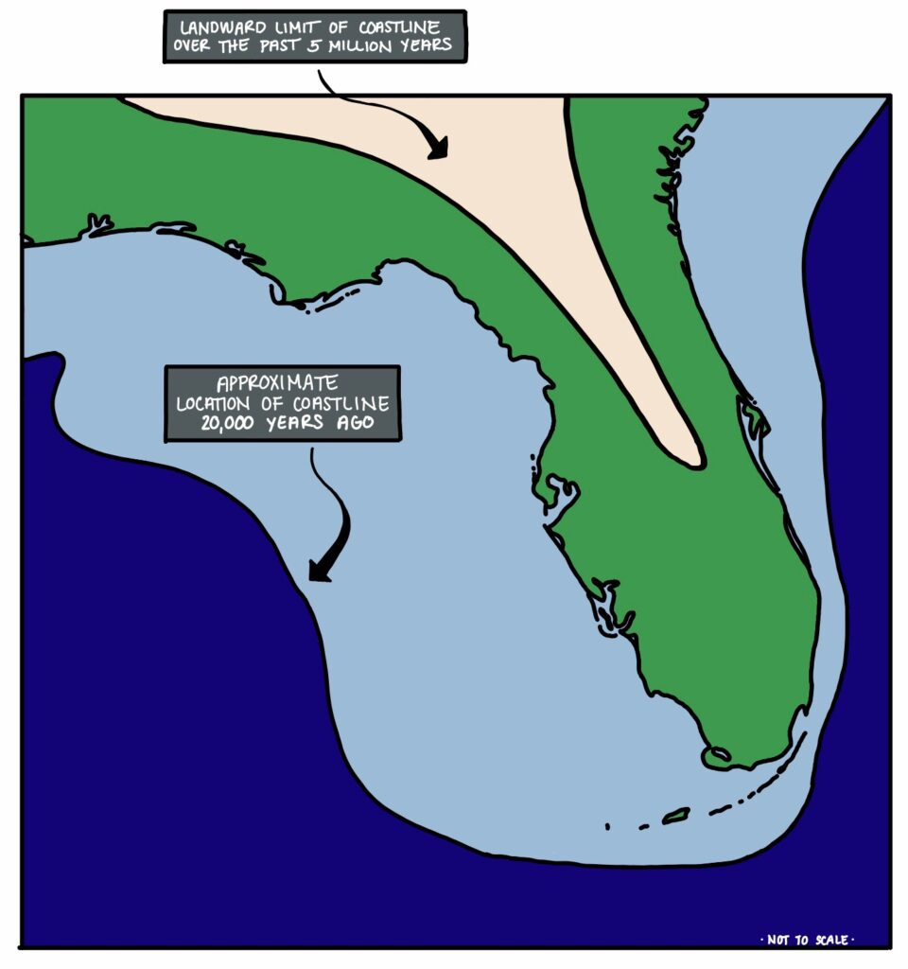
Over 2.5 million years ago, Venice was the stomping grounds of “The Meg”. Expectant mothers would come to the shallow, nursery-like waters around Venice to drop their pups, many of which stayed in the area to feed on whales and dugongs before heading out into cooler waters.
As the megs fed, they were continually dropping and replenishing their teeth, with younger sharks replacing their teeth more often than older sharks. They had three rows of razor-sharp teeth, shedding thousands of them during their lifetime and making Venice the “Shark Tooth Capital of the World”.
Along with meg teeth, we find a variety of other shark teeth on our dives (‘extinct mako’, Hemipristis serra – aka. snaggletooth, tiger, bull, lemon, sand tiger, and the occasional great white), as well as a plethora of mammal fossils.
Not only were the waters around Venice once deep and megalodon-filled, but during the last Ice Age, they were dry land extending over 100 miles further than today. During this time, the area was home to animals such as Colombian mammoths, American mastodons, giant ground sloths, prehistoric North American horses, saber-toothed cats, dire wolves, and glyptodonts.
Today, these fossils sit all at the bottom of the Gulf waiting for divers to discover them – the most sought after being the infamous megalodon tooth.

History of the Megalodon
Otodus megalodon (/ˈmɛɡələdɒn/ MEG-əl-ə-don; meaning "big tooth"), commonly known as megalodon, is an extinct species of giant mackerel shark that lived approximately 23 to 3.6 million years ago (Mya), from the Early Miocene to the Early Pliocene epochs. O. megalodon was formerly thought to be a member of the family Lamnidae and a close relative of the great white shark (Carcharodon carcharias), but has been reclassified into the extinct family Otodontidae, which diverged from the great white shark during the Early Cretaceous.
While regarded as one of the largest and most powerful predators to have ever lived, megalodon is only known from fragmentary remains, and its appearance and maximum size are uncertain. Scientists have argued whether its body form was more stocky or elongated than the modern lamniform sharks. Maximum body length estimates between 14.2 and 24.3 meters (47 and 80 ft) based on various analyses have been proposed, though the modal lengths for individuals of all ontogenetic stages from juveniles to adults are estimated at 10.5 meters (34 ft). Their teeth were thick and robust, built for grabbing prey and breaking bone, and their large jaws could exert a bite force of up to 108,500 to 182,200 newtons (24,390 to 40,960 lbf).

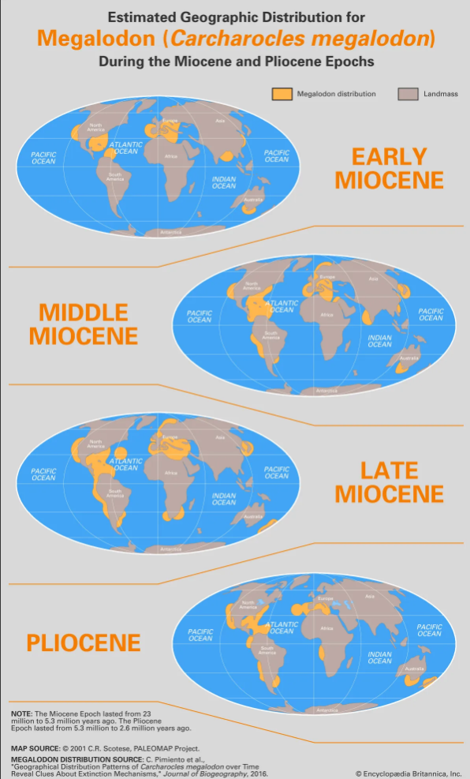

Extinction
Initially, scientists thought that the decline was due to swings in ocean temperatures related to climate change, possibly caused by the closing of the seaway separating North America and South America about 3 million years ago, which deflected ocean currents and caused other changes in ocean circulation. By 2016, however, studies had shown that megalodon’s geographic distribution did not increase appreciably during warm periods or decrease appreciably during cold periods, suggesting that the species demise was not dependent on climatic changes alone. These studies suggested that shifting food-chain dynamics may have been the primary factor in megalodon’s demise, as the availability of its primary food source, baleen whales, decreased and the numbers of its competitors—smaller predatory sharks (such as the great white shark, Carcharodon carcharias) and whales (such as members of the killer whale genus Orcinus)—increased. Several studies note that authentic fossil teeth attributed to megalodon do not occur later than the Pliocene-Pleistocene boundary (2.58 million years ago), suggesting that megalodon died out around that time.
In 2014, a research group at the University of Zurich studied megalodon fossils using a technique called optimal linear estimation to determine their age. Their research, published in the journal PLOS ONE, found that most of the fossils date back to the middle Miocene epoch to the Pliocene epoch (15.9 million to 2.6 million years ago). All signs of the creature's existence ended 2.6 million years ago in the current fossil record. However, A very small portion of the Zurich study's data — 6 out of 10,000 simulations — showed a 1% chance that these giant sharks could still be alive. That chance seems pretty slim, and the researchers wrote in the study that they rejected "popular claims of present-day survival of O. megalodon."

