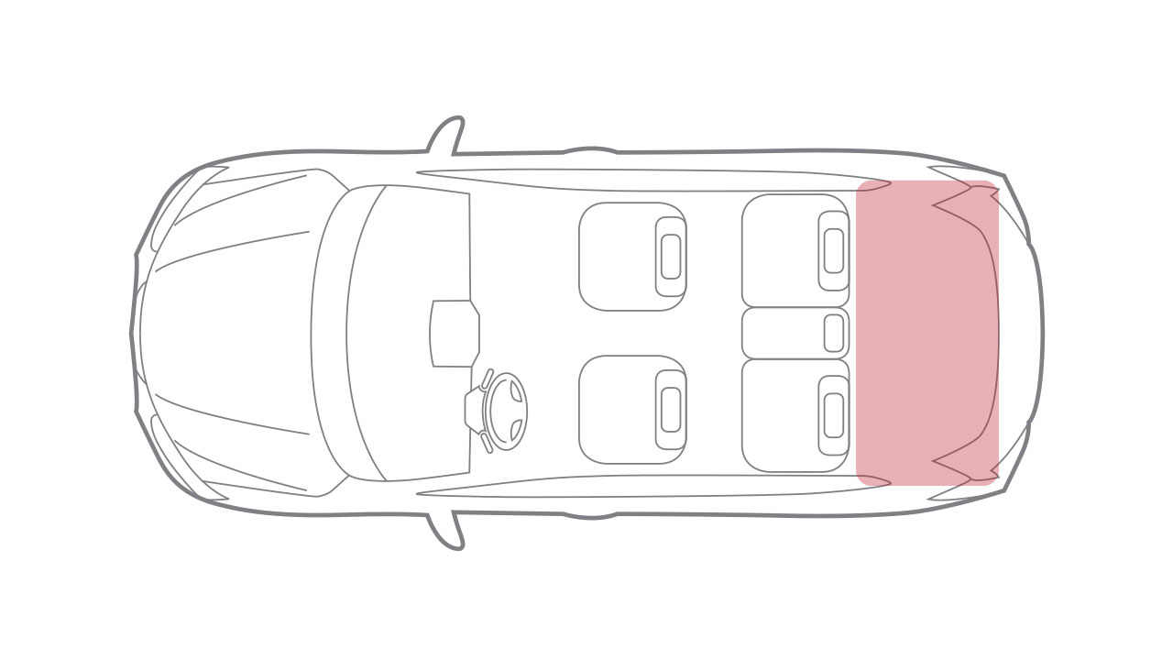

My SuperPower is

____________________________________________________________________________________________

P______________

P______________

P______________

My Personal Motivational Vehicle:

Revving my Engine

Mentor ________

Leader ________

Co-Pilot________

No one _________________________!

Vision ____________________

_________________________

Toxic Habits, Mindset, Environments, Relationships:

___________________________________________________________________________________________________