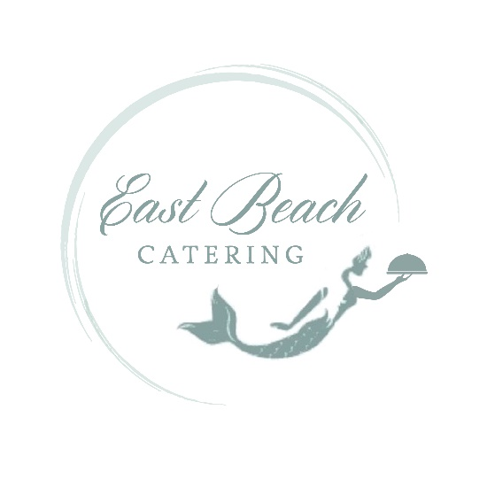

Hor’dourves
…Seafood Appetizers…

Bacon Wrapped Scallops

Hot Crab Dip
Made with Chesapeake Bay Lump Crab Meat served with Assorted Crackers

Mini Crab Cakes
Made with Chesapeake Bay Lump Crab Meat & drizzled with Remoulade Sauce

Crab Stuffed Mushroom Caps topped with Parmesan Cheese

Marinated Crab Salad served in Mini Martini Glasses
Cherry Tomatoes filled with Crab & Tarragon Mayonnaise

Shrimp & Grits
~Served in Mini Martini Glasses with Demi Spoons
~Displayed in Chaffing Dish with individual serving containers for self-serving

Jumbo Shrimp Cocktail

Coconut Shrimp with Mango Orange Salsa

Tuna Tartar served in Wonton Cups

Skewered Blacken Tuna Bites

Phyllo Tarts with Smoked Salmon & Dill Sauce

Smoked Salmon Board
Garnished with Capers, Thinly Sliced English Cucumbers & Cream Cheese

Smoked Salmon Canapés
Phyllo Cup with Herb Cream Cheese, topped with Smoked Salmon and Dill Weed

…Assorted Sushi…
Crunchy/California Rolls/Philadelphia Roll
Salmon
Shrimp
Eel
Tuna

…Chicken & Turkey Appetizers…

Spicy Chicken Satay Sticks

Jerk Chicken Skewers

Tequila Lime Chicken

Chicken Pineapple Teriyaki Skewers

Phyllo Tarts filled with Chicken Salad

Cranberry Chicken Salad Mini Croissants

Mini Orange Muffins with Smoked Turkey
& Cranberry Sauce

…Beef, Pork & Lamb Appetizers…

Garlic Peppered Beef Tenderloin
Sliced & Served with Horseradish Sauce & Assorted Yeast Rolls

Soy Glazed Beef Skewers

Sweet Potato Biscuits
with Smithfield Ham & Pineapple Cream Cheese Spread

Bacon Wrapped Dates Stuffed with Pecans

Mini Smoked Sausage Wrapped in Puff Pastry

Meat Balls with Plum Sauce

Italian Meatballs

Moroccan Meat Balls
(made with Lamb & Fresh Mint)
served with Tzatziki Sauce

Stuffed Mushrooms
Mushroom Caps Stuffed w/ Mild Sausage & Parmesan Cheese or Spinach and Goat Cheese

Lumpia Spring Rolls
Served with Hot Mustard & Duck Sauce

Lollipop Lamb Chops served with Tzatziki

Gourmet BLT’s served on bread rounds

Sliders
Tuna, Beef & Pork BBQ, Hamburger, & Chicken Salad

…Fruits, Veggies Cheeses, & Pastas Appetizers…

Beautiful Arrangement of Fresh Seasonal Fruits

Vegetable Crudités Display

Vegetable Crudités Shots
Veggies cut long & slender arraigned & served in shot glasses with a dollop of Homemade Buttermilk Ranch Dressing in the bottom of the glasses for a Contemporary Look

Grilled Mixed Vegetable Platter
A Beautifully displayed Assortment of Grilled Vegetables Served at Room Temperature

Imported & Domestic Cheese Arrangement
Cheddar, Gouda, Pepper Jack & Swiss served with Assorted Crackers

Caprese Skewers
Mozzarella, Tomatoes & Fresh Basil Skewered drizzled with Balsamic Vinaigrette

Baked Brie
pastry wrapped brie wheel
~Topped with Grapes/ Honey Glazed Walnuts & Dried Cranberries/ Figs & Glazed Walnuts

Caramel Apple Baked Brie
pastry wrapped brie wheel topped with chopped apples, walnuts
& salted caramel sauce

Mini Brie Bites
Puff Pastry Filled with Brie topped with Fresh Cranberry Orange relish

Goat Cheese Crostini
Buttery Croissants filled with goat cheese & topped with grilled garlic & roasted red peppers

Mushroom Caps Stuffed with Spinach & Goat Cheese

Mushroom Crostini’s
marinated chopped mushrooms served on a garlic crostini
& sprinkled with parmesan cheese

Warm Artichoke Spinach Dip
Served with Pita Points

Sweet Petite Peppers stuffed with Pimento Cheese

Fresh Pimento on Endive

Assorted Canapés
(served on Crackers or Panini rounds)
Brie topped with grape & honey glazed walnuts
Goat Cheese with Roasted Red Pepper & Roasted Garlic
Cucumber Cream Cheese
Cream Cheese & Salmon with dill sprig
Marinated Diced Mushrooms topped with Parmesan Cheese
Brochette with Goat Cheese served on Panini Rounds

Caprese Skewers
Mozzarella, Tomatoes & Fresh Basil Skewered drizzled with Balsamic Vinaigrette

Greek Skewers
Cucumber, Tomato & Olive

Italian Skewers
Mozzarella, Marinated Mushrooms, Cherry Tomato & Black Olives

Mediterranean Display
A Beautiful display of Cheddar, Gouda, Swiss & Pepper Jack Cheeses, Salami, Pepperoni, Marinated Mushrooms & Artichoke Hearts, Roasted Red Peppers, Black & Green Olives, Hummus & served with Baggett Bread & Assorted Crackers

Bacon Wrapped Dates Stuffed with Pecans

Spanakopita

Tortellini Skewers
Marinated Cheese Tortellini with a Sweet South African Pepper drizzled with Fresh Parmesan

Harvest Couscous
A Wonderful Combination of Couscous, Dried Cranberries, Garden Peas, Chopped Apples, Celery & Carrots mixed w/a Poppy Seed Dressing served in individual vessels with a demi spoon

Signature East Beach Macaroni & Cheese

Pierogis
served with a Dollop of Sour Cream & topped with Caramelized Onions

Guacamole Shots
Layered Black Bean & Corn Salsa, Guacamole, crumbled Tortillas, a dollop of Sour Cream

Quesadilla Triangles with Hot Pepper Cheese

Tomato Basil served with Grilled Cheese Triangles

