What is a Prostate Massage?
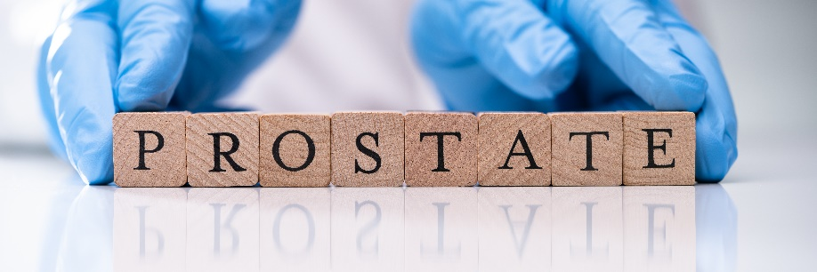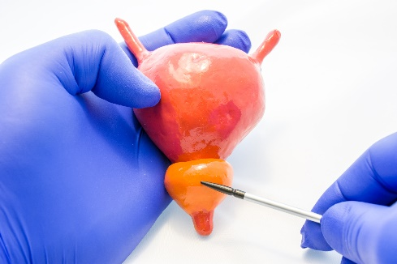

Okay, exactly what and where is the prostate?
The prostate is a walnut-size gland nestled deep inside the male pelvis, and it helps produce semen and nourish it with important substances. The prostate is made up of tissue known as stroma, secretory glands that produce semen ingredients, and muscle fibers. It’s located right in front of the bladder—the ducts in the prostate gland actually flow into the urethra, which is why prostate issues can affect urinary function. For example, if someone has an enlarged prostate (which is common as people get older), they might find that they have a more frequent urge to pee, among other symptoms, the Mayo Clinic explains.

Why can stimulating the prostate feel so good?
The anus and its surrounding area are packed with nerve endings, Hong explains. That’s precisely why anal play can feel so amazing whether or not you have a prostate. Dr. Hong, a Phoenix urologist, also notes that the prostate has plenty of blood vessels that swell with increased blood flow. The extra blood helps make the area more sensitive, which can boost pleasure.
Even though the anus is surrounded by nerve endings, it’s also surrounded by stigma. The human body is amazing in that parts like the vagina and anus (and even your mouth) have natural functions but can also be sites of intense pleasure. Trying out different sex-related acts is normal, and discovering new ways to experience pleasure is always a good idea.

Are there any risks and side effects to prostate massages?
“The anal mucosa [lining of the anus] and the anus itself are very sensitive," Hong explains. Although the anus is built to stretch to a certain extent, it doesn’t self-lubricate, meaning without proper precautions anal stimulation can cause pain and tearing (which would leave you vulnerable to infection). This means that it’s super important for everyone involved to prepare for giving and receiving a prostate massage. It’s also worth mentioning that this might feel a bit uncomfortable at first but lubrication and beginning slow is a key to success.

How do you prepare to give a prostate massage?
The first step in safe prostate play is washing your hands with good old soap and water. You can use these handy instructions from the Centers for Disease Control and Prevention (CDC). As you probably know from the new coronavirus pandemic, keeping your hands clean (and making sure not to touch your face when your hands are not clean) is one way to avoid spreading germs on your hands to the eyes, nose, or mouth. It’s also a good time to mention that you don’t need any special antibacterial soap for this.
After your hands are clean and dry, you can slip on a latex glove if you like. Gloves can protect both of you by making sure any anal bacteria stays away from other areas of the body (like your penis or vagina) post-prostate action. There are a couple of other benefits to gloves: If you have longer nails, they can reduce the chance that your nails will hurt your partner, and they can make any necessary cleanup easier. (Here are some anal sex tips that will make it less likely you’ll encounter any poop.)

How does a person prepare to receive a prostate massage?
One quick FYI is that prostate massages can make people feel like they have to pee, so the person having their prostate massaged should probably empty their bladder beforehand. Then you and your partner should take deep breaths. Deep breathing activates the body’s relaxation response—which is good for everyone involved—and a relaxed anal sphincter is a happy anal sphincter (and one that’s way easier to penetrate). Keep in mind that the more relaxed and turned on one is, the more comfort and pleasure they’re likely to experience.
Another thing to remember: The physical position may make receiving a prostate massage feel better or more feasible. It’s not a guarantee, but some people find that being on top makes anal penetration easier. Your partner can kneel with your hand between their legs, for instance. With that said, it will likely take some experimentation to figure out which position feels best for the person receiving a prostate massage.

How do you find the prostate?
Now for the how-to: You can first access the prostate via the perineum, a spot right in between the testicles and the anus. Communication is important during every step. Even before you begin, consider talking to your partner about what feels right for both of you. You can decide on things like how many fingers (or which fingers) might feel best. You can agree on whether a firm touch or a lighter touch is in order. Maybe as you talk things through, you’ll discover you both feel comfortable enough to explore and see what feels right in the moment. That way, even if prostate massage isn’t something you regularly want to incorporate into your sex life, you’ll have explored it in a way that feels safe and fun for everyone involved.

How do you give a prostate massage with your fingers?
If, after talking through a few specifics, you’re still not sure where to start, Brown-James has some techniques. “Bring your pointer, middle, and ring fingers together, then push up into [the perineum],” Brown-James explains. “Stimulating this area with gentle but firm strokes also stimulates the prostate.” It's basically a playground down there—Brown-James recommends techniques like rubbing clockwise for 8–10 strokes, then going counterclockwise, stroking toward the scrotum or touching the penis while you massage your partner’s perineum. Even though you’ve hopefully discussed what you’d both like beforehand, you and your partner should talk about what you think you might each like to do and feel and then, if you agree to test things out, try that next, making sure you’re each being open about what feels good and what doesn’t feel so good in the moment.
If you’d like to move on from the perineum and actually enter the anus, lube is essential. Keep in mind that oil-based lubricant eats away at condoms, and silicone-based ones can damage silicone sex toys. But if you’re using your fingers, either of these should be fine. You might consider lube that’s designed just for anal play. Be sure not to use any numbing agents, either with or without lube. Numbing agents that use topical anesthetic ingredients, like benzocaine, are readily available, but that doesn’t mean they’re a good option for anal play. Pain is there to tell you to stop, Brown-James says. If you and your partner are both new to anal penetration, or new to it with one another, it’s a good idea to start with a pinky unless you both decide to start with a bigger finger. Once your finger is adequately lubed up, you can try rubbing your partner’s anus and the surrounding area, then slowly sliding it in—just be sure to check in so that your partner isn’t caught off guard (unless, of course, you’ve both agreed that it should be a surprise).
As someone who’s performed thousands of prostate exams, Hong emphasizes the importance of going at a pace that’s comfortable for your partner. Once you’ve got a finger in and your partner’s go-ahead, it’s up to both of you what happens next. As Brown-James mentioned, the area is a “playground,” so feel free to move your finger around in ways that feel pleasurable and comfortable. If you’re looking for a specific technique, Brown-James suggests moving your finger upwards in a “come here” motion toward the front of their body. Because the prostate is a bit farther in and higher than the anus, that upward motion is a good way to make contact.

How about giving a prostate massage with a toy?
If you’re using a sex toy, only opt for one that is specifically made for anal play, meaning it has a flared base or some other feature that makes it so that nothing can go in that cannot come back out. You might try something like the 2-6” butt plug, but there are also toys made specifically for prostate play. Even if you don’t grab a toy specifically for prostate play, please don’t use random things lying around your house to explore prostate pleasure. “Every physician who’s ever worked in the ER has a story of a household anal sex toy gone awry,” Hong warns. “If you can imagine it, it’s probably been up the rectum.”

If this is all feeling good to your partner, they may orgasm from the stimulation. Don’t be nervous if there’s a climax that doesn’t involve ejaculation—according to Brown-James, that can happen during prostate play. As long as you and your partner are enjoying yourselves, the journey is way more important.
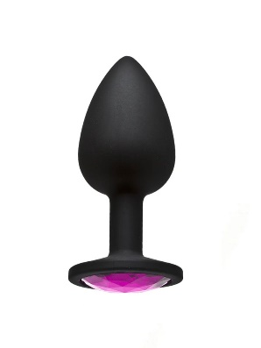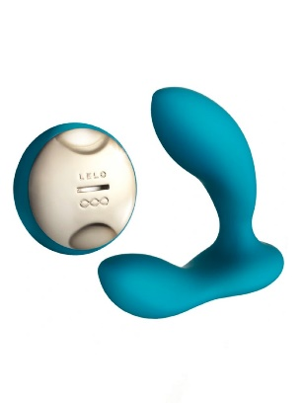

Any final tips to remember or things to avoid?
Let’s do a quick recap, shall we?
- Stimulating the prostate—a walnut-size gland inside the male pelvis—can feel really, really good thanks to the many nerve endings in the anus and surrounding area.
- Because the anal lining and anus are very sensitive, prostate massages do come with risks like pain and tearing. It’s essential to prepare beforehand, first by communicating what you and your partner are and aren’t comfortable with.
- You also need to prepare physically by doing things like washing your hands, slipping on latex gloves if you want, taking deep breaths, and engaging in some foreplay.
- If you’re using your fingers to give a prostate massage, you can try applying firm yet gentle area to the perineum, that bit of skin between the testicles and anus, and experiment from there.
- Lube is a must before any anal penetration occurs—but leave the numbing agents out of it.
- Only use sex toys that have a flared base for anal play.
- Enjoy!

