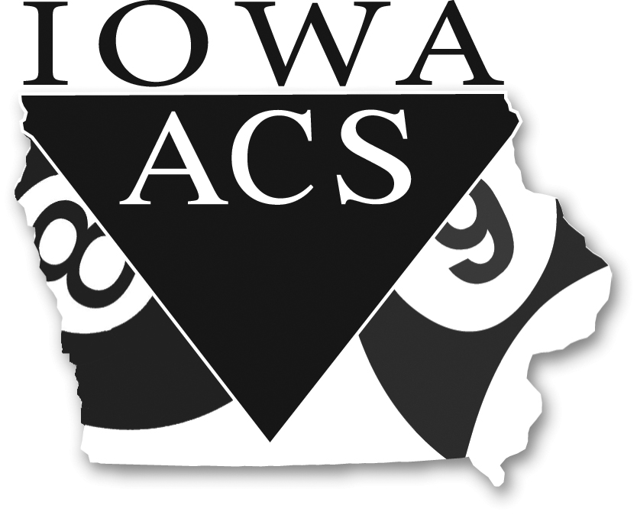

**ANNUAL GENERAL MEETING AGENDA**

**Sunday, January 20, 2019 at 1 pm, Room TBA**

Type of Meeting: Board of Directors

Meeting Facilitator: Tim Bringman, President

Invitees: All Iowa ACS League Operators and Officers

I. Call to Order: Note Date and Time

II. Roll Call:

A. By sign-in sheet

B. Check accuracy of contact info

III. Open Issues:

A .Welcome

B. Approval of the agenda

C. Approval of minutes from last meeting sent out with this agenda (please read ahead)

D. Checking & approval of the annual reports from the

President (if any)

Secretary (if any)

Treasurer (Profit/Loss Statement, statistics)

E. Reports from the membership (if any)

F. Approval of budget for the next year

Discuss current contract & get input for future negotiations - 3-yr contracts 2018-2020

How to reduce budget - become more profitable

G. Discussion of 2018 Iowa ACS Tournament – improvements/comments

H. Two core players with 2 non-operator, league sanctioned players forming teams

Players can be from any ACS league? Within Iowa or out-of-state?

If this should be just Iowa ACS players only – not for out-of-state players

I. Discuss player ratings to help operators better understand and place players correctly

J. Look at options for setup contract

K. Discuss Junior tournament

L. Election of the Officers

Vice-President

Treasurer

IV. New Business:

A. Open to the floor.

V. When do we need to meet again?

VI. Adjournment.