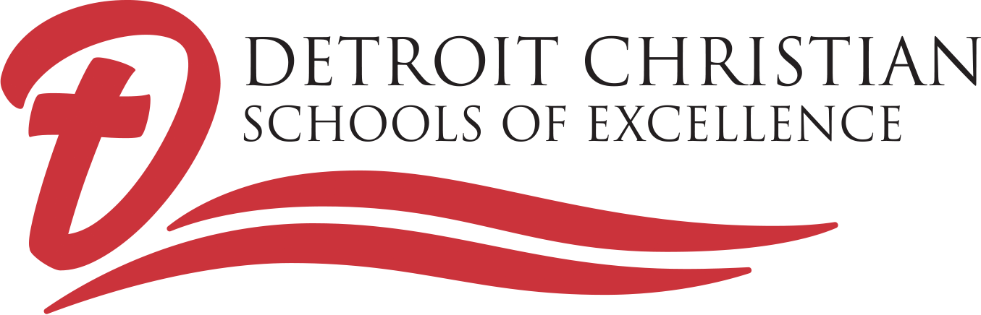

SCHOOL HOURS: 8:15 A.M. – 3:15 P.M.

ARRIVAL: Classes begin at 8:15 a.m.
Morning Latch Key is available beginning at 7:00 a.m. ($1.00 per half-hour).
Current COVID procedures include temperature checks on arrival, with masks required for everyone.
An all-school Praise and Worship is held each morning (9:05-9:30 a.m.)

DISMISSAL: Classes end at 3:15 p.m.
Current COVID procedures include socially-distant dismissal between 3:00-3:15 p.m., with younger children dismissed first.
Afternoon Latch Key is available between 3:30 and 5:30 p.m. ($1.00 per half-hour).

LUNCH PROGRAM
Currently, during COVID-times, cold bag lunches are provided free to all students who desire them, and children eat in classrooms. Notification of changes in lunch procedures will be provided when available.

SCHOOL UNIFORMS
School uniforms are a solid color polo shirt (white, black, red, or heather gray) with black or khaki pants or skirt.

DETROIT CHRISTIAN SCHOOLS OF EXCELLENCE IS NOT A CHARTER SCHOOL
Christian Education at Detroit Christian Schools of Excellence means… SMALL CLASS SIZES… a COLLEGE-PREP EDUCATION PROGRAM… RESOURCE ROOM FOR THOSE WHO NEED IT… a K-12 FAMILY… AFFORDABLE TUITION… EXPERIENCED, DEDICATED, CHRISTIAN TEACHERS… a SAFE, SECURE ENVIRONMENT. CURRENTLY WE PLAN TO CONTINUE FACE-TO-FACE LEARNING WITH A LIMIT OF 8 STUDENTS PER CLASSROOM.

BUT MORE THAN THIS, IT MEANS PRAISE & WORSHIP, RELIGION CLASSES, PRAYER IN SCHOOL, AND LEARNING HOW TO BECOME A CHRISTIAN LEADER !!

