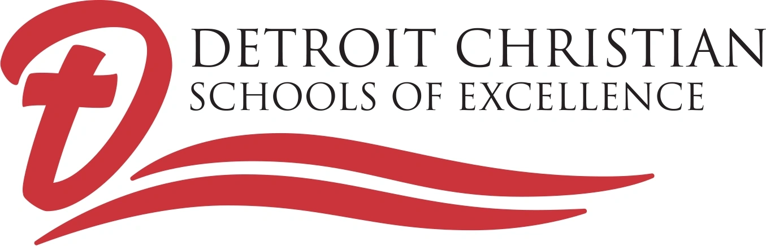
19370 Greenfield
Detroit, Michigan 48235
__________________________________________________________________________________________________________________________________________________________________________________________________________________
Roy (Dave) Siefker, M.Ed., Principal Principal Cell Phone (313) 333-3024
Office (313) 281-8144 Fax (313) 281-8218
www.detroitchristianschools.com E-mail: principal@detroitchristianschools.com

Welcome to Detroit Christian Schools of Excellence!
We are excited about beginning the 55th year of our unique K-12 Christian school ministry! This packet includes information and materials needed for 2026-2027 enrollment & re-enrollment at DCSE.
For more information or scheduling a new enrollment interview*:
- School Phone: (313) 281-8144
- Enroll NOW! Classes begin August 24, 2026
- Principal Dave Siefker (cell phone): (313) 333-3024
- E-mail: principal@detroitchristianschools.com
- Website: www.detroitchristianschools.com
*Elementary interviews include the parent/guardian, DCSE principal, and homeroom teacher when possible.
High School interviews: For transferring high school students, bring high school transcript or semester report cards.

THE D.C.S.E. MISSION
Detroit Christian Schools of Excellence offers co-ed, quality, college-preparatory K-12 Christian education, helping each child reach his/her greatest potential – preparing Christian leaders for Detroit and the World.
DCSE is committed to strengthening and expanding Christian education in the city of Detroit.
19370 Greenfield
Detroit, Michigan 48235
__________________________________________________________________________________________________________________________________________________________________________________________________________________
Roy (Dave) Siefker, M. ED., Principal Principal Cell Phone (313) 333-3024
Office (313) 281-8144 Fax (313) 281-8218
www.detroitchristianschools.com E-mail: principal@detroitchristianschools.com

K-12 Christian Education
2026-2027 TUITION &FEES- Same rates as the past 15 years!

REGISTRATION FEES
K4 (4-yr. olds) $100 per student
Grades K-12 $100 per student
TUITION FEES
Grade K4 thru Grade 12 - $3500 per year (10 monthly payments of $350)
(Tuition rates are the same for all grades.)

Multi-Student Tuition Rates:
2 students $6,000 per year (10 monthly payments of $600)
3 or more students $7,500 per year (10 monthly payments of $750)
(4th or 5th students, etc. are FREE)

MAKING TUITION PAYMENTS
Monthly Payments are due by the 15th of each month, August 15th through May 15th. A $25 late fee may be applied to any account if payment is received after the 30th of the month.

Payments may be made by CASH, CHECK, MONEY ORDER, DEBIT OR CREDIT CARD, through Zelle on your bank’s mobile app, or through PayPal on the school website, www.detroitchristianschools.com

SCHOOL HOURS: 8:15 A.M. – 3:15 P.M.

ARRIVAL: Classes begin at 8:15 a.m.
Morning Latch Key is available beginning at 7:00 a.m. ($1.00 per half-hour).
Temperature checks may be conducted, and masks may be required in some classrooms as needed.
An all-school Praise and Worship is held each morning (8:15 a.m.)

DISMISSAL: Classes end at 3:15 p.m.
Permission from the parent/guardian is required for early dismissal.
Afternoon Latch Key is available between 3:30 and 5:30 p.m. ($1.00 per half-hour).

LUNCH PROGRAM
A free cold breakfast (8:30 – 8:45 a.m.) and free hot lunches will be offered to all students. Students also have the option to bring lunches from home.

SCHOOL UNIFORMS
School uniforms are a solid color polo shirt (white, black, red, or heather gray) with black or khaki pants or skirt. Embroidered school apparel (optional) may be purchased from Educational Outfitters (see the DCSE website).

DETROIT CHRISTIAN SCHOOLS OF EXCELLENCE IS NOT A CHARTER SCHOOL
Christian Education at Detroit Christian Schools of Excellence means… SMALL CLASS SIZES… COLLEGE-PREP EDUCATION PROGRAM… RESOURCE CLASSES WHERE NEEDED… A K-12 CHRISTIAN FAMILY… AFFORDABLE TUITION… EXPERIENCED, DEDICATED, CHRISTIAN TEACHERS… SAFE, SECURE ENVIRONMENT. CURRENTLY WE PLAN TO CONTINUE FACE-TO-FACE LEARNING WITH A LIMIT OF 10 STUDENTS OR LESS PER CLASSROOM.

BUT MORE THAN THIS, IT MEANS PRAISE & WORSHIP, RELIGION CLASSES, PRAYER IN SCHOOL, AND LEARNING HOW TO BECOME A CHRISTIAN LEADER !!

K-12 Christian Education
is Alive and Shining in Detroit!

Detroit Christian Schools of Excellence, located at 19370 Greenfield at Vassar, is an independent K-12 Christian school program. DCSE was opened to continue K-12 Christian education in Detroit after Detroit Urban Lutheran School was closed. Detroit Urban Lutheran/Detroit Christian Schools of Excellence begins its 55th year.

12 Strengths of Detroit Christian
Detroit Christian offers a K-12 College-preparatory Christian Education.
- Complete, Christian education
- Full Face-to-Face Learning
- Daily Worship and Christian Instruction
- Excellence in Academics
- Resource Help and College-prep Classes
- Experienced, Caring Teachers
- Small Class Sizes
- 10 Students or Less per Classroom
- Safe, Secure Environment
- Affordable Tuition
- Family Atmosphere
- Full use of Community Resources
Detroit Christian Schools of Excellence
19370 Greenfield (at Vassar)
Detroit, MI 48235
Phone: (313) 281-8144 Fax: (313) 281-8218

Roy (Dave) Siefker, Principal
Cell Phone: (313) 333-3024
E-mail: principal@detroitchristianschools.com
Web : www.detroitchristianschools.com


Detroit Christian Schools of Excellence
19370 Greenfield
Detroit, MI 48235
Phone: (313) 281-8144
Cell Phone: (313) 333-3024
E-mail: principal@detroitchristianschools.com

2026-27 APPLICATION/REGISTRATION
*Detroit Christian Schools of Excellence accepts students of any race, color, and national or ethnic origin.

Name of Student: ________________________________________________ Grade (2026-27): _____
Address: __________________________________ City: _______________________ Zip: __________
Birthdate:__/__/__ Phone # (_____)__________ E-mail:_____________________________________
Church: ___________________________________________ Pastor:__________________________
Student Cell Phone: (____)______________ Student Lives with________________________________
Last School Attended: _________________________________________________________________
Mother Father Other
Name _______________________ _______________________ ________________________
Address _______________________ _______________________ ________________________
City/Zip _______________________ _______________________ ________________________
Home Phone _______________________ _______________________ ________________________
Cell Phone _______________________ _______________________ ________________________
E-Mail Address _______________________ _______________________ ________________________
Employer _______________________ _______________________ ________________________
Occupation _______________________ _______________________ ________________________
Work Phone _______________________ _______________________ ________________________
Church _______________________ _______________________ ________________________

EMERGENCY CONTACT(S)
Name ____________________________________________________________________________________
Relationship to Student _____________________________________________________________________
Home Phone ______________________________________________________________________________
Cell Phone _________________________________________________________________________________
Work Phone _______________________________________________________________________________
*List any health conditions such as heart disease, diabetes, epilepsy, severe allergies, sickle cell disease, eye or ear problems or any chronic conditions. Also, please list any medications here.
____________________________________________________________________________________________________________________________________________________________________________________
Parental Pledge - As parent(s) of the above student, I (we) herby pledge:
- Cooperative participation in the Detroit Christian Schools program by my child
- My cooperation with teachers and administration of Detroit Christian Schools
- Regular church attendance and support of the Christian purposes of the school
- Meeting of school financial obligations including tuition, fees, damage, to or loss of any school property
SIGNATURE(S) of Parent(s) or Legal Guardian(s):
(Father) _______________________________________________________ Date ________________
(Mother) ______________________________________________________ Date ________________
(Other) _______________________________________________________ Date ________________
At DCSE, We Believe…

WE BELIEVE in a revival of Christian education for Detroit children! Fifty years ago, approximately ten percent of Detroit’s children attended Christian schools, but today, it’s less than one percent!

WE BELIEVE Christian education should be affordable for all of Detroit’s Children. Only public and public charter schools are funded by Michigan’s tax dollars. Christian schools, however, can only receive funds from parent tuition, donations, federal funds, and grants. We appreciate the many dedicated people who sacrifice to maintain our school.

WE BELIEVE all children can achieve excellence, and failure is not an option! We achieve excellence when we use all of His gifts to His praise and His glory.

WE BELIEVE in meeting the diverse needs of students. DCSE offers a basic college-preparatory Christian education, and accommodates students with varied learning abilities through Title I and resource help.

WE BELIEVE Detroit doesn’t need more public charter schools, but more Christian schools. DCSE is committed to expanding Christian education in Detroit.

WE BELIEVE in the revitalization of Detroit – and we believe a real revitalization of our city must begin with our children receiving Christian education.

WE BELIEVE the best Christian leaders have and will come from Christian schools. At Detroit Christian Schools of Excellence we are developing Christian leaders for Detroit and the World.

WE BELIEVE in JESUS – all day, every day!

K-12 CHRISTIAN EDUCATION IS STILL ALIVE AND SHINING IN DETROIT!

