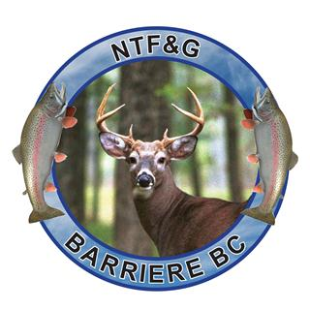
North Thompson Fish & Game Club Society
NEWSLETTER

*****Contest: Enter to WIN Free Membership*****

Those who renew their Membership before December 31, 2019 for the 2020 year will be entered to WIN their 2020 Membership. If you are drawn at our AGM, your Membership fee for 2020 will be returned to you that night!

UP and COMING for 2020

ANNUAL GENERAL MEETING ~ January 27, 2020

WILD GAME DINNER ~ March 28, 2020

POKER RUN @ THE RANGE ~ May 23, 2020

FATHER’S DAY FISHING DERBY ~ June 21, 2020

RANGE CLOSED ~ May 15 to July 1st, 2020

OPEN HOUSE @ THE RANGE ~ July 12, 2020

Don’t forget ~ the Annual General Meeting Features Voting!
You Must be at the Meeting to Nominate or Vote
For our Next Board Members

SEE YOU ALL THERE..!!!

