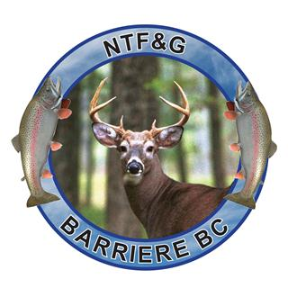

North Thompson Fish & Game Club Society

Notice: Reopening of the NTF&G Club Range with interim Covid 19 Procedures

As provincial guidelines for Covid 19 restrictions are eased for low impact sports, we are reopening the range on Jul 1st 2020 at the end of our normal closed period.

Physical distancing is required and people are encouraged to continue washing their hands frequently, covering their mouth when they cough, and to avoid handshakes.

Covid 19 Interim Range Rules

- If you are sick please stay home. Do not enter the NTF&G Club grounds if you meet the following criteria:
  - Have or had symptoms of Covid-19 in the past 10 days (cough, sneeze, sore throat, fever, difficulty breathing, etc.)
  - Have travelled outside of Canada within the previous 14 days
  - Have been exposed to someone with Covid-19
  - Share a home with someone who has been exposed to Covid-19
- Members only, no guests at this time.
- Physical Distancing of 2 meters is required. Every other shooting position closed.
- Masks are not mandatory but are encouraged to keep others safe.
- Bring your own cleaning materials and hand sanitizer. We recommend you add those items to your Range Bag
- All NTF&G Club Range Policies and Rules remain in effect.

You will be using the range facilities at your own risk. The Club and its Executive Board are not responsible should you become infected with COVID 19.

