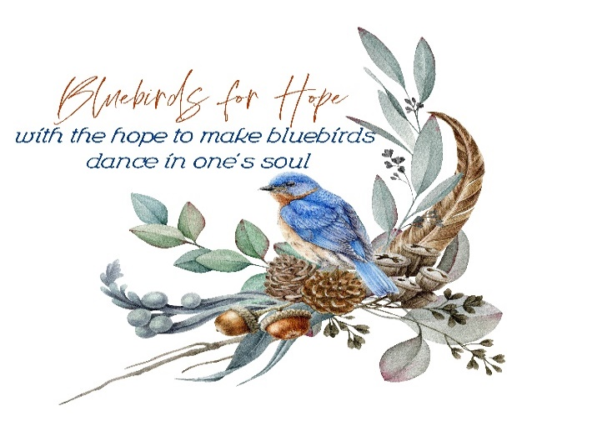

**SPONSOR REGISTRATION FORM**

Organization and Contact Name: ________________________________________________________

Mailing Address: ____________________________________________________________________

Email Address: ______________________________________________________________________

Phone Number: _________________________________________________________________

**SPONSORSHIP LEVEL** - All sponsorships are for both nights of the Haunted Hayride.

____ DIAMOND SPONSOR @ $700 – 2 AVAILABLE (Banner posted at intersection of HWY 142 and 83N in Shady Dale, GA along with hayride banner starting in September and going through October 26. Includes advertising on t-shirt, Bluebirds for Hope website and Facebook posts.)

____ PLATINUM SPONSOR @ $500 – 4 AVAILABLE (Banner along with the hayride banner in retail windows in Monticello Square for the entire month of October. Includes advertising on the t-shirt, Bluebirds for Hope website and Facebook posts.)

____GOLD SPONSOR @$325 – 6 AVAILABLE (Banner on hayride trailer. Includes advertising on Bluebirds for Hope website and Facebook posts.)

­­­____ SILVER SPONSOR @$225 – 6 AVAILABLE (Banner on carnival games. Includes advertising on Bluebirds for Hope website and Facebook posts.)

____BRONZE SPONSOR @ $150 (Logo on group banner placed above concession stands. Includes advertising on Bluebirds for Hope website and Facebook posts.)

____ Sleeve t-shirt logo @ $125 – 2 AVAILABLE (Logo placed on sleeve of hayride t-shirt.)

____ Back of t-shirt logo @ $100 (Logo placed on back of hayride t-shirts)

Payment accepted via check, Venmo (@christy-wyatt-0), and Cashapp ($ChristyWyatt). Checks should be made payable to “Bluebirds for Hope” and can be dropped off at 22805 North Main St. Shady Dale, GA 31085. Upon payment please send official logo to bluebirdacresproject@gmail.com.

All net proceeds from the hayride and sponsorships will be donated to a person/family/or organization in need. Thank you for your support in our endeavors. This form will be marked paid and returned as receipt of payment.