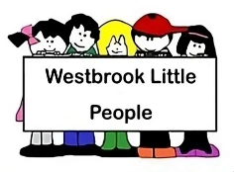
- Policy and procedures implementation and review

Alongside associated procedures, this policy was adopted by Westbrook Little People in September 2025.

Aim
We have one set of policies and procedures which are consistent across our early education and childcare provision and in line with the current EYFS requirements.
Objectives
We adhere to and implement operational policies and procedures by:
- ensuring that all members of staff, agency workers, assistants, and students (hereon referred to collectively as staff), are aware of their role and responsibility in policy and procedure implementation
- ensuring that members of staff are aware of the content of the policies and procedures through:
- induction
- line management and staff meetings and training events
- contributing feedback to procedure review
- use of relevant publications
- staff are aware of their duty to adhere to the operational policies and procedures and how they contribute to a consistent approach throughout the organisation.
- All policies and procedures are reviewed annually as a minimum and when there are any changes to the settings practice or legislation

Legal references
Childcare Act (2006)
Education Act (2011)

