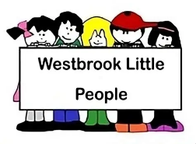
02.1a Fire safety risk assessment form Westbrook Little People
Risk Area |  | Carried out by |  | Date
Fire Hazards:  Examples: Ignition; fuel; oxygen | Who is at risk  People on premises and those most vulnerable | Level of risk  of fire occurring and the risk to people | Control measure  Remove and reduce hazards that may cause fire; Remove and reduce risks to people | Review  Record, plan, inform, instruct, train and review
Before completing this form, please refer to the five steps in procedure 02.01 Fire safety

